Contents

SVI 1

DTP & VTP 5

Spanning Tree Protocol (STP) 15

STP (Part 1) 15

STP (Part 2) 23

STP Additional Features 31

Rapid Spanning Tree 38

EtherChannel 45

Dynamic Routing 54

Intro to Dynamic Routing 54

RIP & EIGRP 61

OSPF 67

OSPF (Part 1) 67

OSPF (Part 2) 75

## SVIs

Things covered

* Native VLAN on a route
* Wireshark analysis
* Layer 3 Switching/Multilayer Switching

Native VLAN

* 2 methods to configure native VLAN on a router
  + "encapsulation dot1q <vlan_id> native"
    - Use on sub-interface
  + Configure the IP address for the native VLAN on the router's physical interface
    - Don't need to create a sub-interface, instead just key in ip address to the actual interface
    - E.g. set vlan10 as default, create sub-interface vlan20 and 30, the interface g0/0, set ip address to vlan10

Layer 3 (Multilayer) Switch

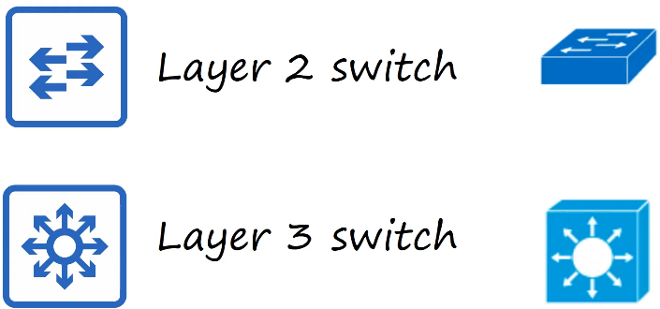

* Capable of both switching and routing
* It is layer 3 aware
* Can assign IP addresses to the interfaces, like a router
* Can create virtual interfaces for each VLAN, and assign IP addresses to those interfaces
* Can configure routes, just like a router
* Can be used for inter-VLAN routing
* SVI (Switch Virtual Interface)
  + They are virtual interfaces you  can assign IP addresses to in a multi-layer switch
  + Configure each PC to use the SVI (not the router) as their gateway address
  + To send traffic to different subnets/VLANs, the PCs will send traffic to the switch, and the switch will route the traffic

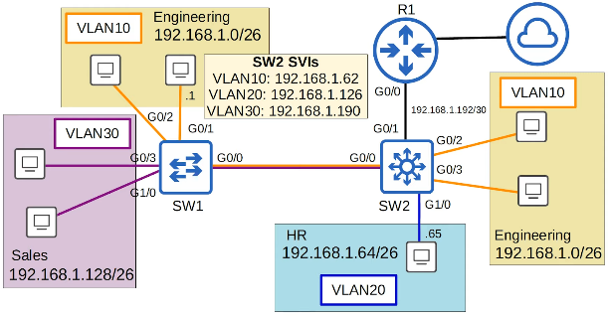

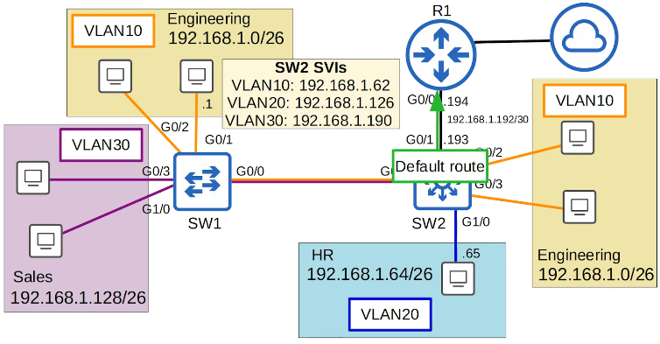

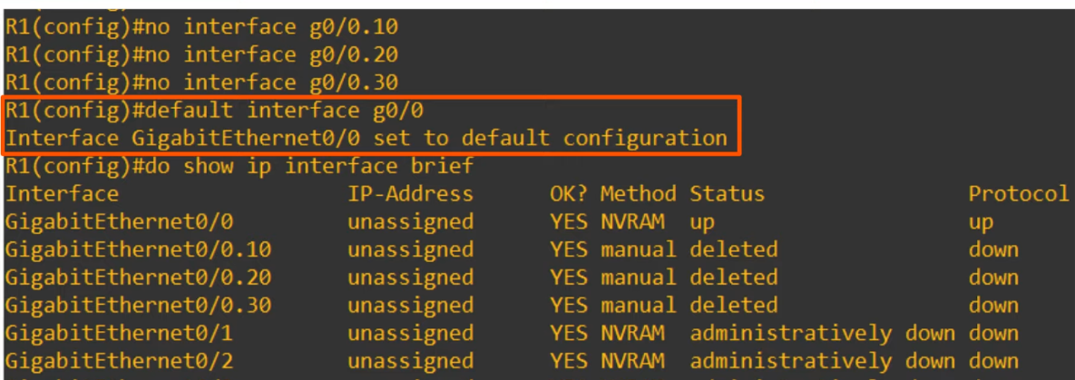

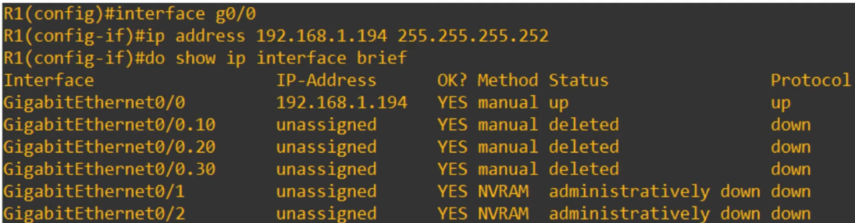

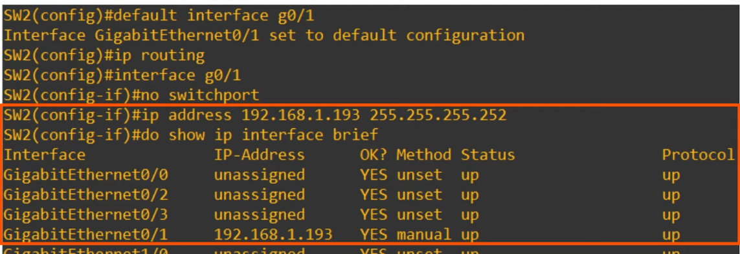

* "default interface g0/1"
  + Previously was used as trunk port
* "ip routing"
  + IMPORTANT
  + Allows the switch to act as multi-layer switch
* "no  switchport"
  + Changes the switch from layer 2 to layer 3 switch

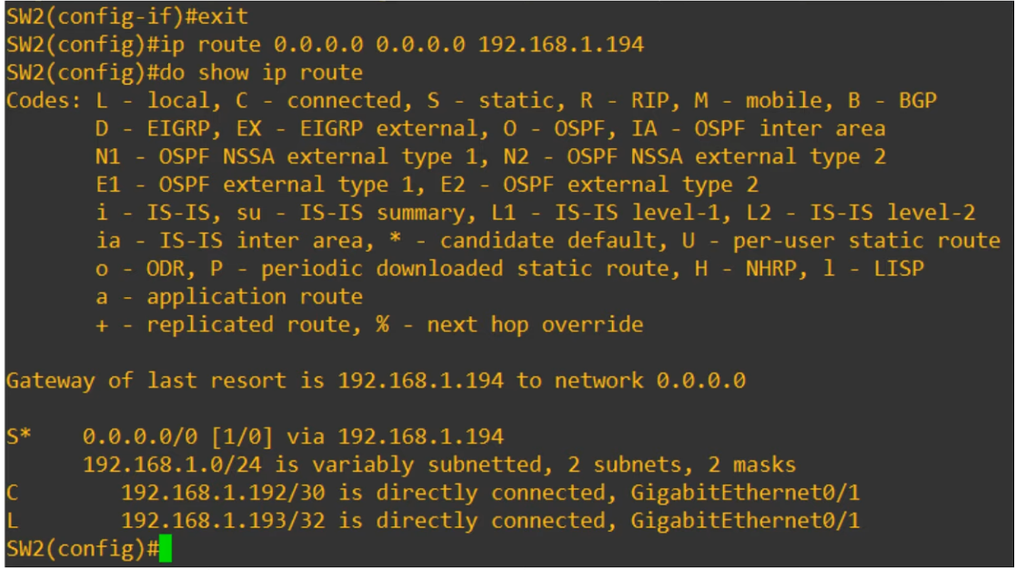

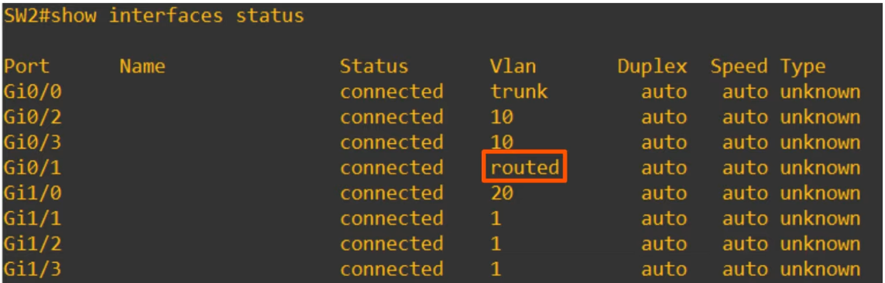

Configuring the SVIs

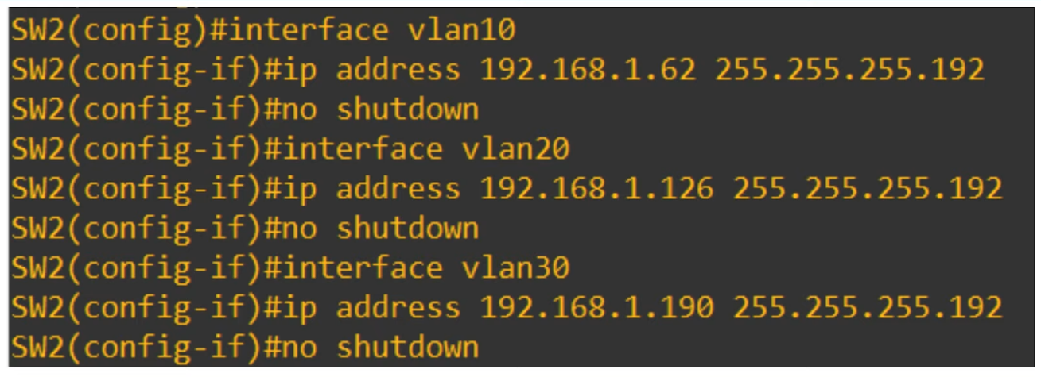

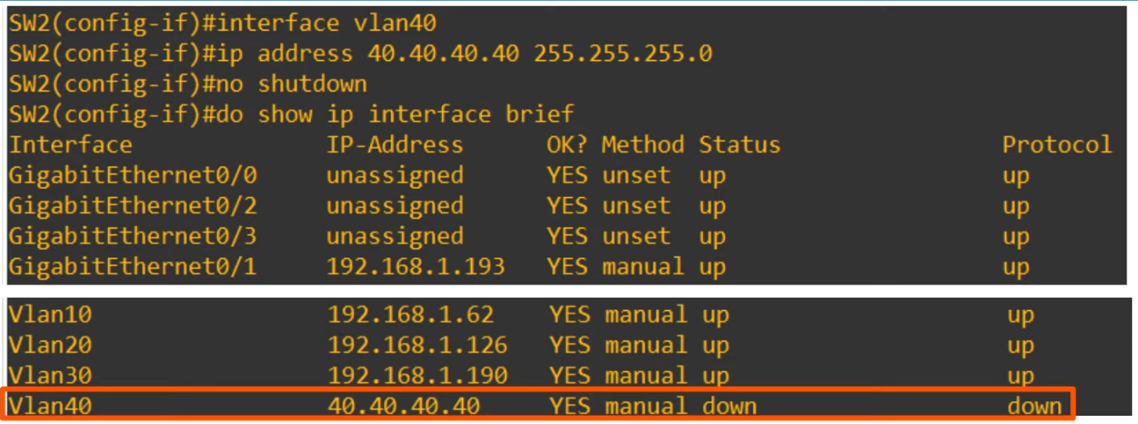

* For SVI to be in up/up state
  + The VLAN must exist on the switch
  + The switch must have at least 1 access port in the VLAN  in an up/up state, AND/OR 1 trunk port that allows the VLAN that is an up/up state
  + The VLAN must not be shutdown
  + The SVI must not be shutdown (disabled by default)

Commands

* Configure switch to layer 3 switch
  + "ip routing"  (give permission to act as layer 3 switch)
  + "interface <interface>"
  + "no switchport"               (enable layer 3 switch)
  + "interface <vlan num>
  + "ip address <ip addr>
  + "no shutdown"

## DTP & VTP

Things covered

* Dynamic Trunking Protocol
* VLAN Trunking Protocol

DTP (Dynamic Trunking Protocol)

* Is a Cisco proprietary protocol that allows Cisco switches to dynamically determine their interface status (access or trunk) w/o manual config
* Enabled by default on all Cisco switch interfaces
* So far, configure using
  + "switchport mode access" OR "switchport mode trunk"
  + With DTP, don’t need to do so
* For security purposes, manual config is recommended
  + DTP should be disabled for all switchports

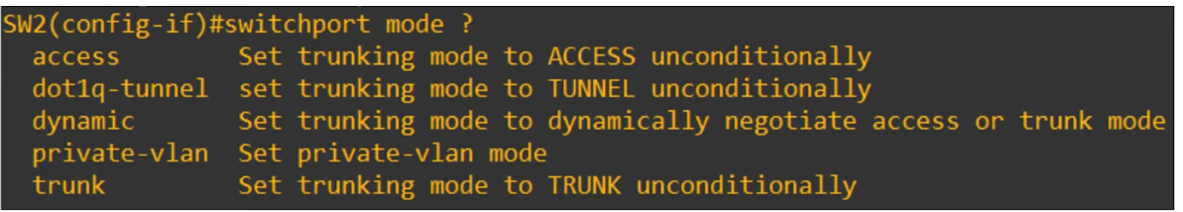

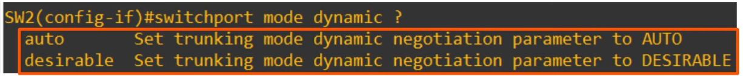

* "dynamic desirable"
  + Switchport will actively try to form a trunk with other Cisco switches
  + Will form a trunk if connected to another switchport in the following modes
    - "switchport mode trunk"
    - "switchport mode dynamic desirable"
    - "switchport mode dynamic auto"
* "dynamic auto"
  + Will not actively try to form a trunk with other Cisco switches
  + However, will form a trunk if other switch actively doing so
  + It will form a trunk in the following modes
    - "switchport mode trunk
    - "switchport mode dynamic desirable"

Dynamic Desirable

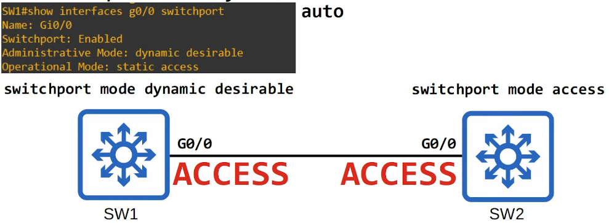

* "static access"
  + Access port that belongs to a single VLAN that doesn't change (unless you configure a different VLAN)
  + There are also "dynamic access" ports, in which a server auto assigns the VLAN depending on the MAC address of the connected device (not in CCNA)

Dynamic Auto

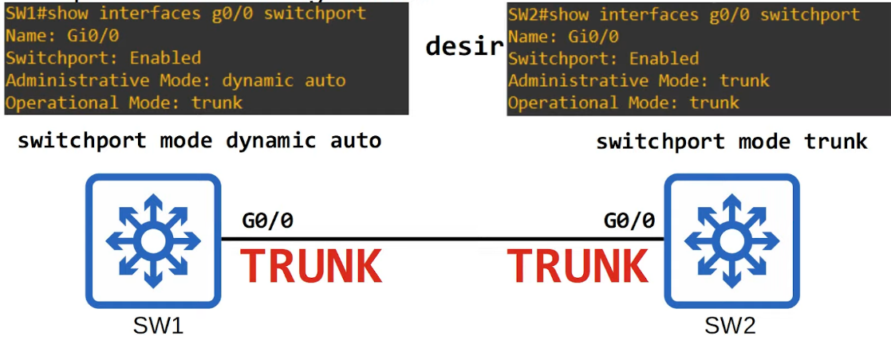

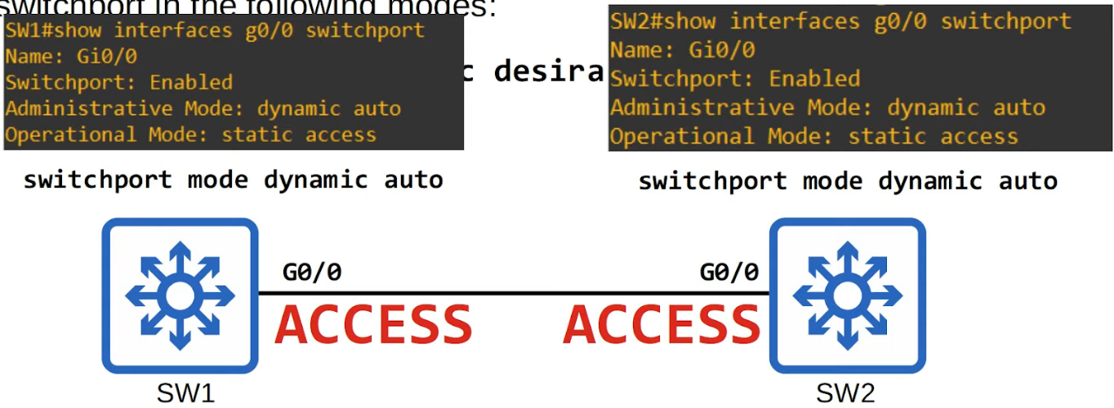

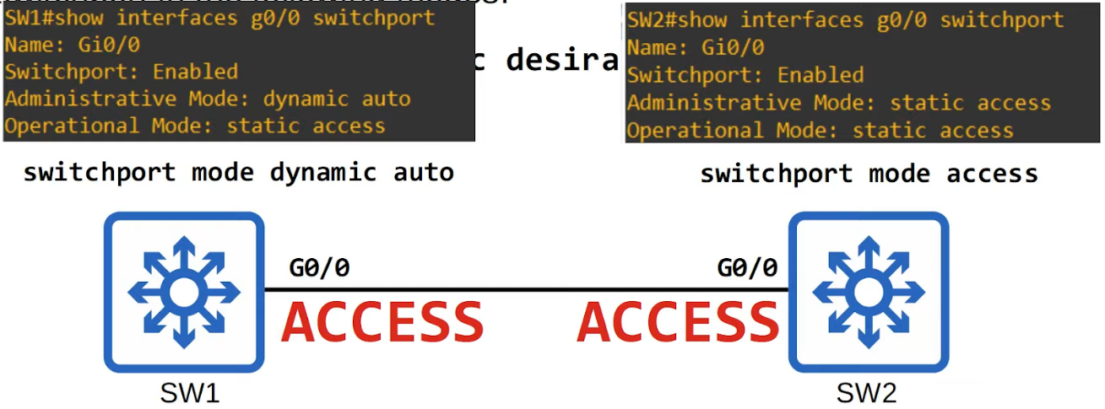

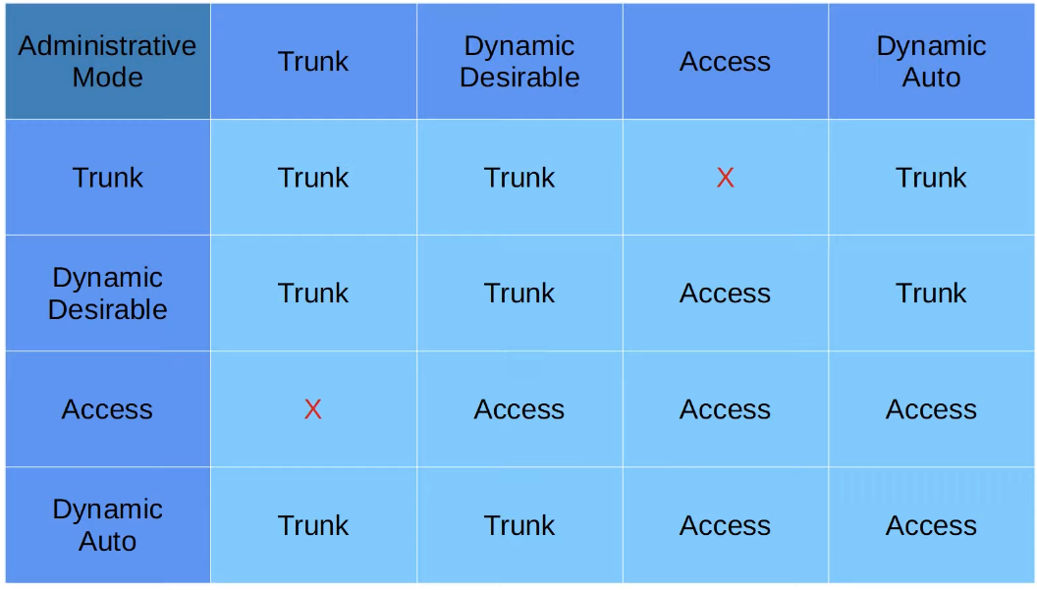

* DTP will not form a trunk with a router, PC etc
* The switchport will be in access mode
* Older switches, "dynamic desirable" by default
* Newer switches, "dynamic auto" by default
* Can disable DTP on interface
  + "switchport  nonegotiate"
* Configuring an access port with "switchport access mode" also disabled DTP on the interface
* Better to disable DTP for security

Trunk Encapsulation

* Switches that support both 802.1q and ISL trunk encapsulations can use DTP to negotiate the encapsulation they will use
* This negotiation is enabled by default, as the default trunk encapsulation mode is
  + "switchport trunk encapsulation negotiate"
* ISL is favoured over 802.1q, so if both switches support ISL, it will be selected
* DTP frames are sent in VLAN1 when using ISL, or in the native VLAN when using 802.1q (the default native VLAN is VLAN1, however)

VTP (VLAN Trunking Protocol)

* Allows you to config VLANs on a central VTP server switch, and other switches (VTP clients) will sync their VLAN database to the server
* It is designed for large networks with many VLANs, so that you don't have to config each VLAN on every switch
* It is rarely used, and recommended not to use
* 3 versions: 1,2,3
* 3 modes: server, client and transparent
* Cisco switches operate VTP server mode by default

VTP Modes

* VTP Server
  + Can add/modify/delete VLANs
  + Store the VLAN DB in non-volatile RAM
  + Will increase the revision number every time a VLAN is added/modified/deleted
  + Will advertise the latest version of the VLAN DB on trunk interfaces, and the VTP clients will sync their VLAN DB to it
  + VTP servers also function as clients
    - VTP server will sync to another VTP server with a higher revision number
* VTP clients
  + Cannot add/modify/delete
  + Do not store VLAN DB in NVRAM (in VTP3, they do)
  + Will sync their VLAN DB to the server with highest revision num in their VTP domain
  + Will advertise their VLAN DB, and forward VTP advertisements to other clients over their trunk ports
* VLAN Transparent
  + Does not participate in the VTP domain (does not sync its VLAN DB)
  + Maintains its own VLAN DB in NVRAM
  + Can modify/add/delete VLANs, but won't advertise
  + Will forward VTP advertisements that are in the same domain

* To reset revision number
  + Change to transparent mode OR
  + Set domain name to an unused one

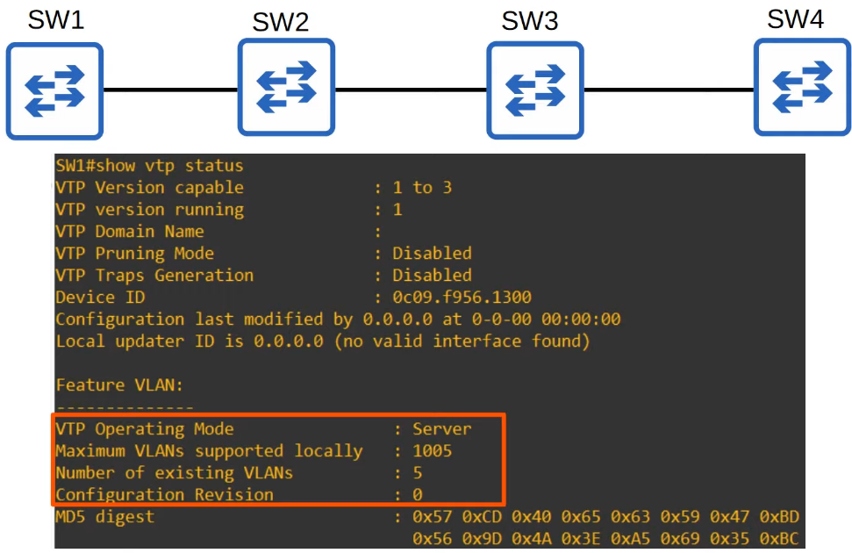

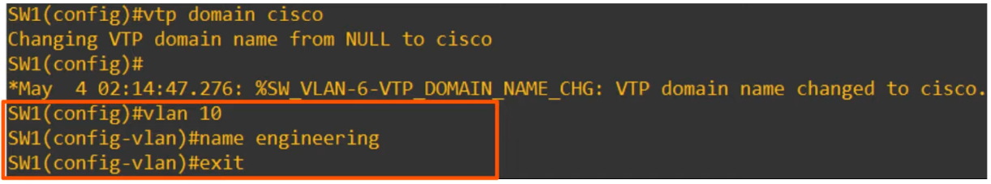

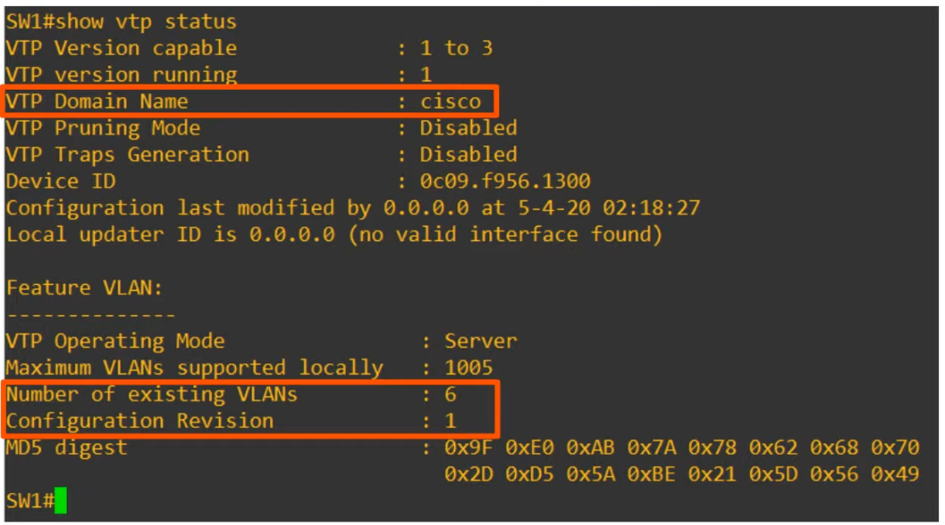

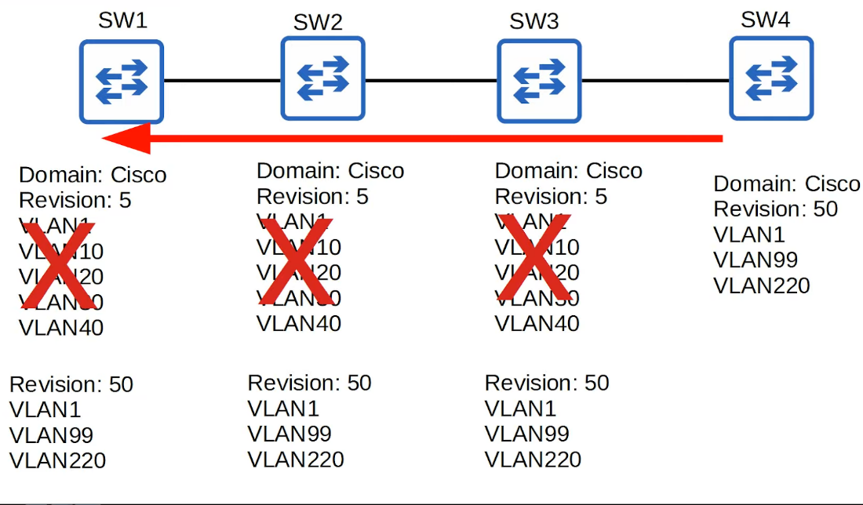

* If same name, dangerous

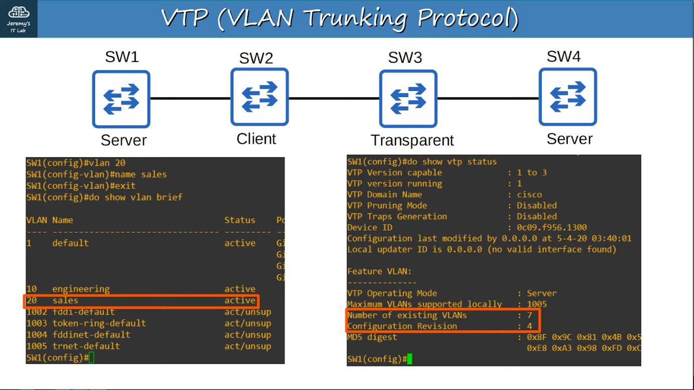

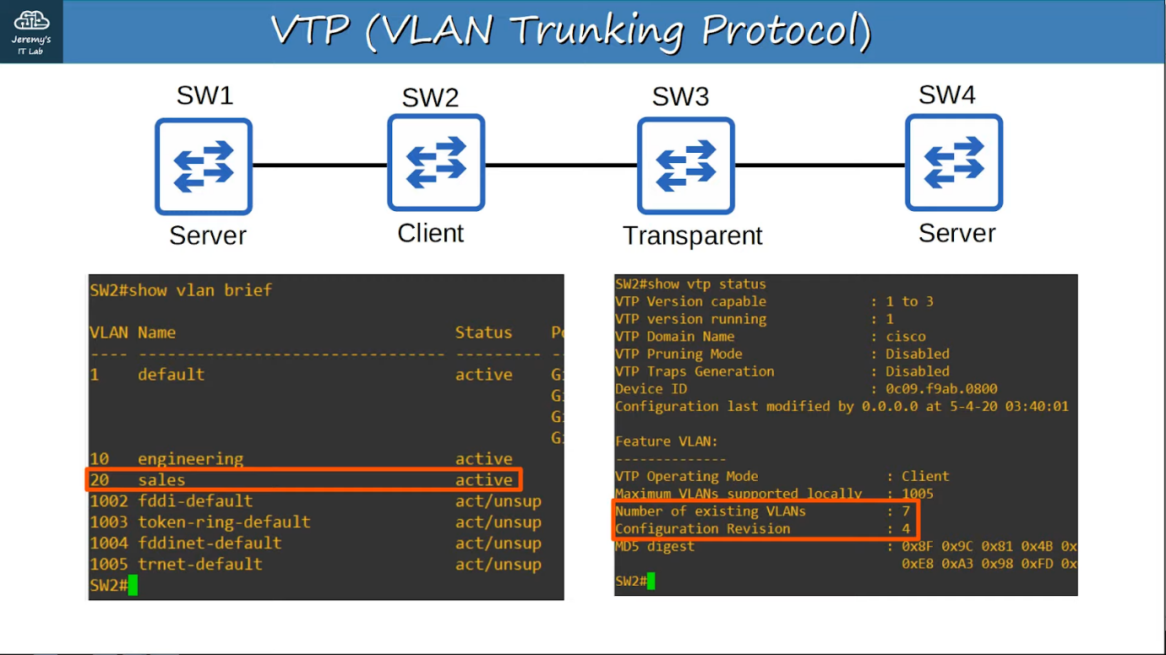

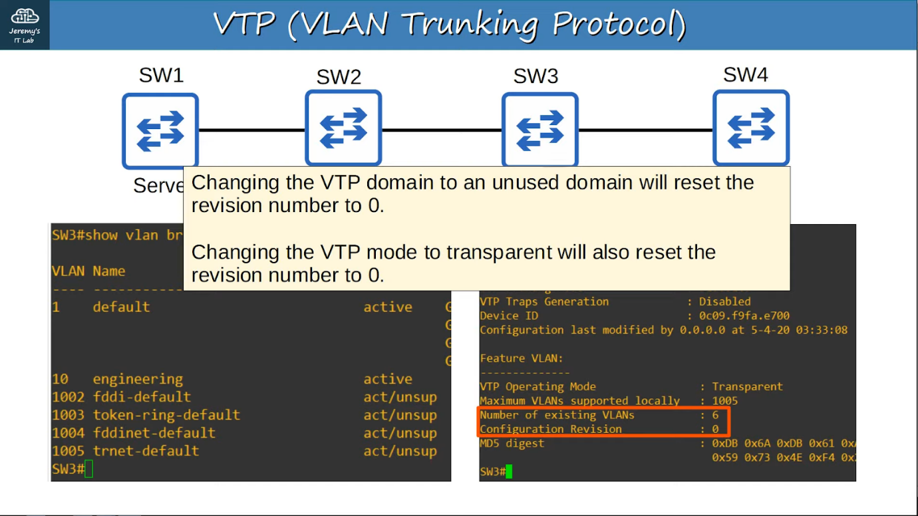

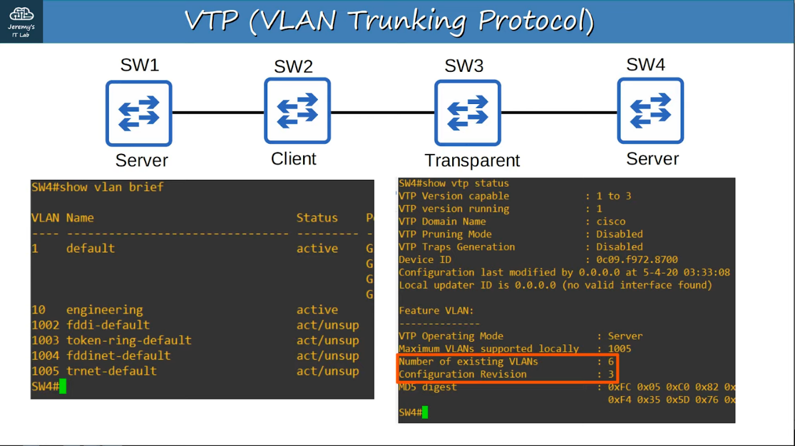

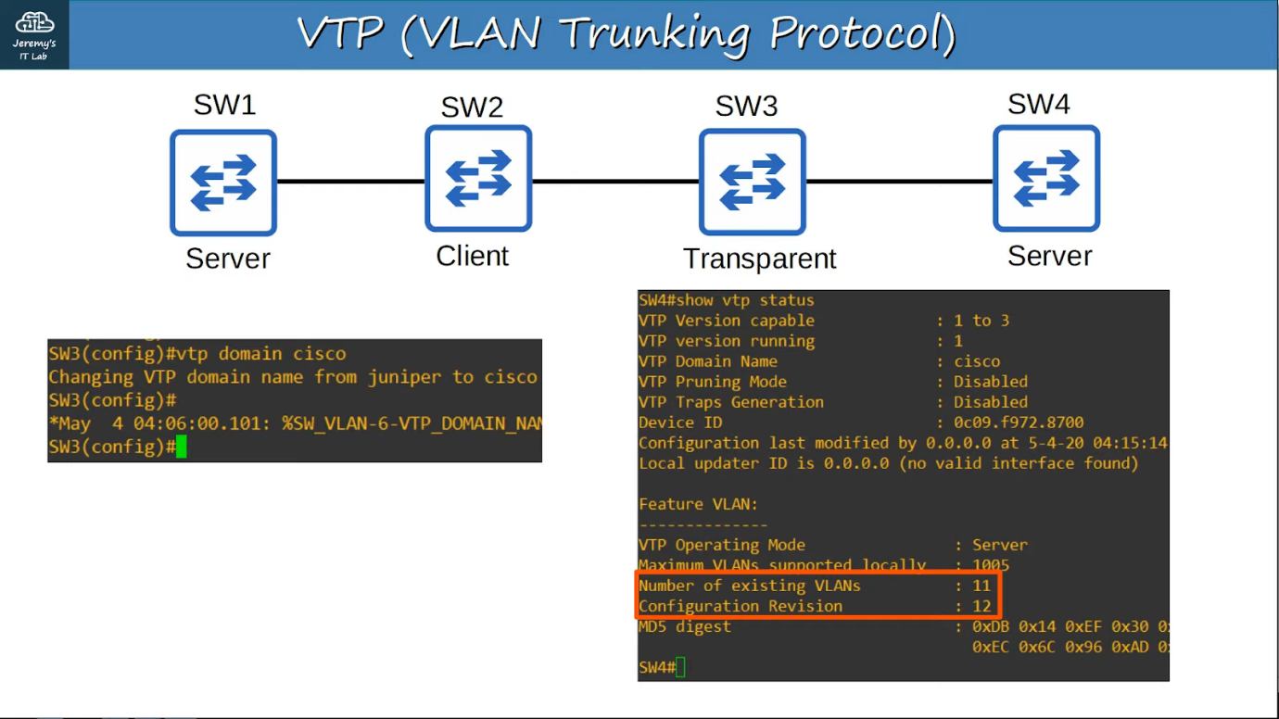

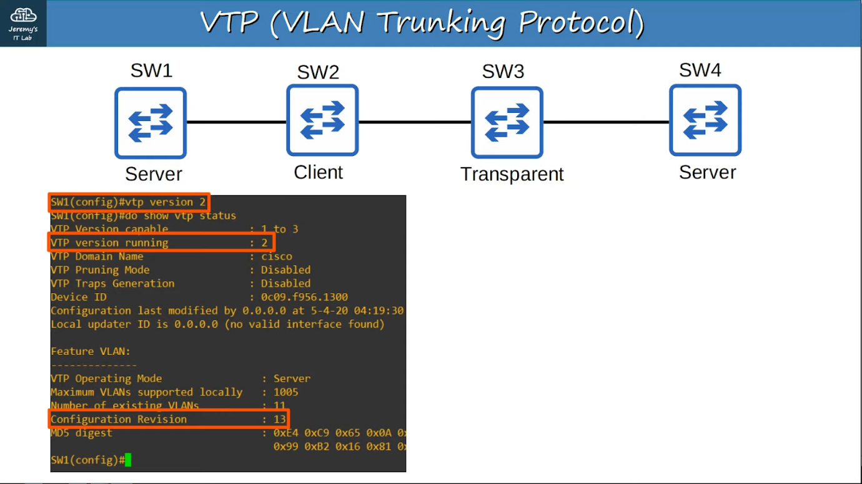

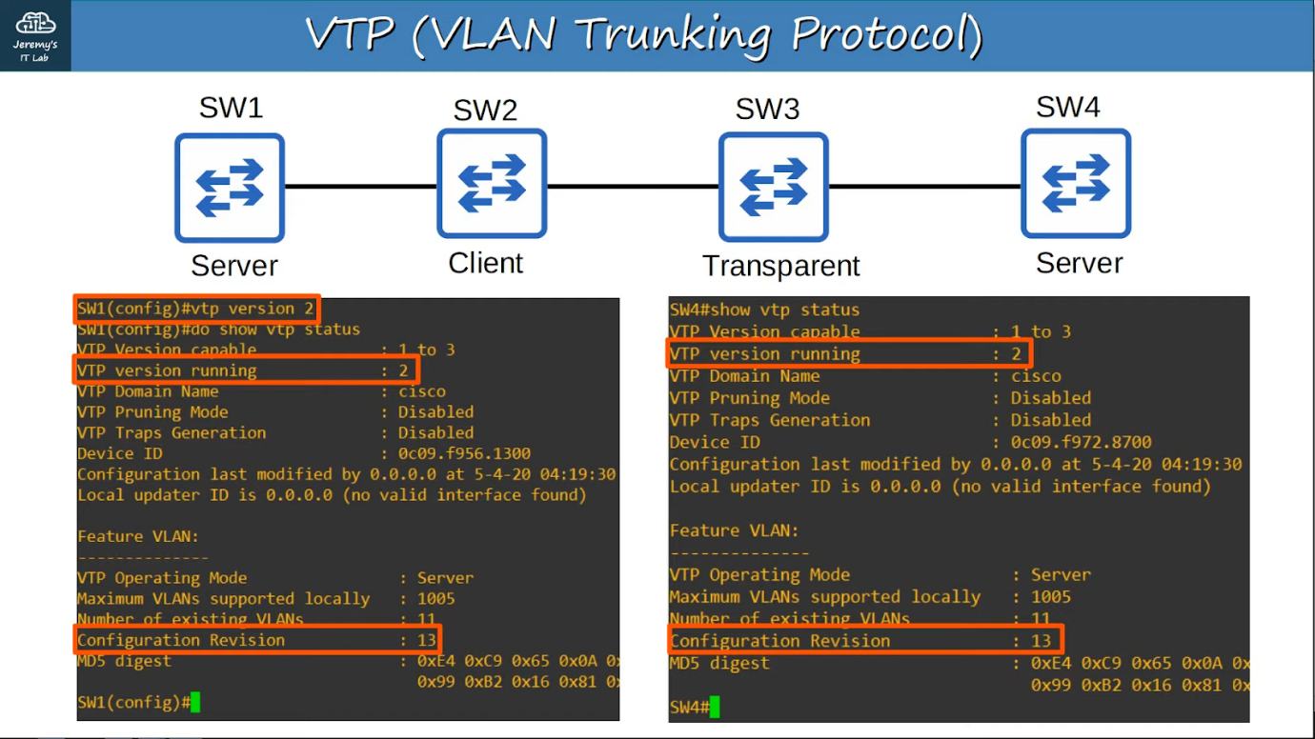

# Spanning Tree Protocol (STP)

## STP (Part 1)

Topics covered:

* Redundancy in networks
* STP

Network Redundancy

* Essential part of network design
* Modern networks expected to run 24/7
* Need to design with redundancy in mind

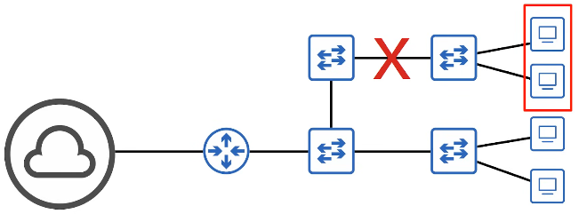

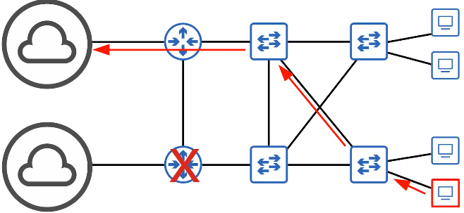

* PCs usually only have 1 NIC, however servers usually have multiple

Broadcast Storms

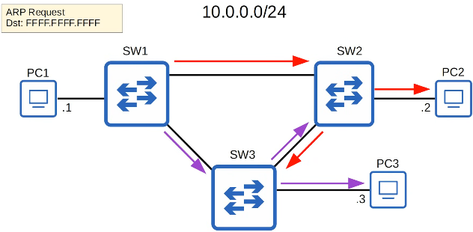

* When broadcast message sent out of PC1, the packet keeps on looping around and around
* In layer 3, the TTL header prevents this
* However, no TTL header in Ethernet field
* The broadcast frames will loop around the network indefinitely
* If too many, network will be too congested for legitimate traffic to use the network
* This is called a broadcast storm
* MAC Address Flapping
  + Each time a frame arrives on a switchport, the switch uses the source MAC address field to learn the MAC address and update its MAC address table
  + When frames from the same source repeatedly arrive on different interfaces, the switch is continuously updating the interface in its MAC address table

Spanning Tree Protocol

* "Classic Spanning Tree Protocol" is IEEE 802.1D
* Switches from all vendors run STP by default
* Prevents Layer 2 loops by placing redundant ports in a blocking state, essentially disabling the interface
* These interfaces acts as backups that can enter a forwarding state if an active (currently forwarding) interface fails
* Interfaces in a forwarding state behave normally. They send and receive traffic
* Interfaces in a blocking state only send or receive STP messages (called **BPDUs = Bridge Protocol Data Units**)

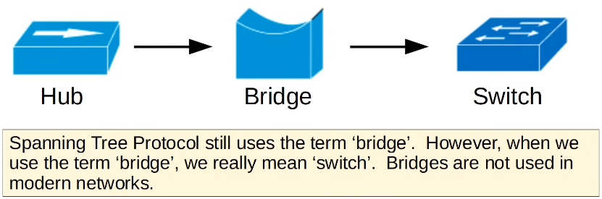

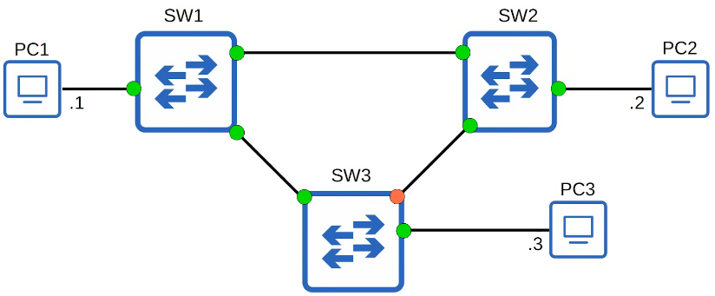

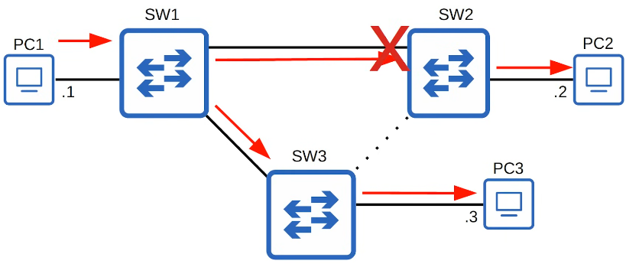

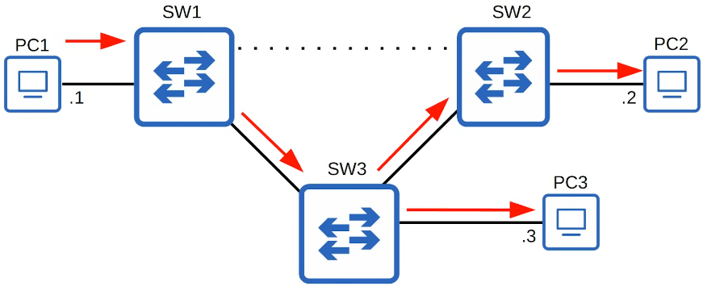

* By selecting which ports are forwarding and which are blocking, STP creates a single path to/from each point in the network
  + Prevents Layer 2 loops
* There is a set process that STP uses to determine which ports should be forwarding and which should be blocking
* STP-enabled switches send/receive Hello BPDUs out of all interfaces, the default timer is 2s, (switch will send Hello once every  2s)
* If a switch receives Hello BPDU on an interface, it knows that interface is connected to another switch (other devices don’t use STP - don’t send Hello BPDUs)

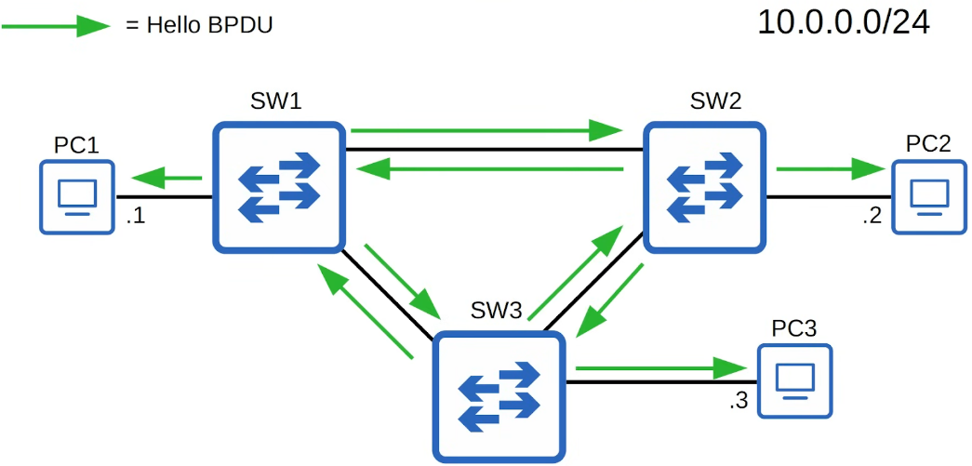

* Switches use 1 field in the STP BPDU, the Bridge ID field, to elect a root bridge for the network
* The switch with the lowest Bridge ID becomes the root bridge
* All ports on the root bridge are put in a forwarding state, and other switches in the topology must have a path to reach the root bridge

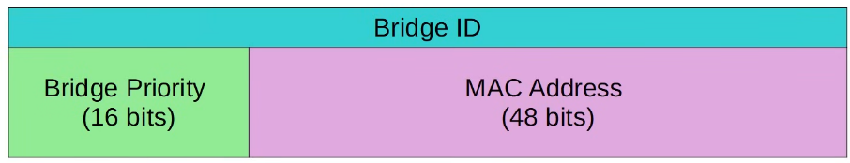

* Default bridge priority is 32768 on all switches
* So, the lowest MAC address is used as tie-breaker
* Bridge priority compared first before MAC address

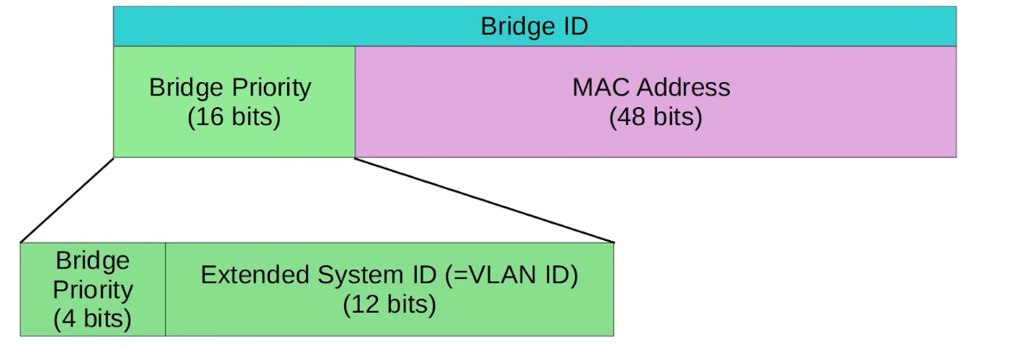

* Cisco switches use a version of STP called PVST (Per-VLAN Spanning Tree)
* PVST runs a separate STP instance in each VLAN, so in each VLAN different interfaces can be forwarding/blocking

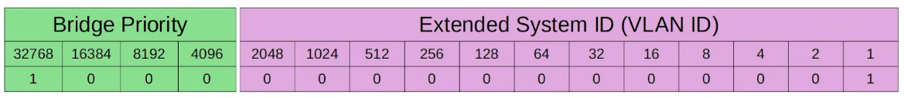

* Bridge priority + Extended System ID is a single field of Bridge ID
* Extended sys ID cannot be changed (determined by VLAN ID)
* Can only change bridge priority in units of 4096

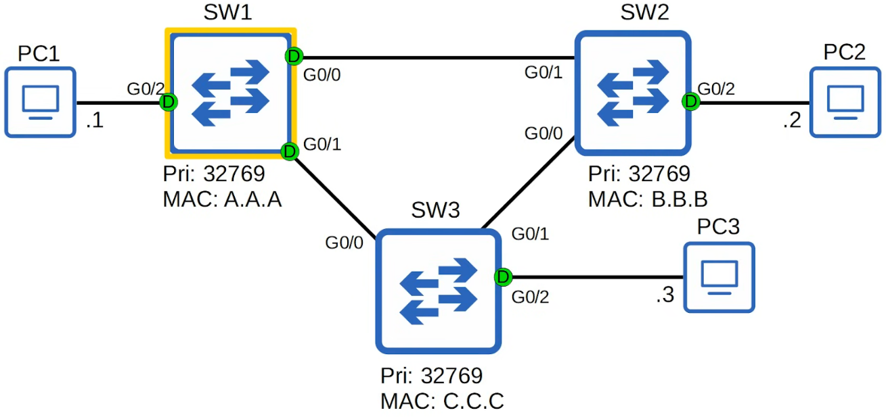

Root bridges

* When a switch is powered on, it assumes it is the root bridge
* It will give up position if it receives from a 'superior' BPDU (lower bridge ID)
* Once the topology has converged and all switches agree on the root bridge, only the root bridge sends BPDUs
* Other switches in the network will forward these BPDUs, but will not generate their own one

Root Cost

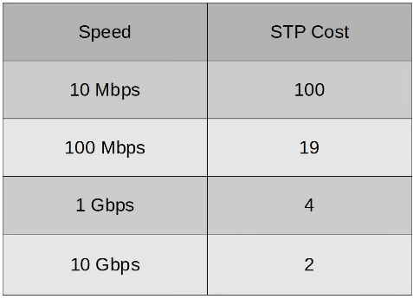

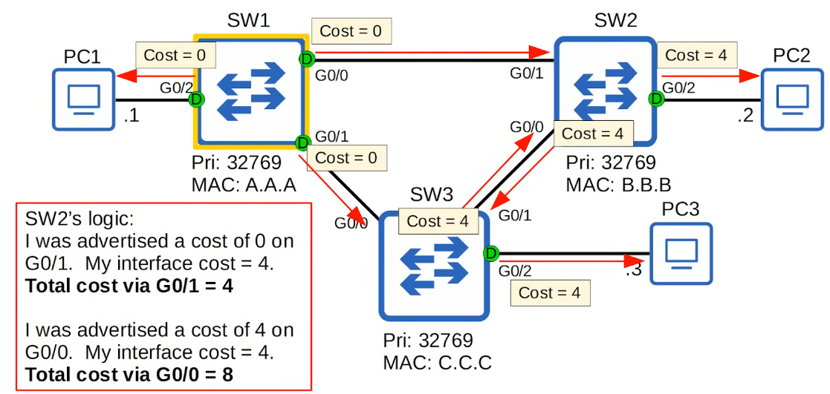

* SW2 will select G0/1 as root port

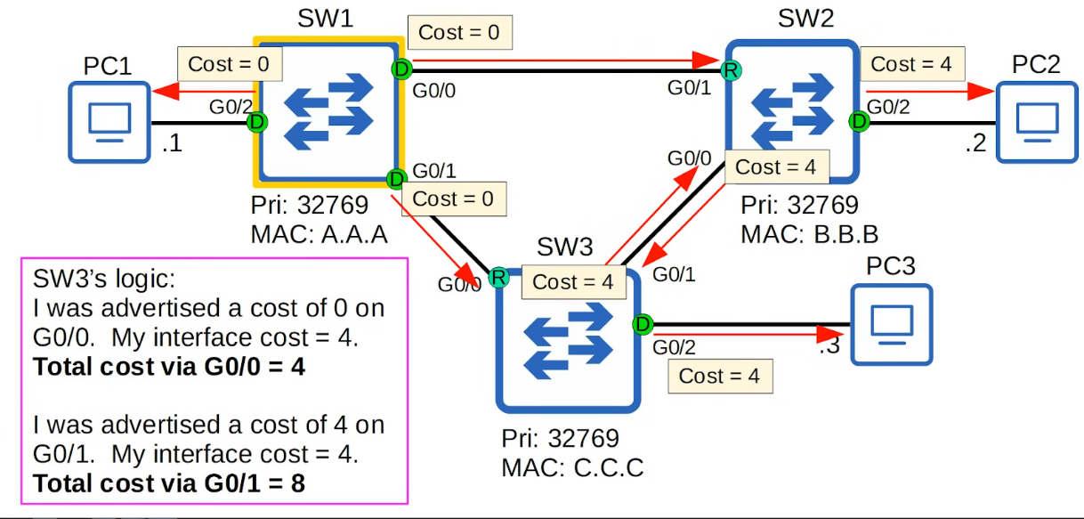

* Ports connected to another switch's root port MUST be designated.
  + Because the root port is the Switch's path to the root bridge, another switch must not block it

Port ID

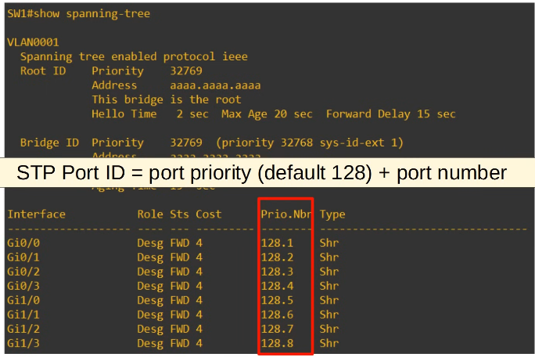

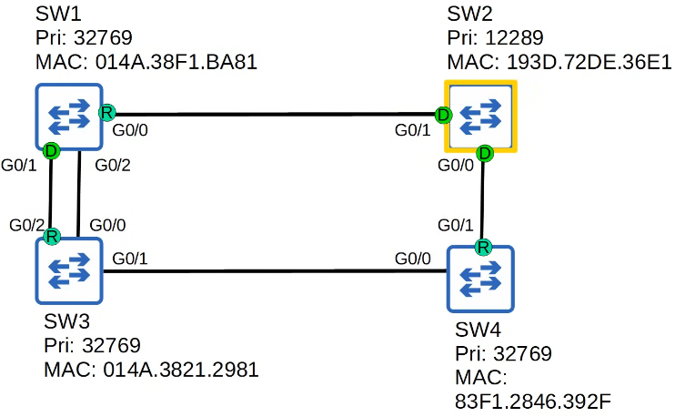

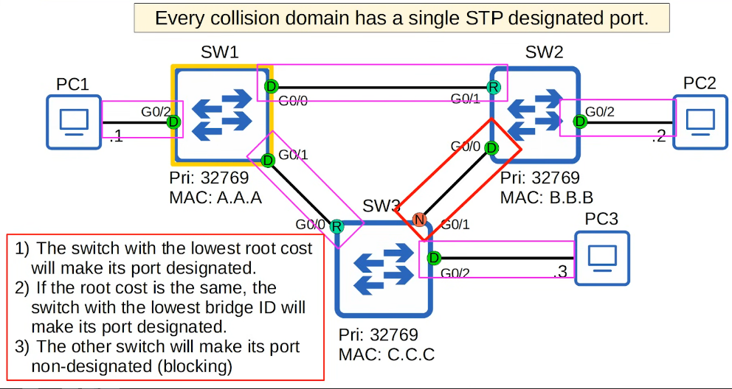

**Steps for STP**

1. **The switch with the lowest bridge ID is elected as the root bridge. All ports on the root bridge are designated ports (forwarding state).**

**Root bridge selection:**

1. **Lowest bridge ID**

1. **Each remaining switch will select 1 of its interface to be its root port. Interface with lowest root cost will be root port. Root ports are also in the forwarding state.**

**Root port selection:**

1. **Lowest root cost**
2. **Lowest neighbour bridge**
3. **Lowest neighbour port ID**

1. **Each remaining collision domain will select 1 interface to be a designated port (forwarding state). The other port in the collision domain will be non-designated (blocking)**

**Designated port selection:**

1. **Interface on switch with the lowest root cost**
2. **Interface on switch with lowest bridge ID**

When at step 3, ports connected to the root bridge will be non-designated

Commands

* "show spanning tree"
* "show spanning tree vlan 1"
* "show spanning tree detail"
* "show spanning tree summary"

## STP (Part 2)

* Things covered
  + STP state/timers
  + STP BPDU
  + STP optional features
  + STP configuration
* STP States  
    
   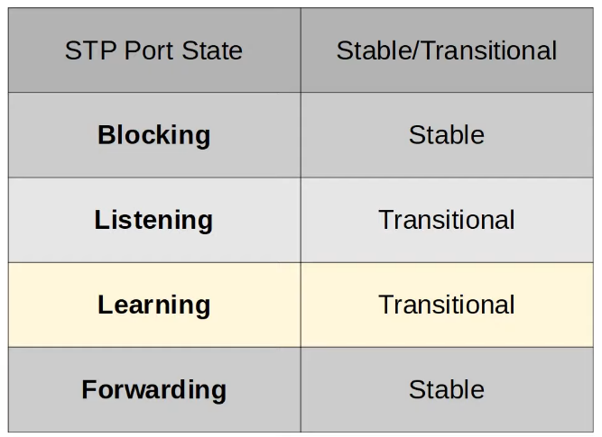  
    
  + Root/Designated ports remains stable in a **Forwarding state**
  + Non-designated ports remain stable in Blocking state
  + Listening and Learning are transitional states which are passed through when an interface is activated, or when a Blocking port must transition to a Forwarding state due to a change in the network topology
  + Blocking State
    - Non-designated ports are in a blocking state
    - Interfaces in a blocking state are effectively disabled to prevent loops
    - Interfaces do not send/receive regular network traffic
    - Interfaces receive BPDUs
    - Do not forward BPDUs
    - Do not learn MAC address
  + Listening
    - After the blocking state, interfaces with the Designated or Root role enter the Listening state
    - Only Designated or Root enter the Listening state (Non-designated ports are always Blocking)
    - The Listening state is 15s by default. Determined by Forward delay timer
    - An interface in the Listening state ONLY forwards/receives BPDUs
    - An interface in the Listening state does NOT send/receive regular traffic
    - Does NOT learn MAC address from regular traffic that arrives on the interface
  + Learning
    - After Listening state, a Designated or Root port will enter the Learning state
    - 15s by default, determined by Forward delay timer (same used in Listening state)
    - An interface ONLY send/receive BPDUs
    - Does NOT send/receive regular traffic
    - Learns MAC address  from regular traffic that arrives on the interface
  + Forwarding
    - Roots and Designated ports are in Forwarding state
    - Port in the Forwarding state operate as normal
    - Send/receives BPDUs
    - Send/receives normal traffic
    - Learns MAC addresses
  + 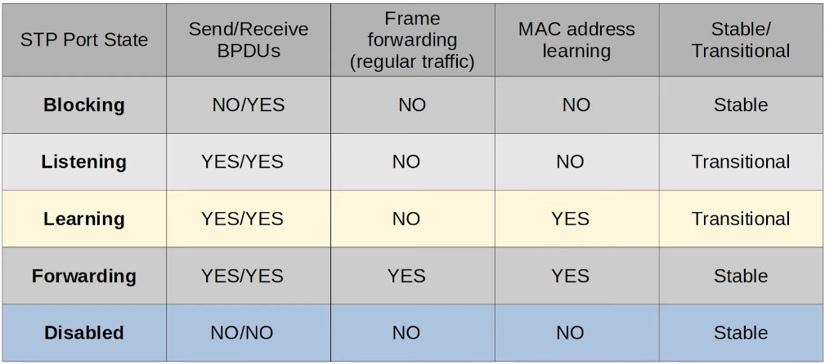
* Spanning Tree Timers  
    
   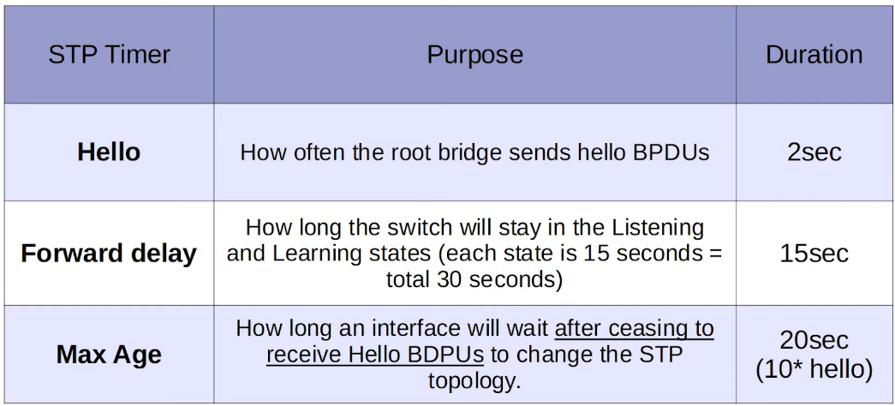  
    
      
    
  + Max Age
    - If BPDU is received before max age, timer reset to 20s
    - If not received, switch will reevaluate its STP choices, including root bridge, local root, and non-designated ports
    - If a non-designated port is selected to become a designated/root port, it will transition from the blocking state to the listening state (15s), learning state (15s), and then the forwarding state. Can take 50s for a blocking interface to transition to forwarding
    - These timers and transitional states are to make sure loops aren't created due to interface moving to forwarding state to soon
    - But a forwarding state can go straight to blocking state
  + The STP timers on the root bridge determines the timer for the whole network

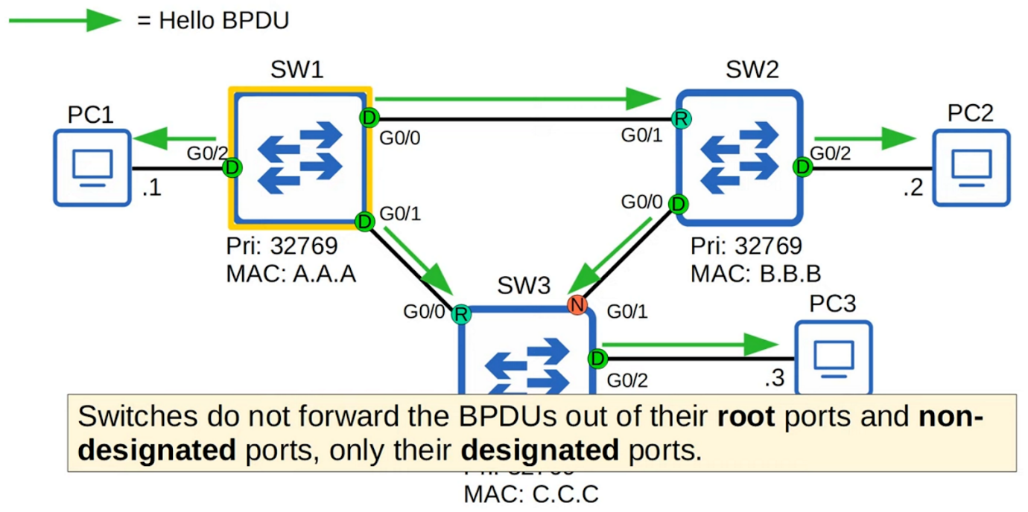

* Ethernet Destination MAC address
  + PVST - only ISL trunk encapsulation
    - 01:00:0c:cc:cc:cd
  + PVST+ - supports 802.1q
    - 0180:c2000:0000

STP Optional Features (STP Toolkit)

* Portfast
  + Allows port to move immediately to the Forwarding state, bypassing Listening and Learning (not waiting 30s)
  + Must be enabled only on ports connected to end hosts
  + Else, if connected to switch, can cause layer 2 loops
  + 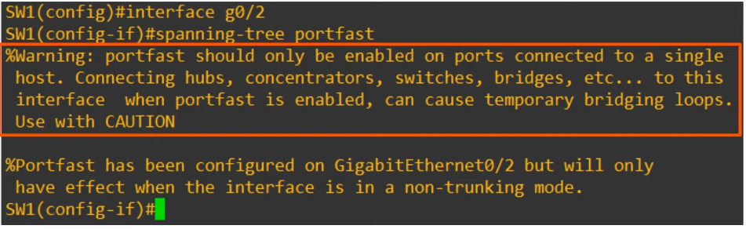
  + SW1(config)# **spanning-tree portfast default**
    - Enable portfast on all access ports, not trunk ports
* BPDU Guard
  + If an interface receives a BPDU from another switch, the interface will shutdown to prevent a loop from forming
    - Occurs when instead of connecting to end host, connect to switch
  + 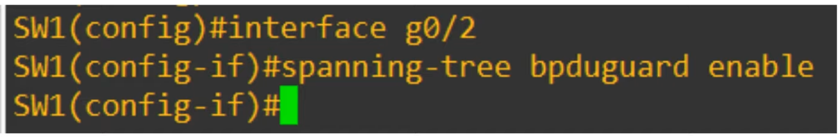
  + SW1(config)# **spanning-tree portfast bpduguard default**
    - Enables BPDU guard on all portfast enabled interface

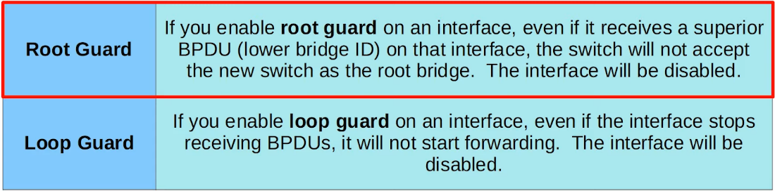

* Probably wont need to know for CCNA

Spanning Tree Configuration

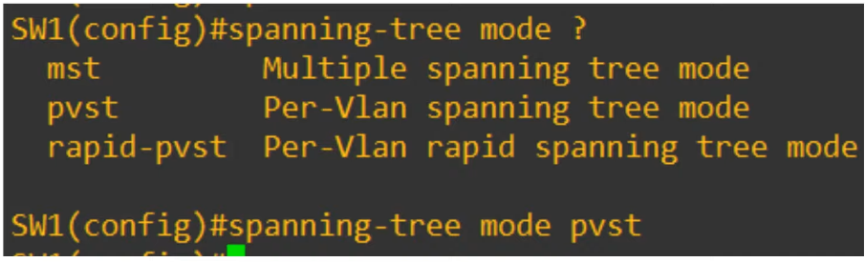

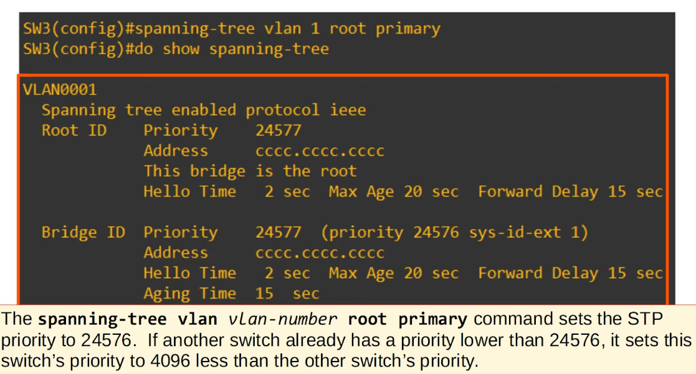

* STP priority is bridge priority

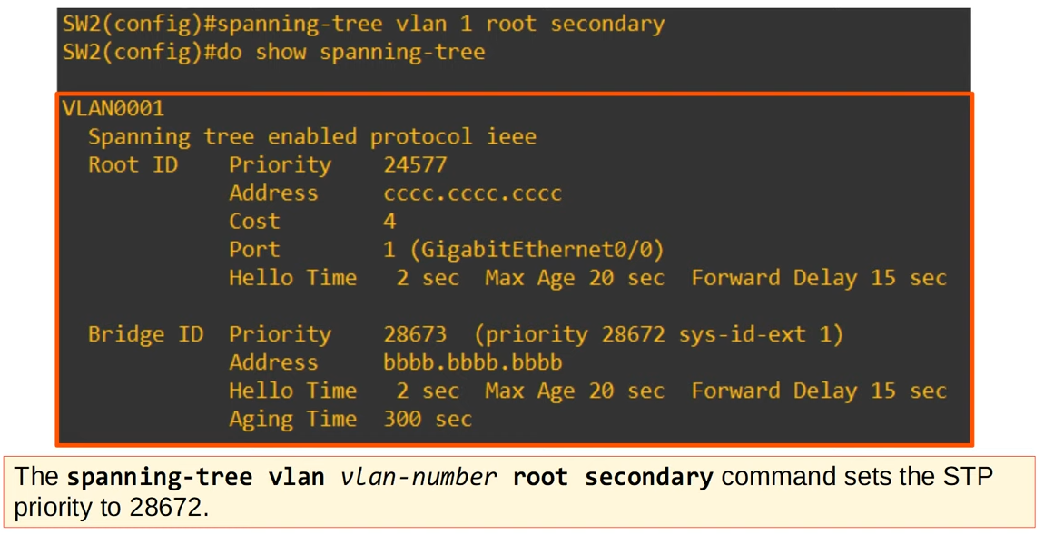

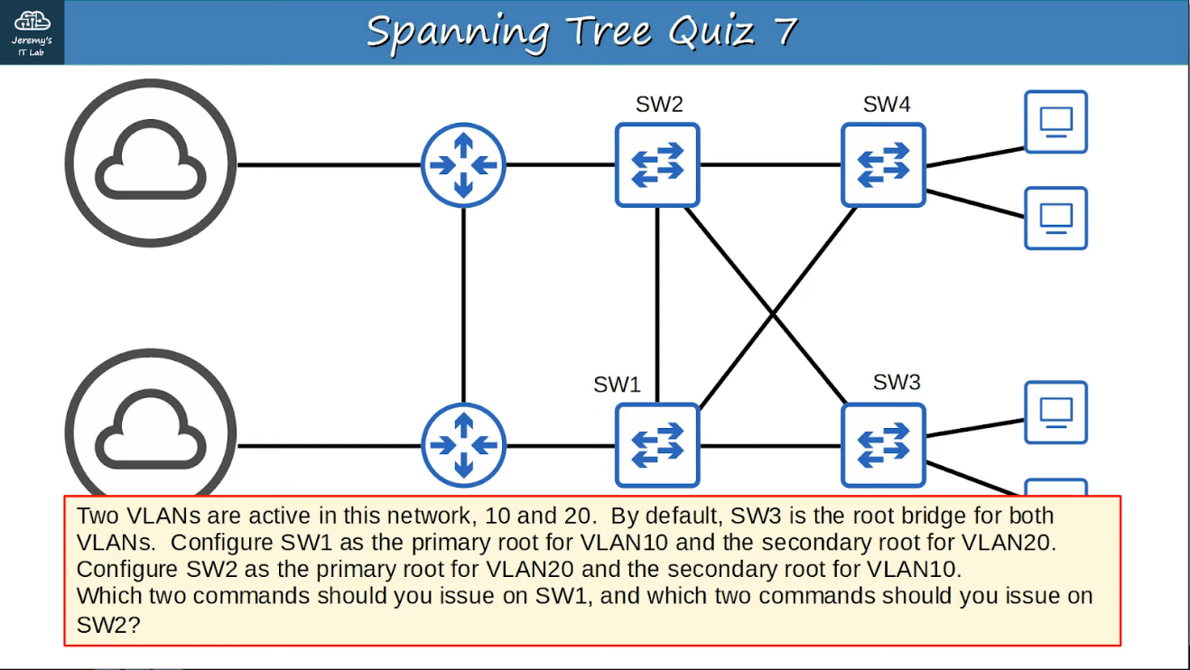

* SW1
  + "spanning-tree vlan 10 root primary"
  + "spanning-tree vlan 20 root secondary"
* SW2
  + "spanning-tree vlan 10 secondary"
  + "spanning-tree vlan 20 primary"

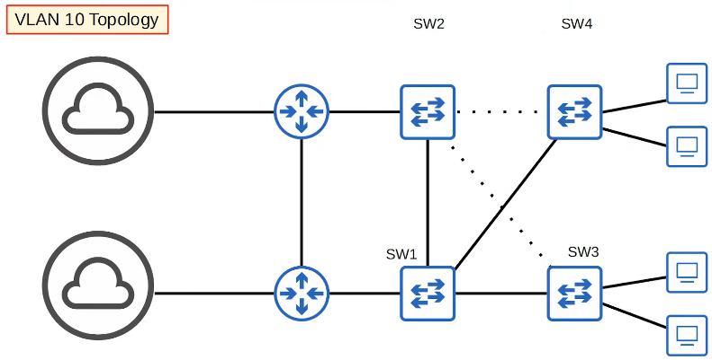

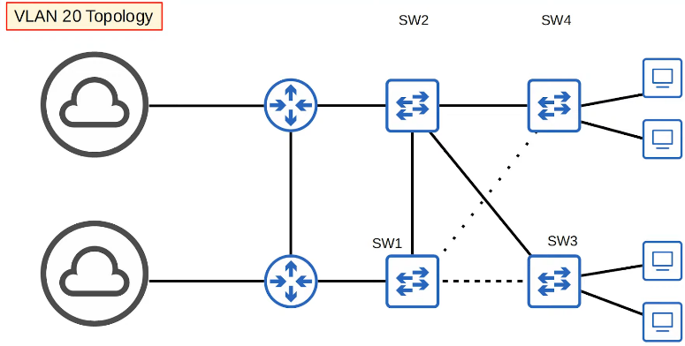

Port settings

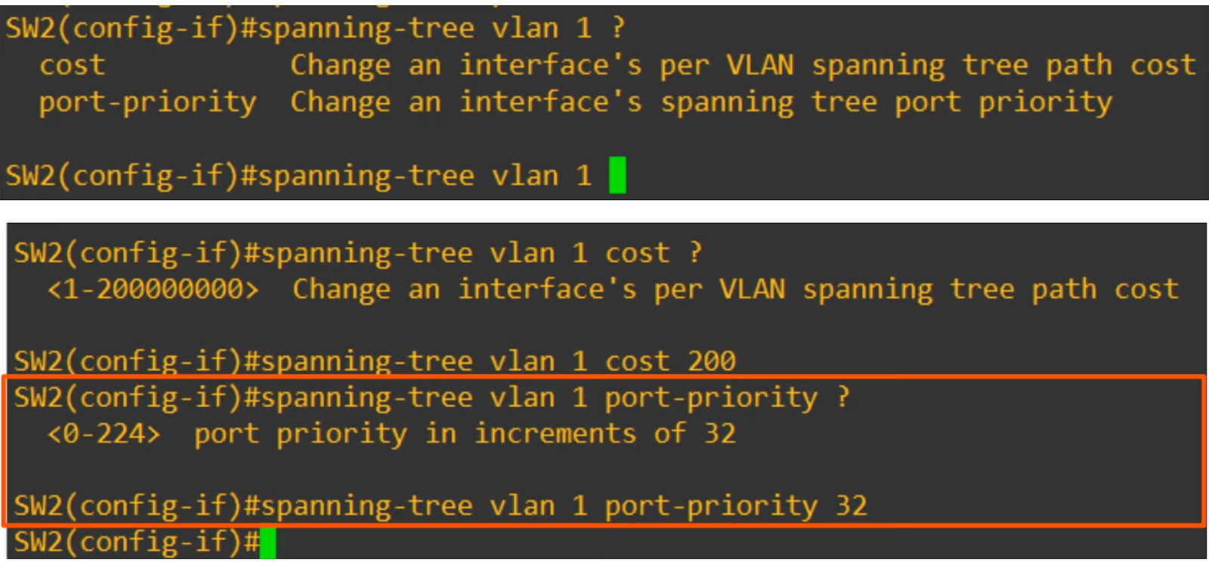

## STP Additional Features

PortFast

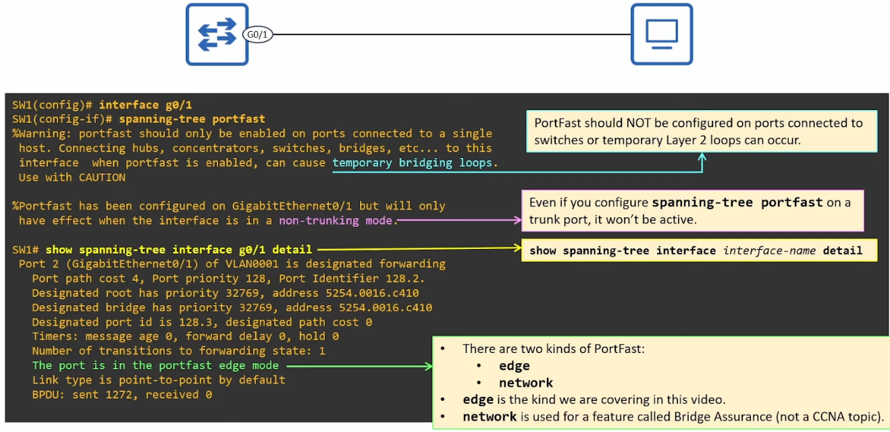



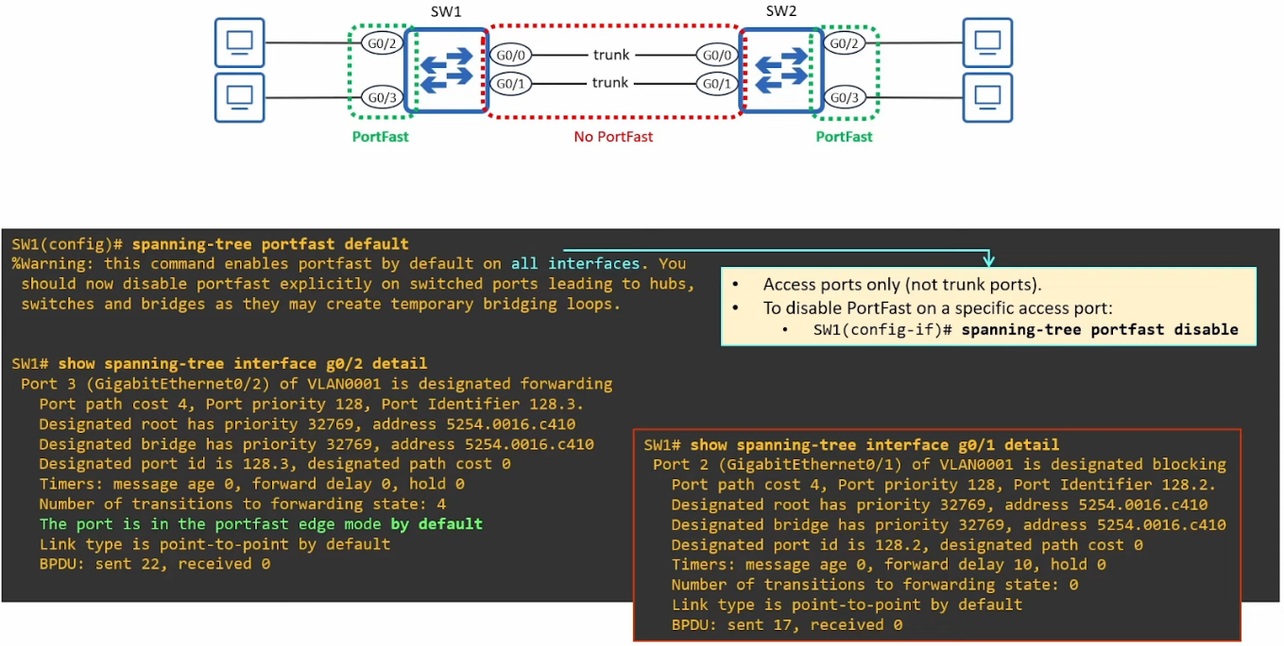

* In some cases, you might want to enable PortFast on a trunk
  + Port connected to a virtualization server with VMs in different VLANs
  + Port connected to router via router-on-a-stick (ROAS)
* Can only be configured per port
  + SW1(config-if)# spanning tree portfast trunk

PortFast Edge

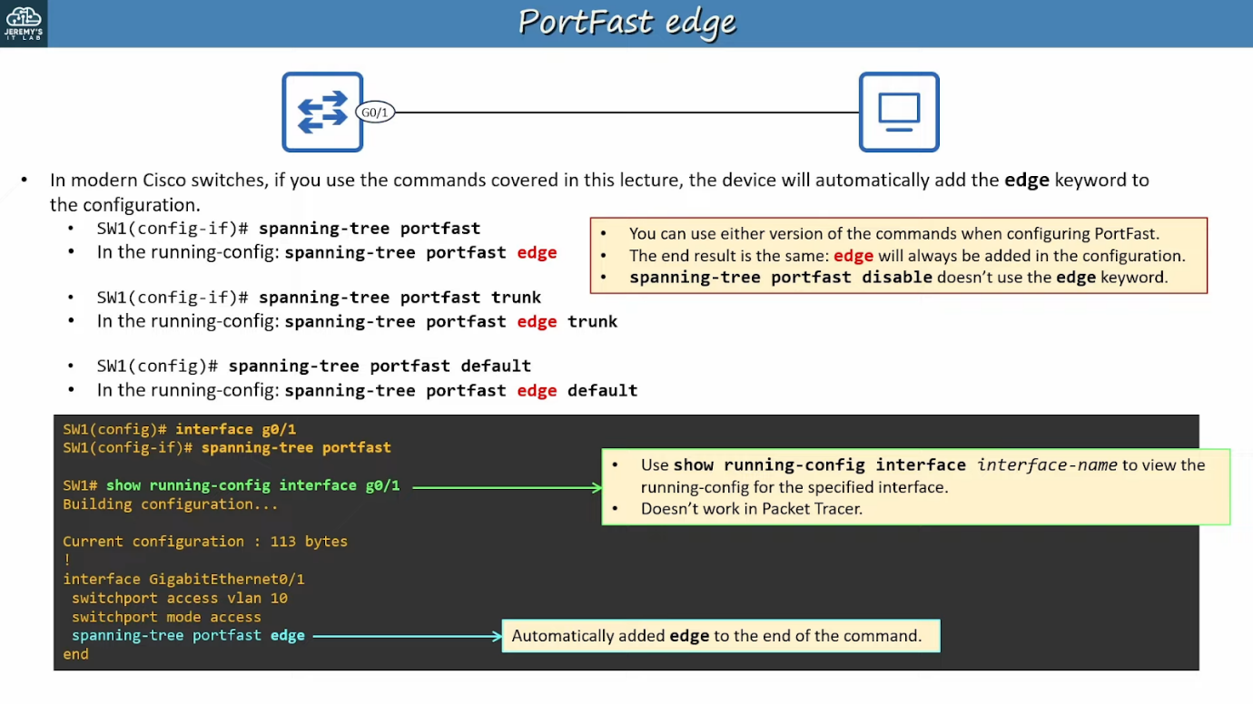

Summary

* When a host connects to a switch port, by default, it takes 30s before port can send/receive data
* PortFast allows a switch port to immediately enter the STP Forwarding state, bypassing the Listening and Learning states
* It can be configured 2 ways
  + SW1(config-if)# **spanning-tree portfast [edge]**
  + SW1(config)# **spanning-tree portfast [edge] default**
* Can use "spanning-tree portfast disable" to disabled specific ports
* Portfast should not be configured on ports connected to a switch, as it can cause temporary layer 2 loops
* Can enable on trunks using, **"spanning-tree portfast [edge] trunk"**

BPDU Guard

* If a portfast enabled port receives a BPDU (it should not receive since portfast enabled should only be connected to non-switch), it will revert to acting like a normal STP port (no portfast)
* If BPDU Guard enabled port receives a BPDU, it enters error-disabled state (disables the port)
* Config
  + SW1(config-if)# **spanning-tree bpduguard enable**
  + SW1(config)# **spanning-tree portfast [edge] bpduguard default**
    - Enabled only on all portfast enabled ports
  + SW1(config-if)# **spanning-tree bpduguard disable**
* Enabling the error-disabled port
  + Fix the underlying issue
  + Manual
    - Shutdown and no shutdown
  + Auto
    - ErrDisable Recovery
* ErrDisable Recovery
  + Feature that auto re-enable err-disabled ports after a certain period of time

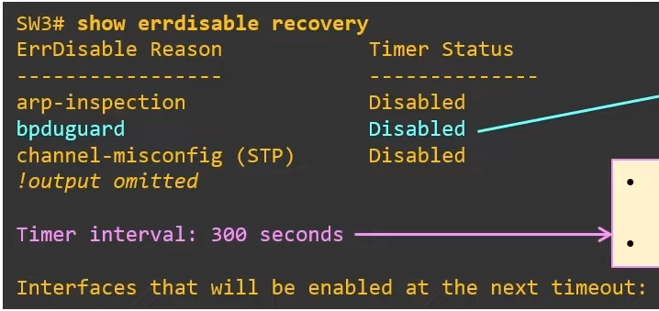

* Disabled by default
* SW3(config)# **errdisable recovery cause <cause>**
  + <cause>: bpduguard
  + Enable bpduguard
* SW3(config)# **errdisable recovery interval <interval>**
  + Set the timing interval in seconds
* Default time is 300s / 5mins

BPDU Filter

* Problem
  + Switch connected to not-switch (e.g. PC) sends BPDU
  + Waste processing power and bandwidth
  + Security concern
* BPDU Filter stops a port from sending BPDUs
  + However, doesn't disable the port if receives a BPDU
* Config
  + SW3(config-if)# **spanning-tree bpdu filter**
    - Port will not send and ignore BPDUs received
    - Disables STP on the port, USE WITH CAUTION
  + SW3(config)# **spanning-tree portfast [edge] bpdufilter default**
    - BPDU filter enabled on ports with portfast
    - "**spanning-tree bpdufilter disable**" to disable on specific ports
    - Will not send BPDUs
    - If receives BPDUs, PortFast and BPDU Filter disabled, acts as normal STP port
* BPDU Guard and Filter can be applied at the same time
  + When BPDU is received
  + If filter applied on global config mode
    - BPDU guard will be triggered (err-disable port)
  + If filter applied on interface mode
    - BPDU ignored
    - BPDU guard will not be triggered
* Recommendation:
  + BPDU guards can use any method
  + BPDU Filter, use global mode

Root Guard

* Root bridge placement

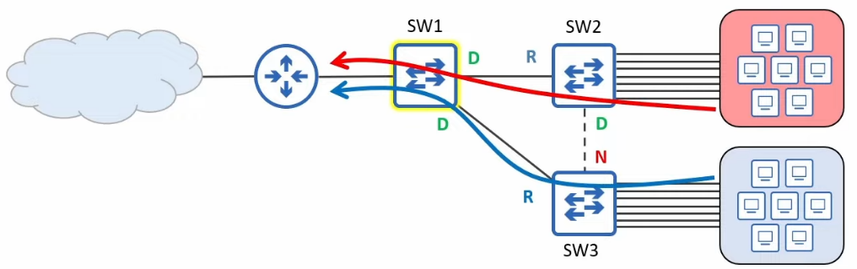

* When electing root bridge, should consider
  + Optimal traffic flow
  + Stability & reliability (use the best switch for root bridge)

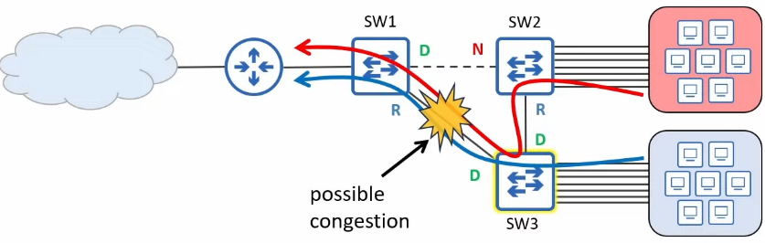

* Problem

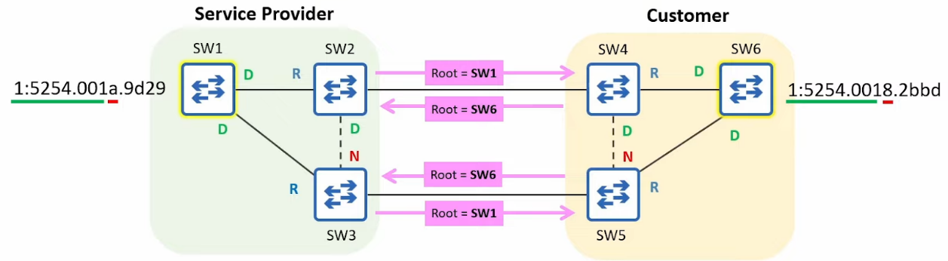

* Customer root switch becomes the root switch because even though same priority, MAC address lower
* Root Guard prevents this
* Root Guard config
  + Only in interface mode
  + Interface the ports connected to the other network
  + SW2(config-if)# **spanning-tree guard root**
  + If root-guard enabled port receives BPDUs, will enter Broken(Root Inconsistent) state, effectively disabling it

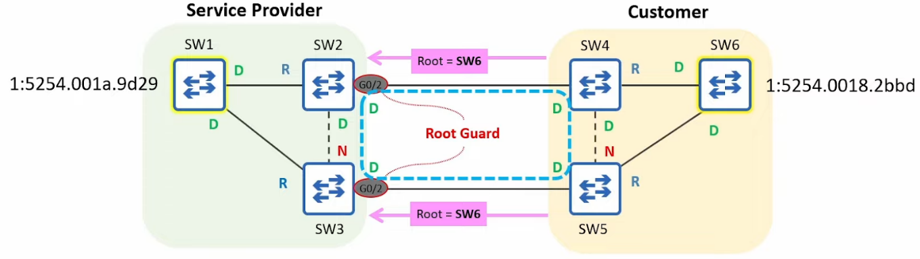

* To re-enable
  + Disabled port must stop receiving superior BPDUs
  + Tell customer to change the priority of their switch
* Once the superior BPDUs received by SW2 G0/2 and SW3 G0/3 age out, the ports will auto re-enable
  + BPDU max age is 20s by default

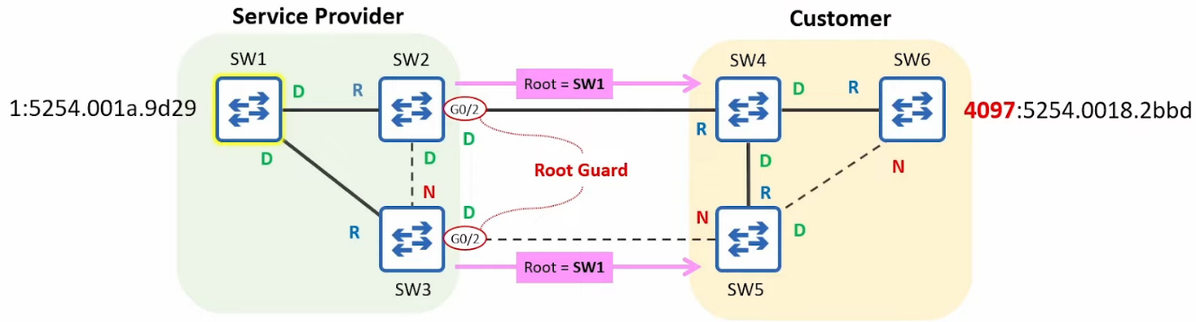

* Note
  + Customer should NOT enable root guard

Loop Guard

* Uni directional link
  + Normally caused by layer 1 issue
    - Damaged cable
    - Faulty connectors/transceivers (e.g. SFP)
  + Common in fibre optics compared to UTP
    - Fibre optic use 2 separate fibres
    - If 1 damaged,  can cause unidirectional link
* Problem

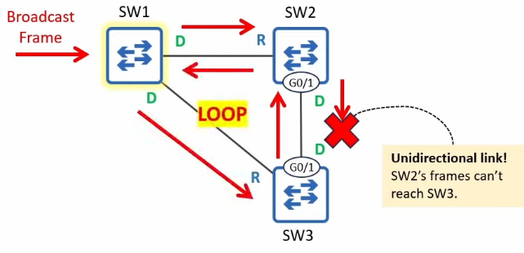

* SW3 G0/1 never receive BPDU
  + Will become Designated port
  + Start forwarding BPDUs
* Loop formed
* Solution
  + When Loop-Guard enabled port's max age timer reaches 0, it doesn't become a Designated port and start transitioning to Forwarding
    - Enters Broken (Loop Inconsistent) state
    - Port remain up/up, but STP blocks it
  + To re-enable
    - When the broken port start receiving BPDUs, auto re-enable

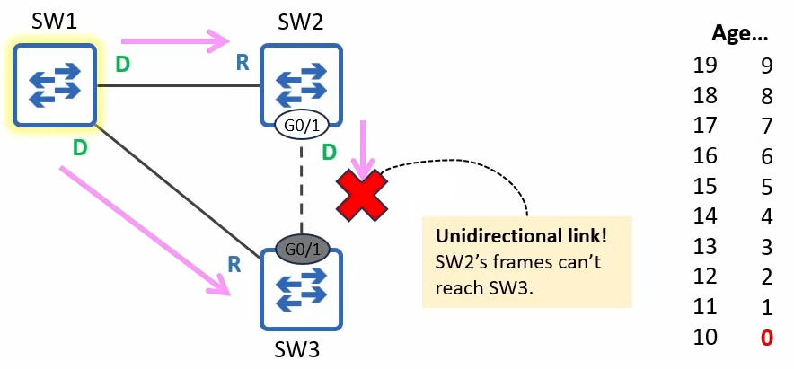

* Config
  + SW3(config-if)# **spanning-tree guard loop**
  + SW3(config)# **spanning-tree loopguard default**
    - Enable on all ports
    - SW3(config-if)# spanning-tree loopguard none (disable for specific interface)
* Note
  + Loop guard should be enabled on root and non-designated ports (ports that are supposed to receive BPDUs)
  + Loop guard and root guard are mutually exclusive
    - Cannot enable both on the same port at the same time
    - Global vs Interface cmd -> Interface cmd takes effect

## Rapid Spanning Tree

Things covered

* Comparison of STP versions
* Rapid PVST+

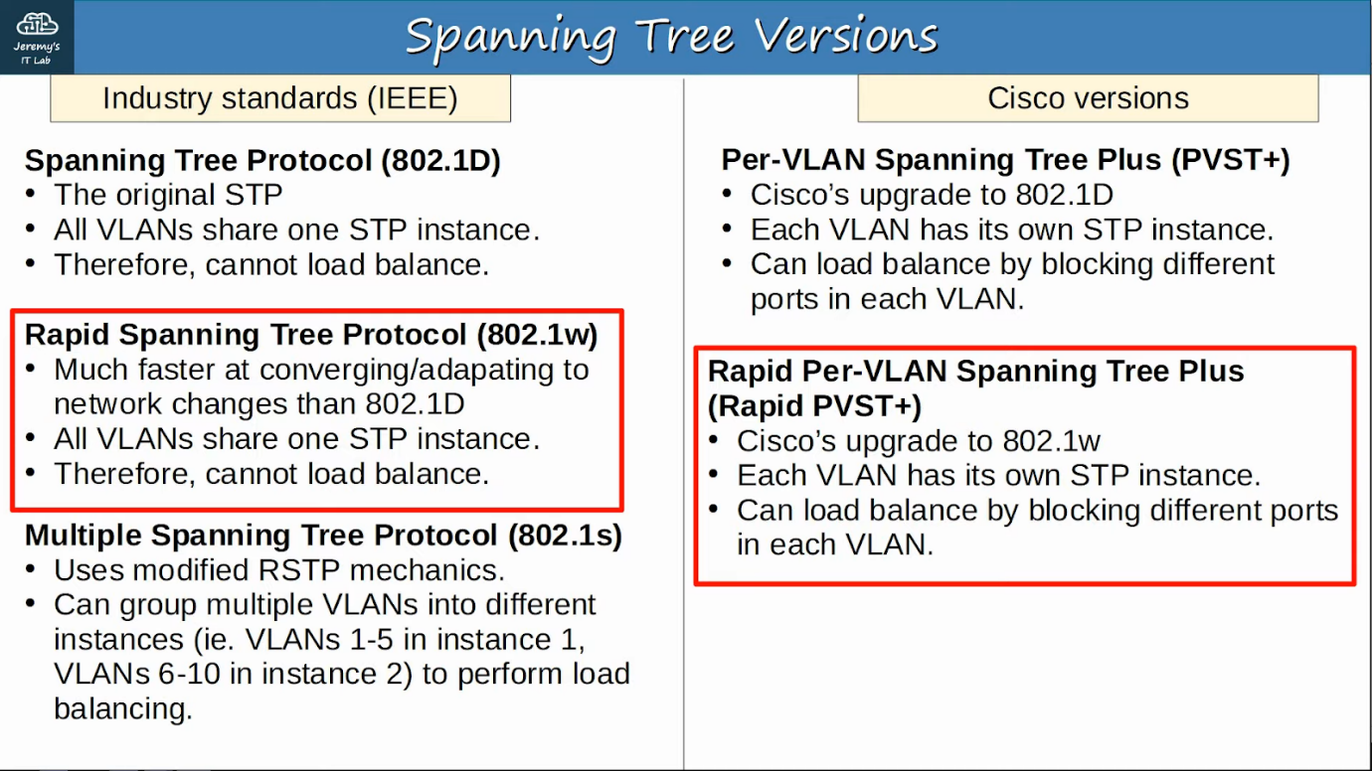

Rapid Spanning Tree Protocol

* Similarities btw STP and RSTP
  + RSTP serves the same purpose as STP, blocking specific ports to prevent layer 2 loops
  + RSTP elects a root bridge with the same rules as STP
  + RSTP elects a root port with the same rules as STP
  + RSTP elects a designated port with the same rules as STP
* RSTP cost

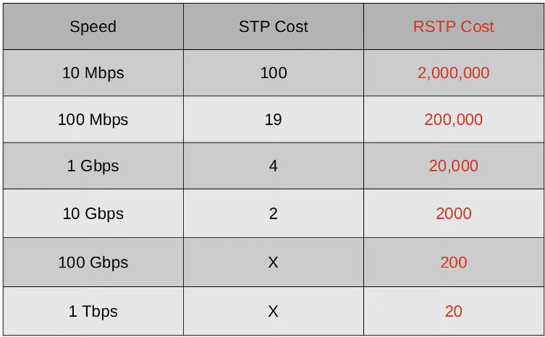

* RSTP States

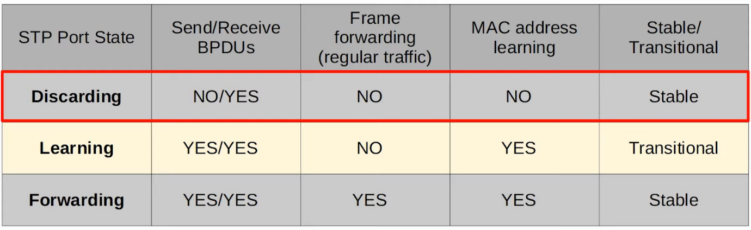

* If a port is administratively down (shutdown command) = discarding state
  + Previously disabled state
* If a port is enabled but blocking traffic to prevent layer 2 loops = discarding state
  + Previously blocking state

* RSTP Port Roles
  + Root port role remains unchanged
  + Designated port role remains unchanged
  + Non-designated port role is split into 2:
    - Alternate port
    - Backup port
  + Alternate port
    - It is a discarding port that receives a superior BPDU from another switch
    - Same as blocking ports in STP
    - Functions as backup to root port
    - If root port fails, the switch can immediately move its best alternate port forward
    - Functions like optional STP feature - UplinkFast, but built into RSTP already
      * RSTP: Backbone functionality (Not in CCNA)
        + Optional STP feature built into RSTP
        + Allows the switch to expire the max age timer on its interface and rapidly forward the superior BPDUs
        + Built in so don't need configure

* Backup port
  + It is a discarding port that receives a superior BDPU from another interface on the same switch
  + This collision only occurs when 2 interfaces are connected to the same collision domain (via a hub)
  + Hubs are not used nowadays so will not encounter a backup port

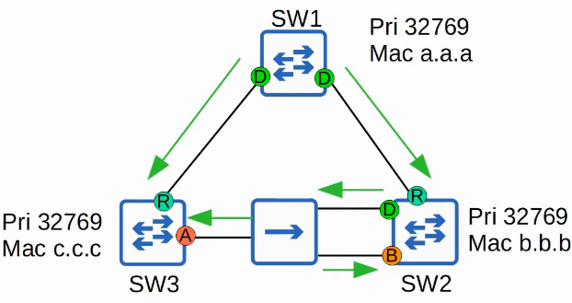

Practice Q

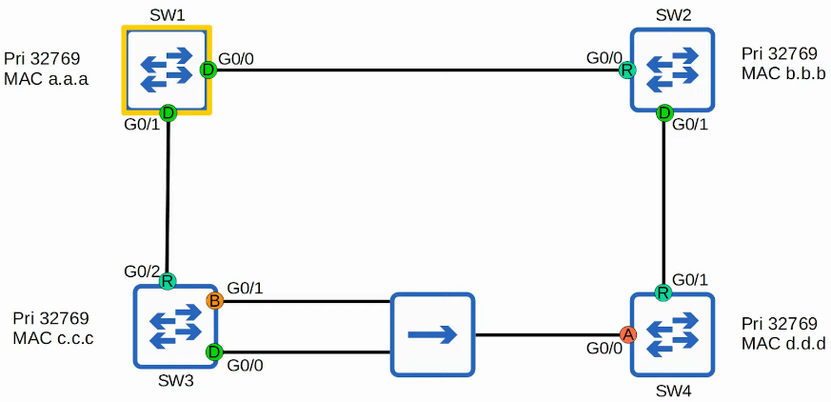

Inter-operability

* Rapid STP is compatible with Classic STP
* Interfaces on RSTP-enabled switch connected to STP-enabled switch will operate in STP mode (timers, blocking-> listening->learning->forwarding process etc)

RSTP BPDU

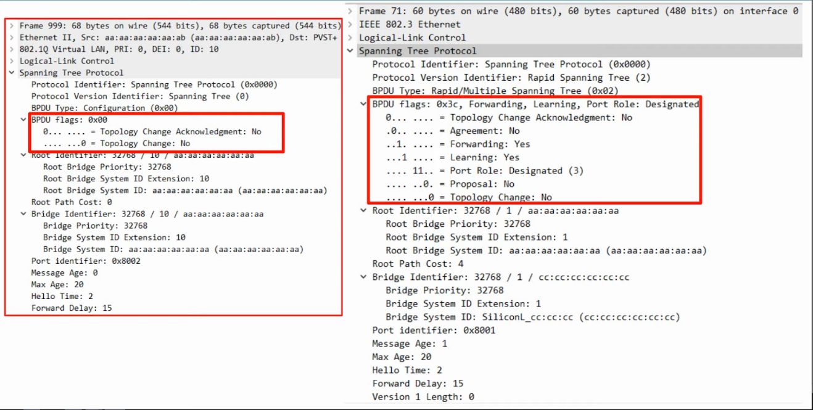

* Differences
  + Protocol Version
    - STP - 0
    - RSTP - 2
  + BPDU Type
    - STP - 0
    - RSTP - 2
  + BPDU Flags
    - STP uses 2 bits
    - RSTP uses all 8 bits
  + In STP, only the root bridge originate the BPDUs, and other switches just forward the BPDUs received
  + In RSTP, ALL switches originate and send their own BPDUs from designated ports

Differences

* All switch running RSTP send  their own BPDUs every hello time (2s)
* Switches 'age' the BPDU information much more quickly
  + In STP, a switch waits 10 hello intervals (20s)
  + In RSTP, a switch considers a neighbour lost if it misses 3 BPDUs (6s)
  + It will then 'flush' all MAC addresses learned on the interface as unable to reach them from that interface

RSTP Link Types

* RSTP distinguishes btw 3 different 'link types'
  + Edge
    - Port that is connected to end host
    - Moves directly to forwarding, without negotiation
    - Need to enable "SW1(config-if)# **spanning-tree portfast**"
  + Point-to-point
    - Direct connection btw 2 switches
    - Full-duplex
    - Don't need to configure, will auto detect
    - SW1(config-if)# **spanning-tree link-type point-to-point**
  + Shared
    - Shared ports connected to another switch(es) via a hub
    - Must operate in half-duplex
    - Don't need configure, will auto detect
    - SW1(config-if)# **spanning-tree link-type shared**

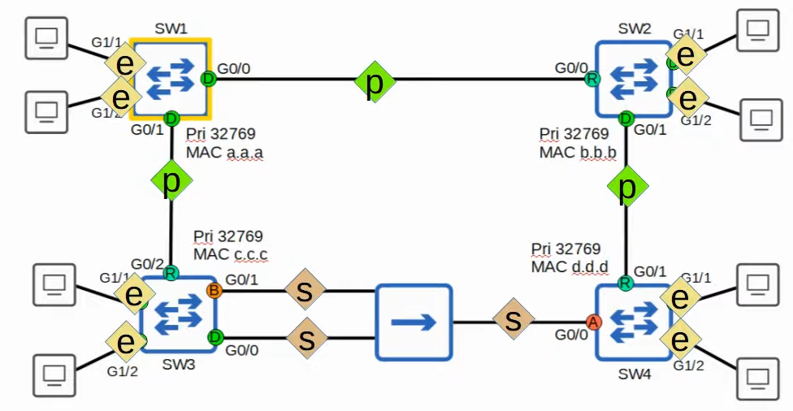

Summary

* Comparison of STP versions (standard vs Cisco)
* Rapid PVST+
  + RSTP port states (discarding, learning, forwarding)
  + RSTP port roles (root, designated, alternate, backup)
  + STP optional features built into RSTP (UplinkFast, BackboneFast, PortFast)
  + RSTP BPDU (sent by all switches, not just the root bridge)
  + RSTP link types (edge, point-to-point, shared)

# EtherChannel

Things Covered

* What is EtherChannel? What problems does it solve?
* Configuring Layer 2/3 EtherChannels

EtherChannel

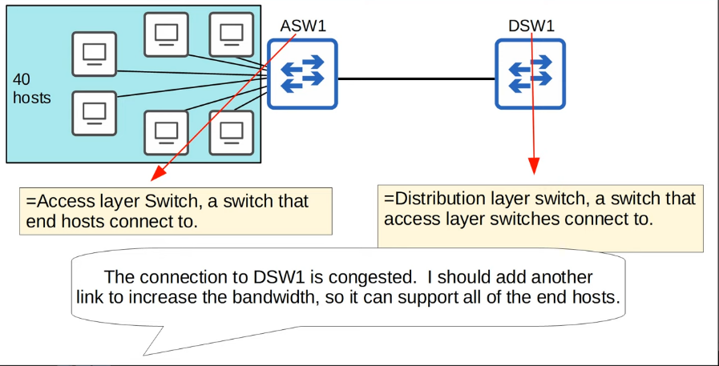

* Oversubcription
  + When bandwidth of interfaces connected to end hosts > bandwidth of connection of distribution switches
  + Some oversubcription is acceptable, but too much will cause congestion

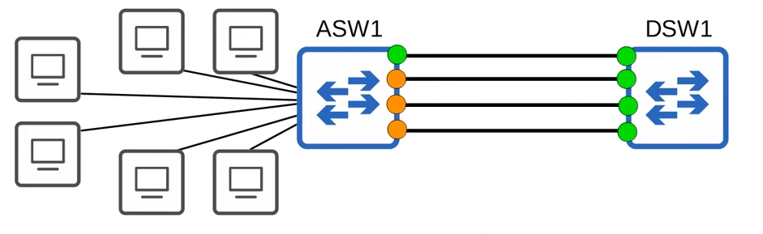

* If you connect 2 switches together with multiple links, all except one will be disabled by spanning tree
* If all of ASW1's interfaces were forwarding, layer 2 loops will form
* Other links will not be used unless active link fails. In that case, one of the inactive links will start forwarding

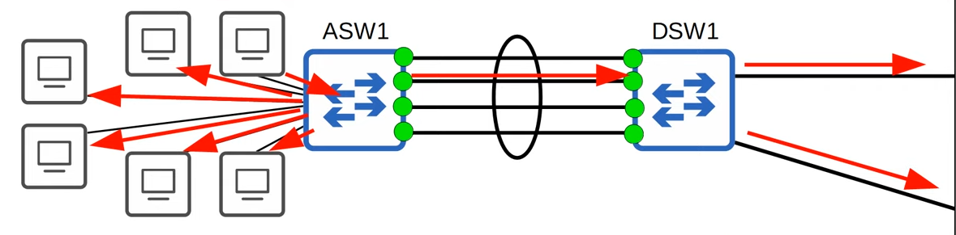

* EtherChannel groups multiple interfaces together to act as a single interface
* Represented by circle
* STP will treat this group as a single interface
* When a PC sends a broadcast message, ASW1 will broadcast to all other PCs and only 1 interface connected to DSW1
* Traffic using the EtherChannel will be load balanced among the physical interfaces in the group
* Common names
  + Port Channel
  + LAG (Link Aggregation Group)

Load Balancing

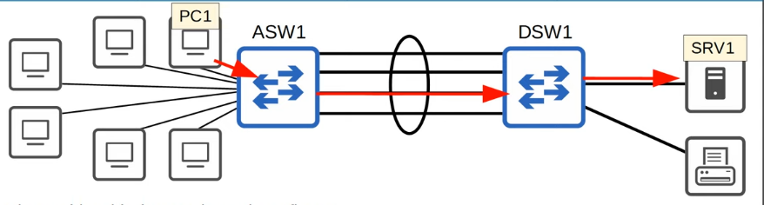

* EtherChannel load balances based on 'flows'
* A flow is a communication btw 2 nodes in the network
* Frames in the same flow will be forwarded using the same physical interface
* If frames in the same flow were forwarded using different physical interfaces, some frames may arrive at the destination out of order, which can cause problems
* E.g. PC1 -> SRV1, will always use the same interface
* You can change the inputs used in the interface selection calculation
* Inputs that can be used (e.g. src MAC, the same source MAC will use the same route)
  + Src MAC
  + Dst MAC
  + Src & Dst MAC
  + Src IP
  + Dst IP
  + Src & Dst IP
* The types of inputs that is  supported by the switch depends on the type of switch
* Configuration of load-balance

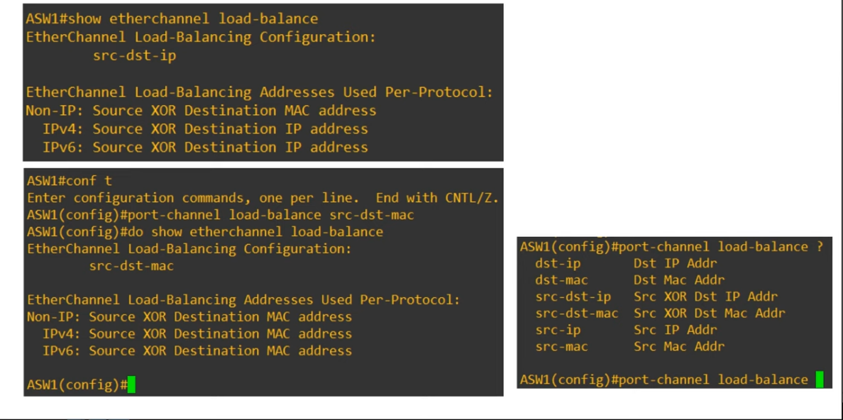

* ASW1# **show etherchannel load-balance**
* ASW1(config)# **port-channel load-balance <method>**
  + **<method>**
    - **dst-ip**
    - **dst-mac**
    - **src-dst-ip**
    - **src-dst-mac**
    - **src-ip**
    - **src-mac**

EtherChannel Config

* There are 3 methods of EtherChannel configuration on Cisco switches
  + PAgP (Port Aggregation Protocol)
    - Cisco proprietary protocol
    - Dynamically negotiates the creation/maintenance of the EtherChannel (like DTP for trunks)
  + LACP (Link Aggregation Control Protocol)
    - Industry standard protocol (IEEE 802.3ad)
    - Dynamically negotiates the creation/maintenance of the EtherChannel
  + Static Channel
    - A protocol isn't used to determine if an EtherChannel should be formed
    - Interfaces are statically configured to form an EtherChannel
    - Should be avoided
* Up to 8 interfaces can be formed into a single EtherChannel (LACP allow 16 but 8 active, 8 standby)

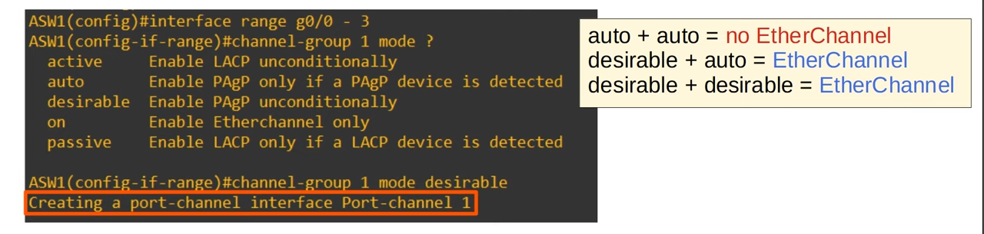

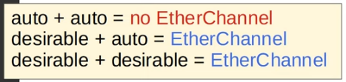

* The channel-group number has to match for member interfaces on the same switch
* However, it doesn't have to match the channel group number on the other switch
* PAgP: "auto", "desirable"
* LACP: "active", "passive"
* Static: "on"
  + "On" mode only works with itself, will not form etherchannel with "desirable" or "active"

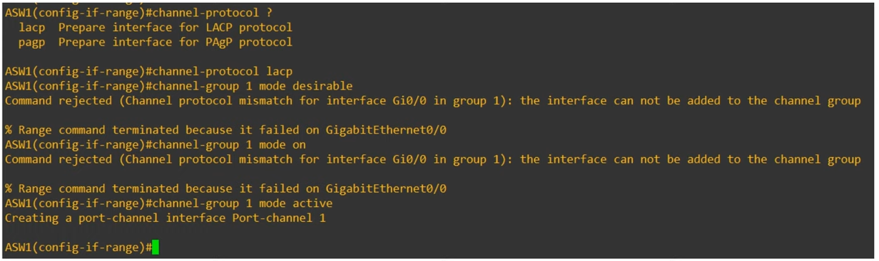

* Not that useful, but good to know for exam

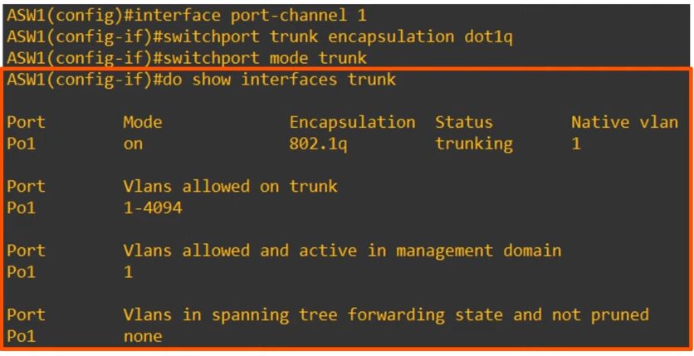

* Members must have the same matching configs
  + Same duplex
  + Same speed
  + Same switchport mode (access/trunk)
  + Same allowed VLANs/native VLAN (for trunk ports)
* If an interface don't match, it will be excluded from the EtherChannel

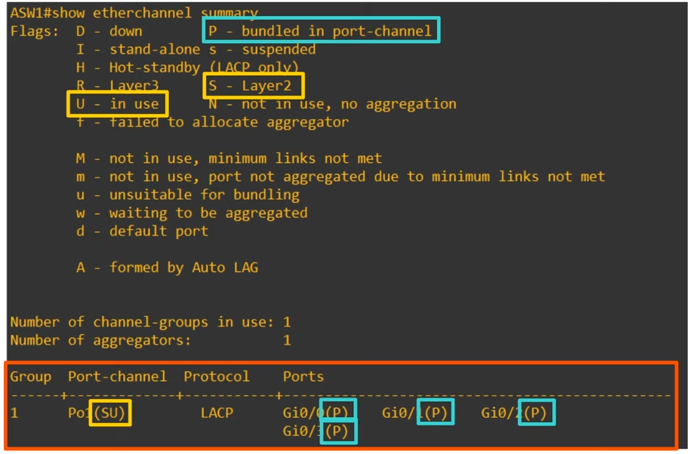

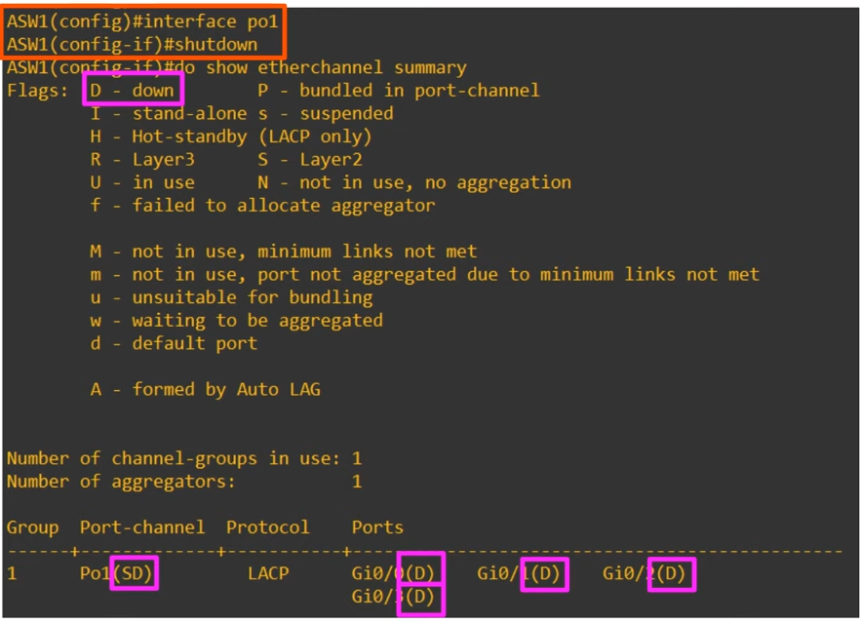

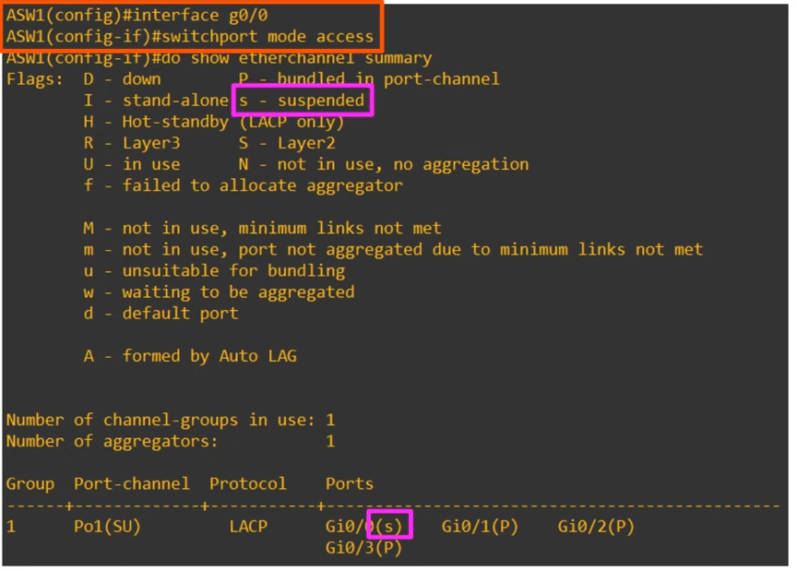

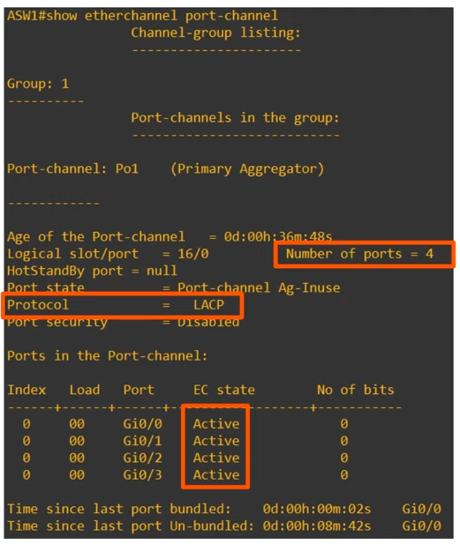

Spanning Tree

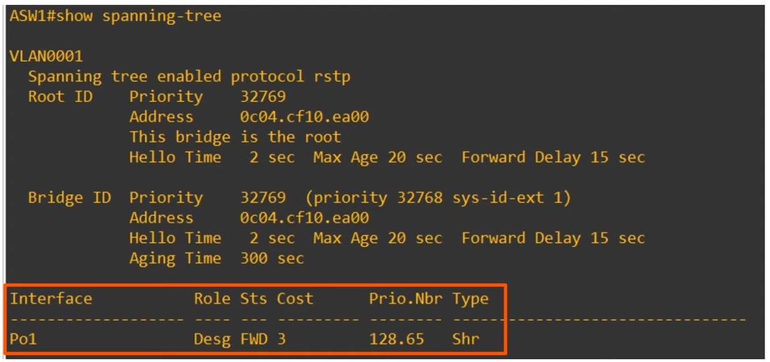

* Spanning tree treats the EtherChannel as a single interface

Layer 3 EtherChannel

* Better since at layer 3, spanning tree is not an issue as broadcast storm won't happen
* Layer 2 loops will not occur
* Spanning tree won't be running

Config

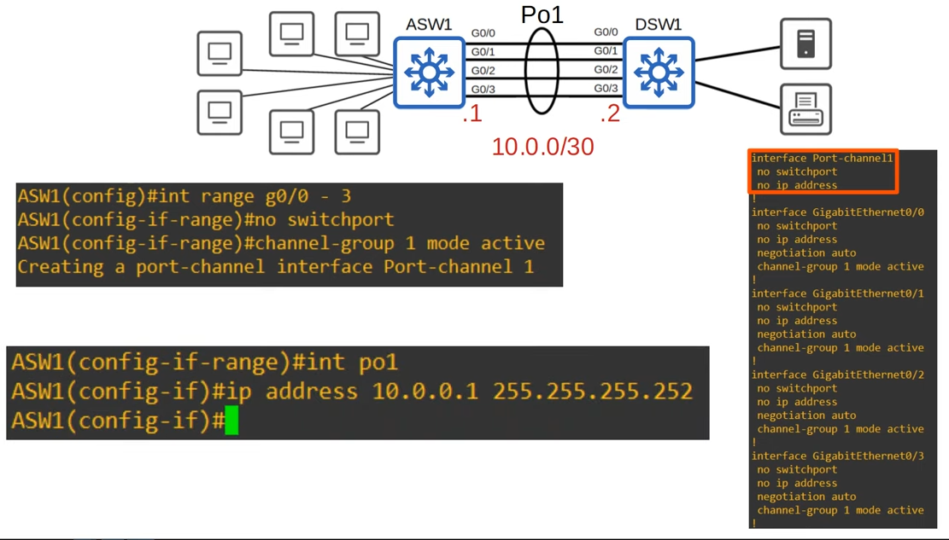

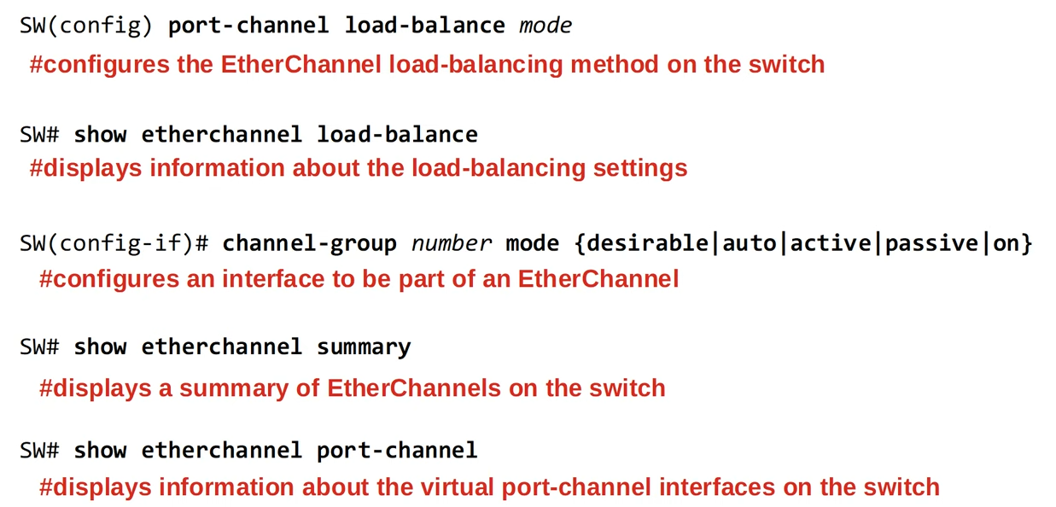

# Dynamic Routing

## Intro to Dynamic Routing

Things covered

* Intro to dynamic routing protocols
* Types of dynamic routing protocols
* Dynamic routing protocol metrics
* Administrative distance

Dynamic Routing

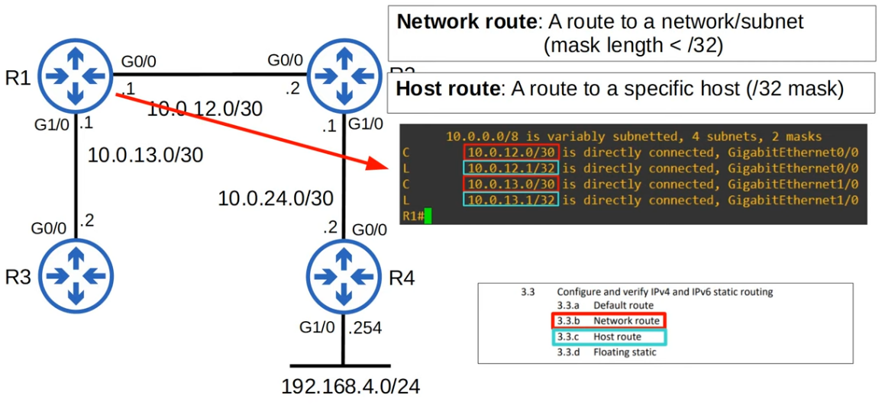

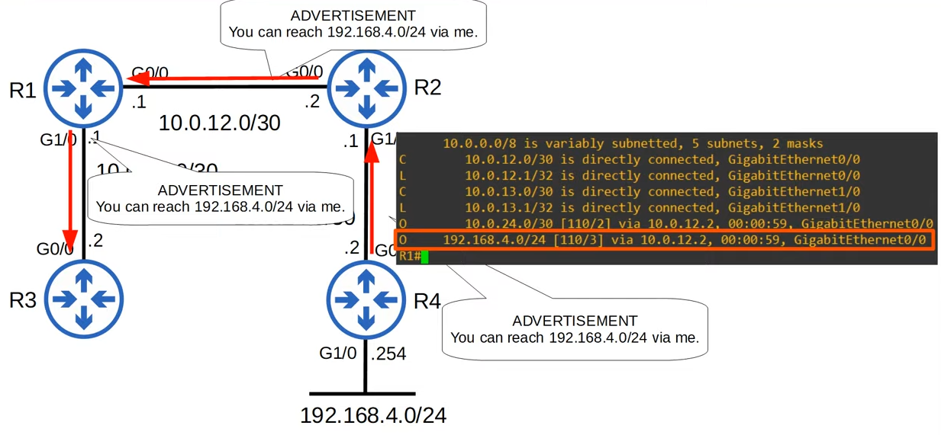

* If one of the link fails, will automatically remove that route if no alternative route
  + If static route, the route will still remain

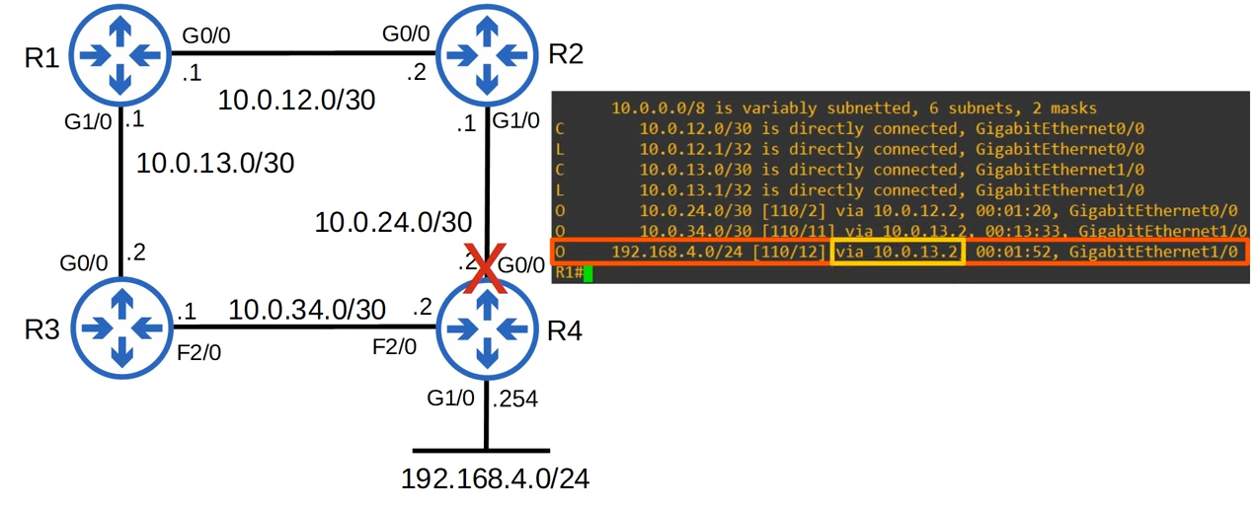

* The dynamic routing protocol will select the path with the lowest cost, that’s why R1->R2->R4 selected first
  + The route only changed when R4 interface was down

* Key points
  + Routers can use dynamic routing protocols to advertise info about the routes they know to other routers
  + They form 'adjacencies' / ' neighbour relationships' / 'neighbourships' with adjacent routers to exchange info
  + If multiple routes to a destination are learned, the router determines which route is superior and adds it to the routing table
    - Uses 'metric' of the route to determine which is superior (lower metric = superior)

Types of Dynamic Routing Protocols

* Can be divided into 2 categories
  + IGP (Interior Gateway Protocol)
  + EGP (Exterior Gateway Protocol)
* IGP
  + Used to share routes within a single autonomous system (AS), which is a single organization
* EGP
  + Used to share routes between different AS

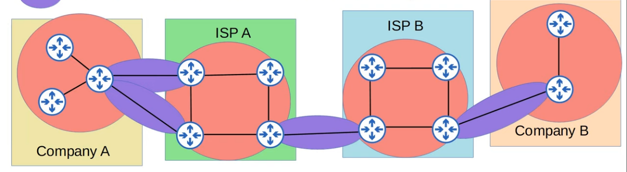

* IGP
  + Distance Vector
    - RIP (Routing Interface Protocol)
    - EIGRP (Enhanced Gateway Routing Protocol)
  + Link State
    - OSPF (Open Shortest Path First)
    - Intermediate System to Intermediate System (IS-IS)
* EGP
  + Path Vector
    - BGP (Border Gateway Protocol)
* For EGP, BGP is the only one that is used by the whole world today
* Distance vector, link state, path vector - algorithm type

Distance Vector Routing Protocols

* Distance vector protocols were invented before link state protocols
* Early examples are RIPv1 and Cisco's proprietary protocol IGRP (which was updated to EIGRP)
* Distance vector protocols operate by sending the following to their directly connected neighbours
  + Their known destination networks
  + Their metric to reach their known destination networks
* This method of sharing information is often called 'routing by rumor'
* This is because the router doesn't know about the network beyond is neighbours. It only knows the info that its neighbours tell it
* Called 'distance vector' because the routers only learn the 'distance' (metric) and 'vector' (direction, next-hop router) of each route

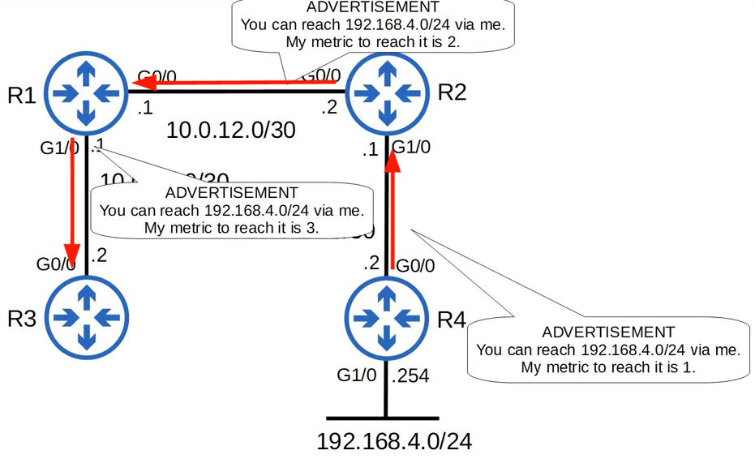

Link State Routing Protocols

* When using a link state routing protocol, every router creates a 'connectivity map' of the network
* To allow this, each router advertises info about its interfaces (connected networks) to its neighbours. These advertisements are passed along to other routers, until all routers in the network develop the same map of the network
* Each router independently uses this map to calculate the best route to each destination
* Link state protocols use more CPU resource on the router, because more info is shared
* However, link state protocols tend to be faster in reacting to changes in the network than distance vector protocols

Metrics

* A router table contains the best route to each destination network it knows about
* If there are multiple routes to a destination, uses metric to determine the best route
* Lower metric = better
* Each routing protocol uses a different metric to determine which route is the best
* If a router learns 2 or more routes via the same routing protocol to the same destination (same network address, same subnet mask) with the same metric, both will be added to the routing table. Traffic will be load-balanced over both routes
  + ECMP (Equal Cost Multi-Path)

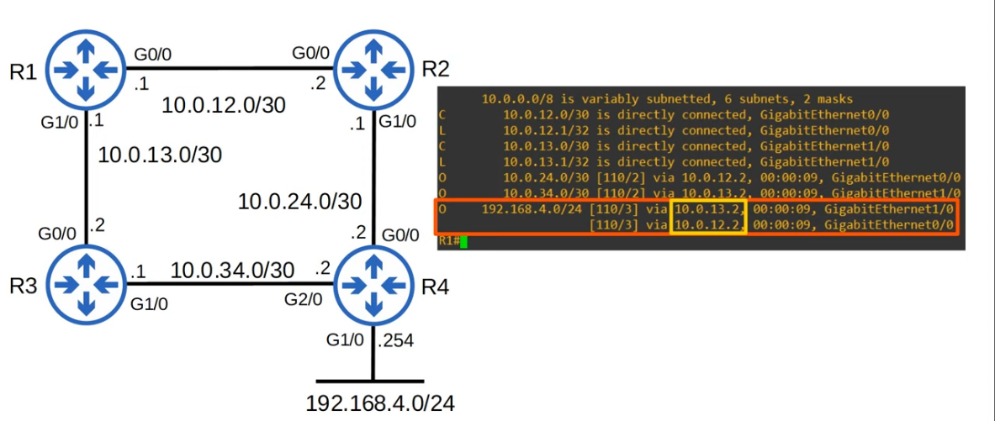

* "[110/3]"
  + 3 - metric
  + 110 - administrative distance
* ECMP for static routes

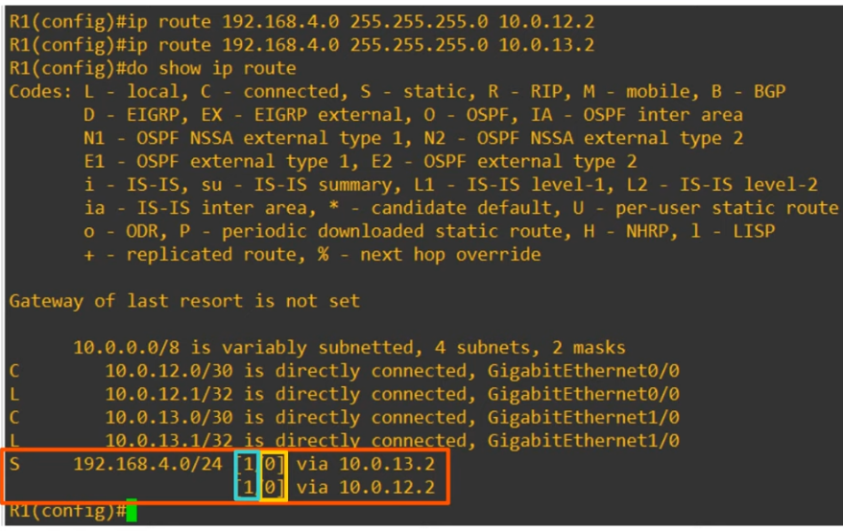

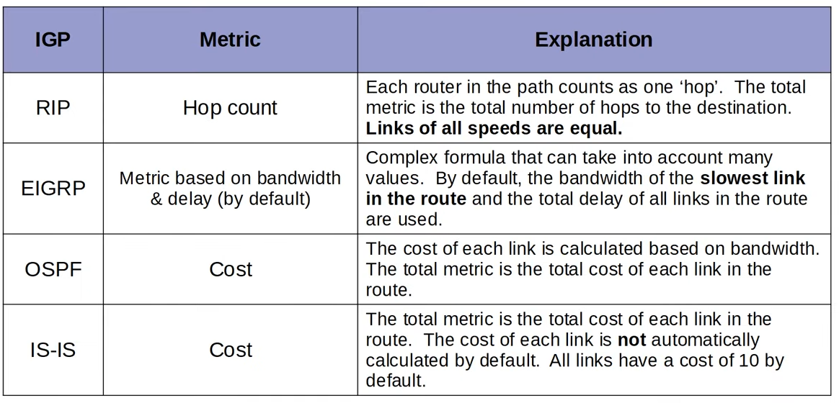

* Administrative Distance
  + In most cases a company will use a single IGP - usually OSPF or EIGRP
  + However, in some cases, they might use 2.
    - E.g. 2 companies connect their networks to share info
  + Metric is used to compare routes learned via the same routing protocol
  + Different routing protocol use totally different metrics, so they cannot be compared
    - E.g. For the route to a particular network, OSPF metric is 30 while EIGRP is 33280
    - Which route is better?
  + The administrative distance (AD) is used to determine which routing protocol is preferred
  + A lower AD is preferred, and indicates that the routing protocol is considered more 'trustworthy' (more likely to select good routes)

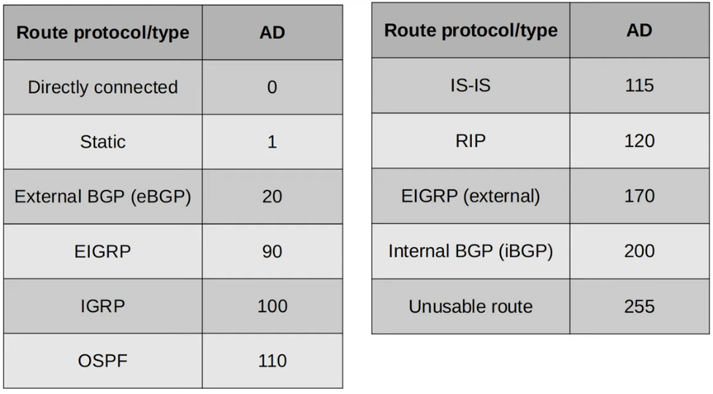

* If the administrative distance is 255, the router does not believe the source of that route and does not install the route in the routing table
* You can change the AD of a routing protocol
  + R1(config-router)# **distance <AD>**
* You can change the AD of a static route
  + R1(config)# **ip route <ip addr> <netmask> <AD>**

Floating Static Routes

* By changing the AD of a static route, can make it less preferred than routes learned by a dynamic routing protocol to the same destination (make sure the AD is higher than the dynamic routing protocol's AD)
* Called 'floating static routes'
* The route will be inactive (not in the routing table) unless the route learned by the dynamic routing protocol is removed
  + E.g. The router stops advertising it for some reason, or an interface failure causes an adjacency with a neighbour to be lost

## RIP & EIGRP

Things covered

* Routing Interface Protocol
* Enhanced Gateway Routing Protocol

Routing Interface Protocol (RIP)

* Industry standard, not propriety
* Distance vector IGP (uses routing-by-rumour logic to learn/share routes)
* Uses hop count as metric. 1 router = 1 hop (bandwidth is irrelevant)
* Max hop count = 15 (if >15, considered unreachable)
* Has 3 versions
  + RIPv1 and RIPv2 (IPv4)
  + RIPng (RIP Next Gen, for IPv6)
* Uses 2 message type
  + Request: Ask RIP-enabled neighbour routers to send their routing table
  + Response: Send the local router's routing table to neighbouring routers
* By default, RIP-enabled routers will share their routing table every 30s

* RIPv1
  + Only advertise classful addresses (Class A/B/C)
  + Don't support VLSM, CIDR
  + Don't include subnet mask information in advertisements (Response messages)
    - If IP address in class A range (1-127), it will assume /8
    - E.g. 10.1.1.0/24 -> 10.0.0.0 (assume /8 mask)
  + Message broadcast to 255.255.255.255
* RIPv2
  + Support VLSM and CIDR
  + Include subnet mask information in advertisements
  + Messages are multicast to 224.0.0.9
* Broadcast: messages are delivered to all devices on local network
* Multicast: messages are delivered only to devices that have joined that specific multicast group

RIP Config

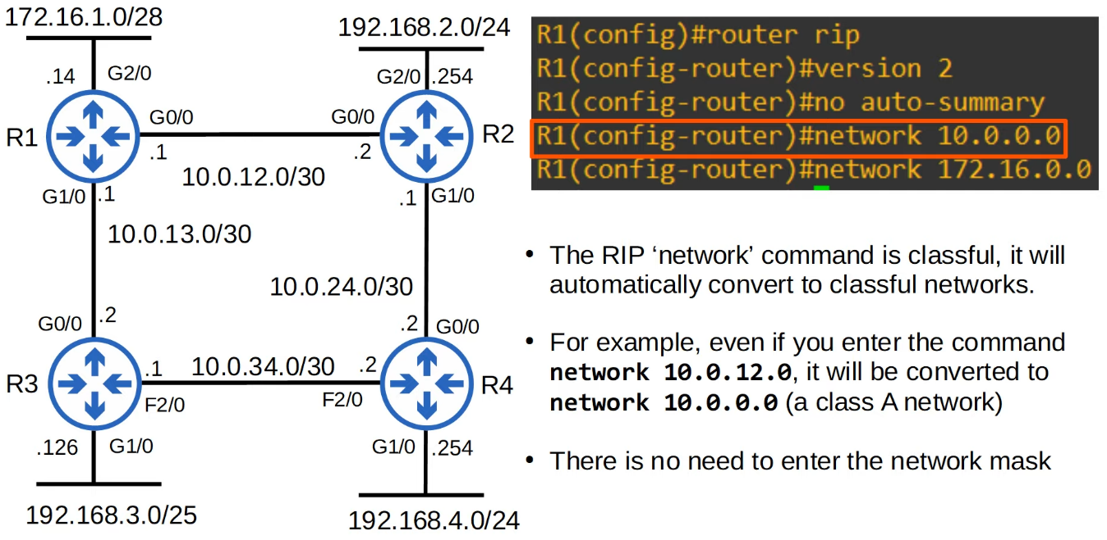

* "no auto-summary": disable default classful settings
* "network" command tells the router to:
  + Look for interfaces with an IP address that is in the specified range
  + Active RIP on the interfaces that fall in the range
  + Form adjacencies with connected RIP neighbours
  + Advertise the network prefix of the interface (NOT the prefix in the network command)
* OSPF and EIGRP network commands operate in the same way
* "network 10.0.0.0"
  + Assumed to be 10.0.0.0/8
  + R1 will look for any interfaces with an IP address that matches 10.0.0.0/8 (since /8, only first 8 bits need to match)
  + G0/0 and G1/0 match, so RIP is activated on their interfaces
  + R1 form adjacencies with R2 and R3
  + R1 advertises 10.0.12.0/30 and 10.0.13.0/30 (NOT 10.0.0.0/8) to its RIP neighbours
* "network" command does not tell the router which networks to advertise, it tells the router which interfaces to active RIP on, and then the router will advertise the network prefix of those interface
* "network 172.16.0.0"
  + Same as above
  + Although there are no RIP neighbours connected to G2/0, R1 will continuously send RIP advertisements out of G2/0
  + This is unnecessary traffic, so G2/0 should be configured as **passive interface**
* R1(config-router)# **passive-interface g2/0**
  + Tells router to stop sending advertisements on the interface
  + However, router will still advertise the network prefix of the interface (172.16.1.0/28) to its RIP neighbours (R2,R3)
  + Should always use this command
  + EIGRP and OSPF have the same passive interface functionality, using the same command
* R1(config-router)# **default-information originate**
  + To share default route

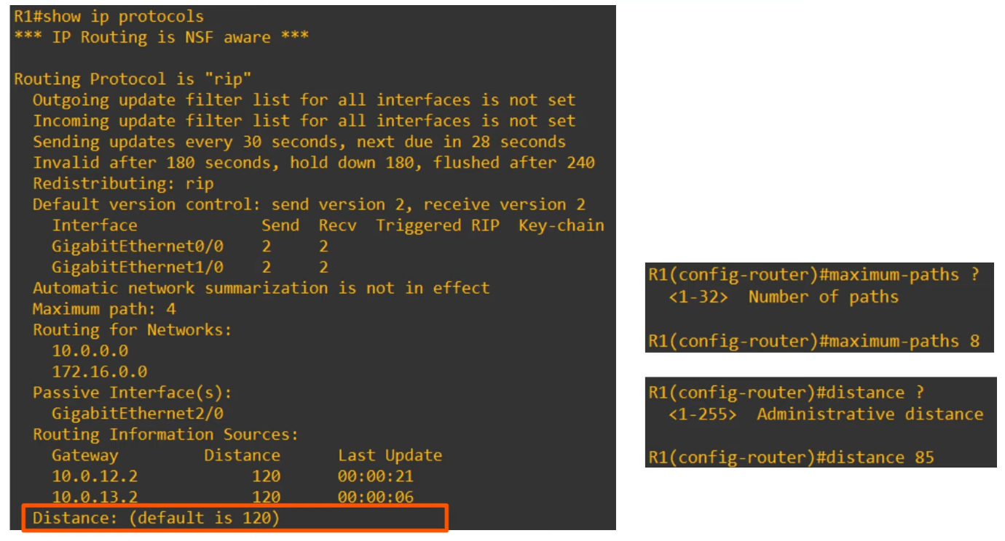

* Distance
  + Administrative distance
  + Can be changed if you want RIP to be preferred over other methods
* Maximum path
  + Max number of paths if they have the same cost
  + Can be changed

EIGRP

* Enhanced Interior Gateway Routing Protocol
* Was Cisco proprietary, but Cisco has now published it openly so other vendors can implement it on their equipment
* Considered 'advanced'/'hybrid' distance vector routing protocol
* Much faster than RIP in reacting to changes in the network
* Does not have the 15 hop count limit in RIP
* Sends messages using multicast address 224.0.0.10
* Is the only IGP that can perform unequal-cost load-balancing (by default it performs ECMP load-balancing over 4 paths like RIP)

Configuration

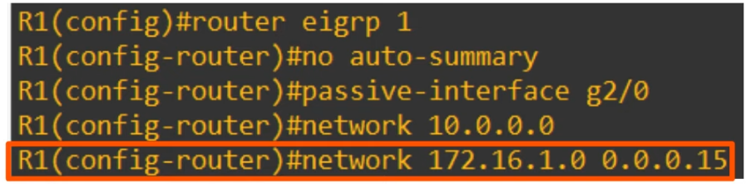

* "router eigrp 1"
  + 1 - Autonomous System number
  + Must match between routers, else they will not form adjacency and won't share info
* "network" command will assume classful address if mask not specified
* EIGRP uses a wildcard mask instead of a regular subnet mask
* Wildcard mask
  + All the 1 becomes 0
  + 255.255.255.0 = 0.0.0.255
  + '0' in wildcard mask - must match
  + '1' in wildcard mask - don’t need to match

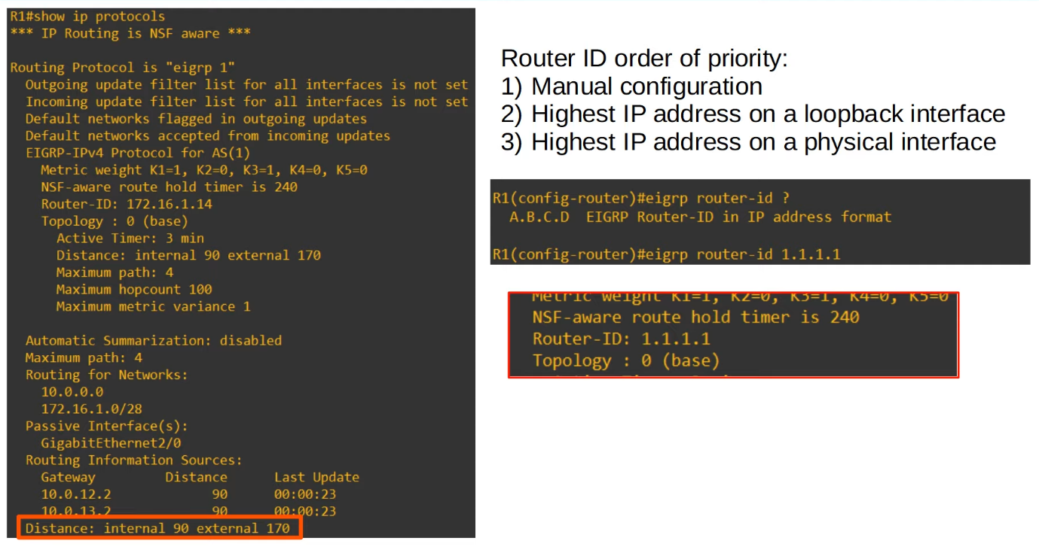

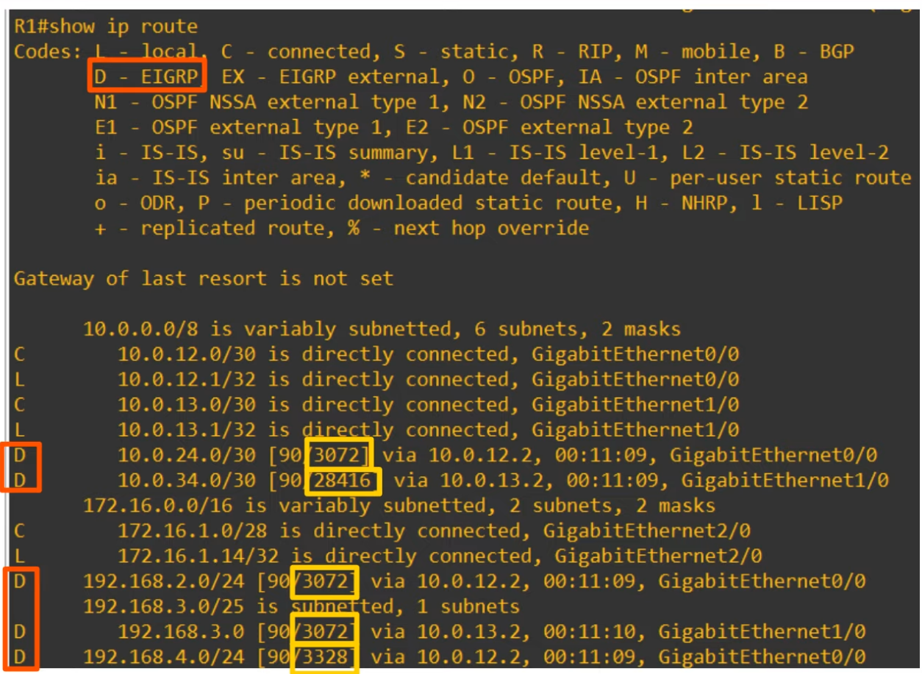

# OSPF

## OSPF (Part 1)

Things covered

* Intro to OSPF
* OSPF Areas
* Basic OSPF Configurations

**OSPF**

* Open Shortest Path First
* Uses Shortest Path First (Dijkstra) algorithm
* 3 versions
  + OSPFv1 (1989) - old, not used anymore
  + OSPFv2 (1998) - used for IPv4
  + OSPFv3 (2008) - used for IPv6 (can use for IPv4 also, but normally use v2)
* Routers store info about the network in LSAs (Link State Advertisements), which are organized in a structure called LSDB (Link State Database)
* Routers will flood LSAs until all routers in the OSPF area develop the same map of the network (LSDB)

**LSA Flooding**

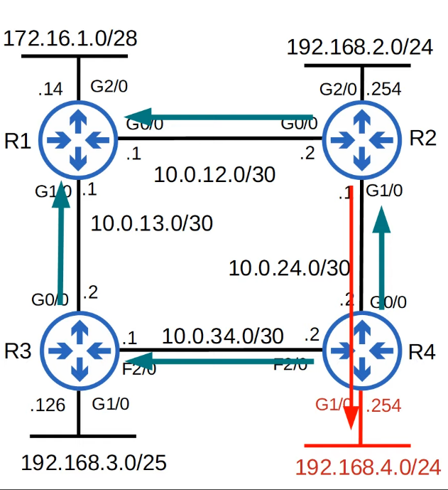

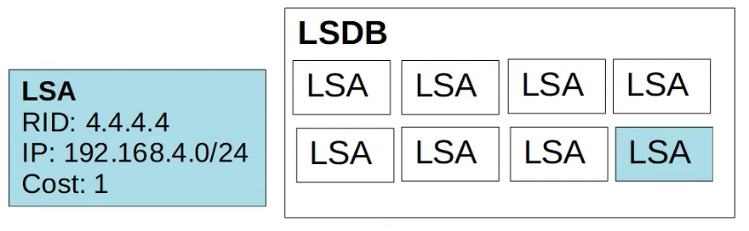

* OSPF is enabled on R4's G1/0 interface
* R4 creates an LSA to tell its neighbours about the network on G1/0
* The LSA is flooded throughout the network until all routers have received it
* This results in all routers sharing the same LSDB
* Each router then uses SPF algorithm to calculate its best route to 192.168.4.0/24
* Each LSA has a timer (default: 30 mins). The LSA will be flooded again after timer expires

**OSPF**

* In OSPF, there are 3 main steps in the process of sharing LSAs and determining the best route to each destination in the network
  1. Become neighbours with other routers connected to the same segment
  2. Exchange LSAs with neighbour routers
  3. Calculate the best routes to each destination, and insert them in the routing table

**OSPF Areas**

* OSPF uses areas to divide up the network
* Small networks can be single-area without any negative effects on performance
* In larger networks, a single-area design can have negative effects
  + SPF algorithm takes more time to calculate routes
  + SPF algorithm requires exponentially more processing power on the routers
  + Larger LSDB takes up more memory on the routers
  + Any small change in the network causes every router to flood LSAs and run the SPF algorithm again
* By dividing a large OSPF network into smaller areas, can avoid the negative effects

**Terminologies**

* Area
  + Set of routers and links that share the same area
* Backbone area (area 0)
  + An area that all other areas must connect to
* Internal routers
  + All of the router's interfaces are in the same area
* Area Border Routers (ABRs)
  + Routers with interfaces in multiple areas
  + Maintain a separate LSDB for each area
  + Recommended to connect to a max of 2 areas. Can overburden the router if 3 areas
* Backbone Routers
  + Routers connected to the backbone area (Area 0)
* Intra-area route
  + A route to a destination inside the same OSPF area
* Inter-area route
  + A route to a destination in a different OSPF area

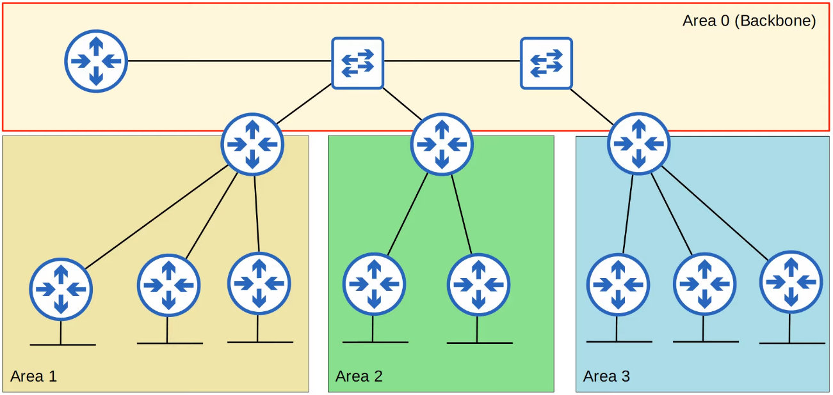

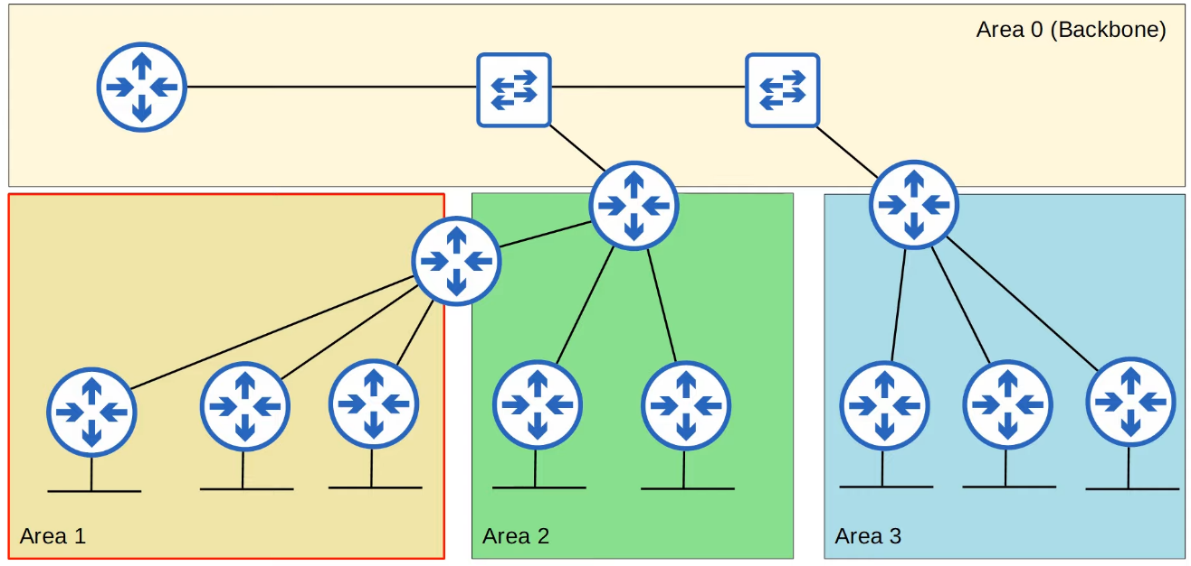

**OSPF Area Rules**

* OSPF areas should be contiguous
* All OSPF areas must have at least 1 ABR connected to the backbone area
* OSPF interfaces in the same subnet must be in the same area

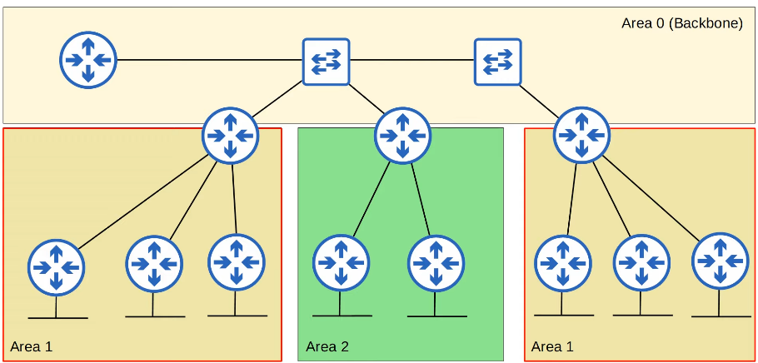

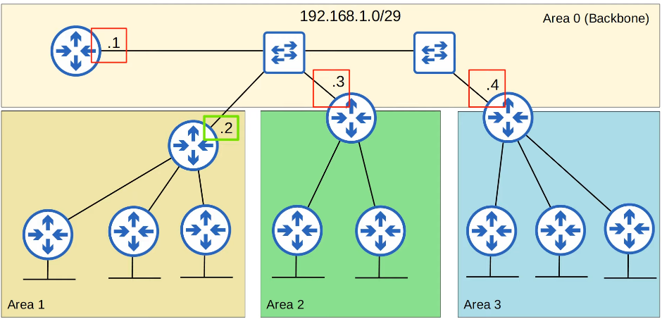

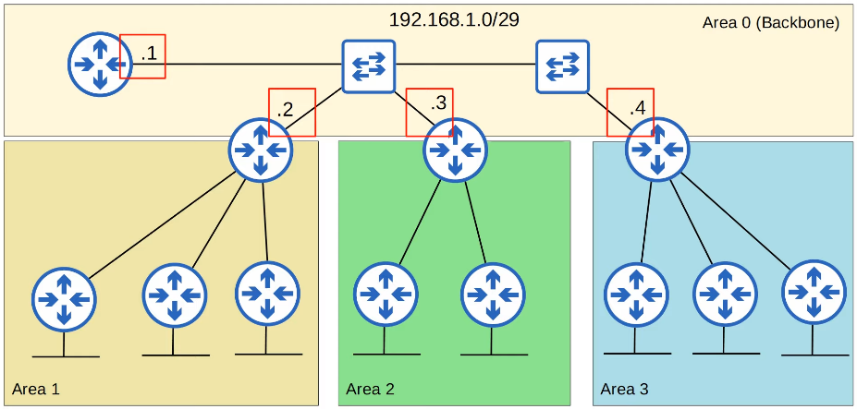

**Configurations**

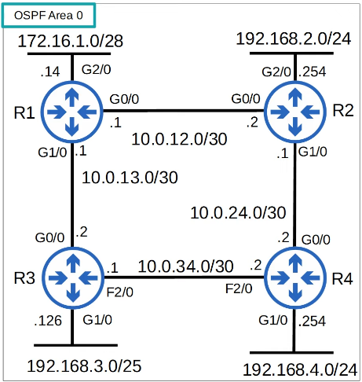

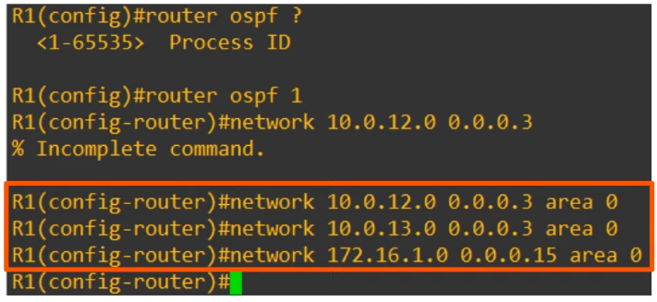

* "Process ID"
  + Locally significant
  + Will work if other routers have different ID
* "network"
  + Need to specify "area"
  + Tells OSPF to
    - Look for any interfaces with an IP address contained in the range specified in the "network" command
    - Activate OSPF in the specified area
    - The router will then try to become OSPF neighbours with other OSPF-activated neighbour routers
* For CCNA, only need to configure single-area OSPF (area 0)

**Passive Interface**

* R1(config-router)# passive-interface g2/0
  + Same as in RIP and EIGRP
  + Tells the router to stop sending out "hello" messages from the specified interface
  + However, the router will continue to send LSAs informing neighbours about the subnet configured on the interface
  + Should use this command for interfaces not connected to OSPF neighbours

Default Route

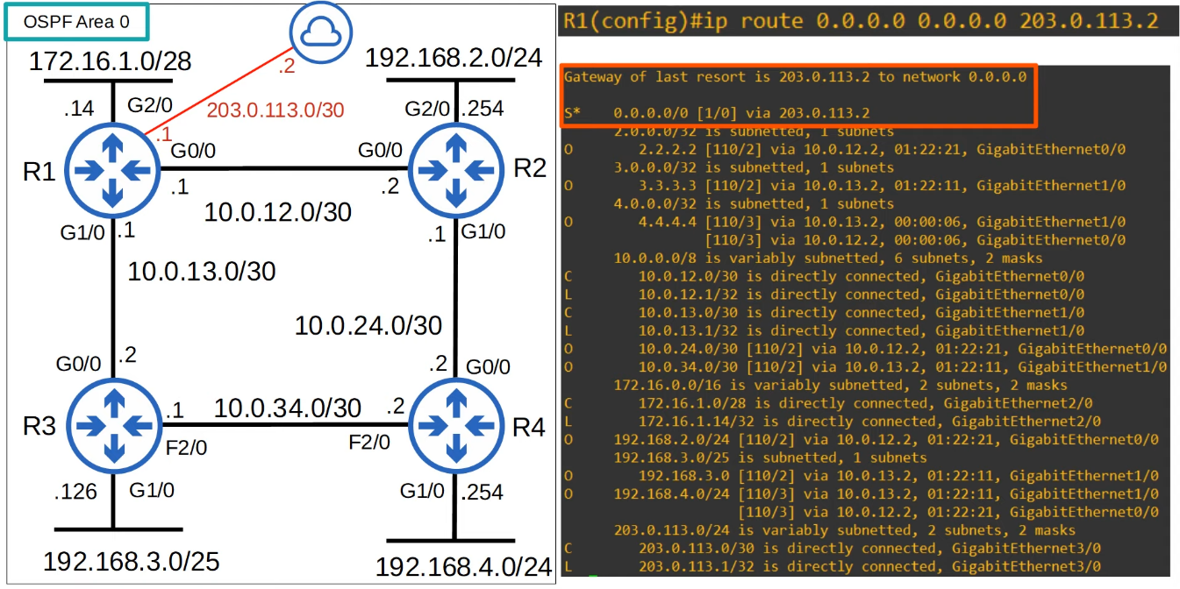

**Advertise Default Route**

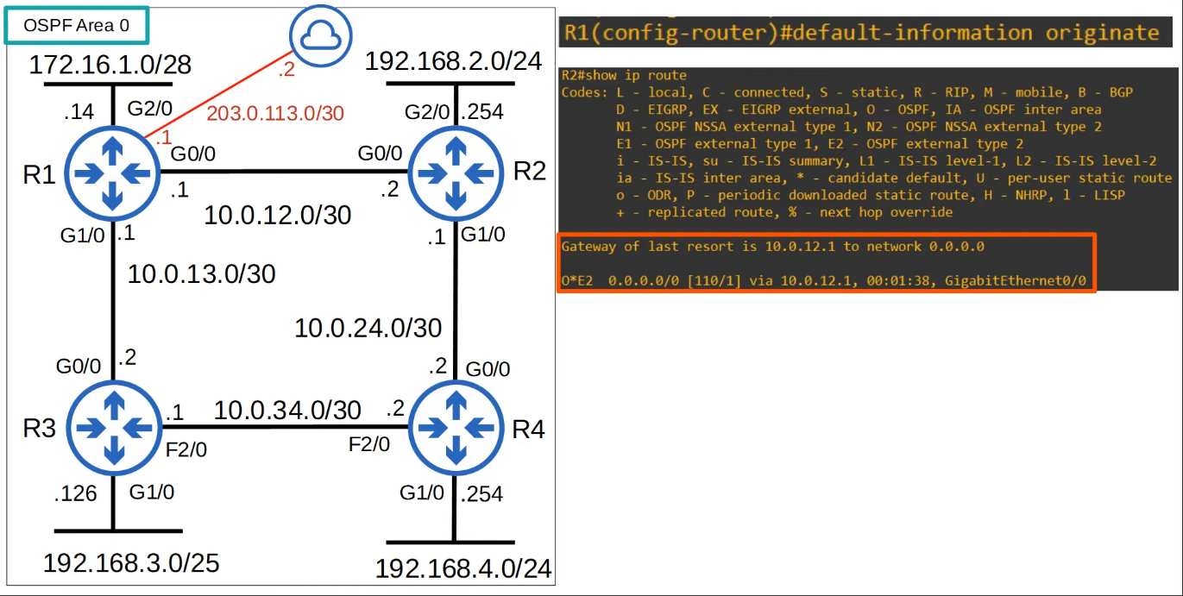

**"show ip protocols"**

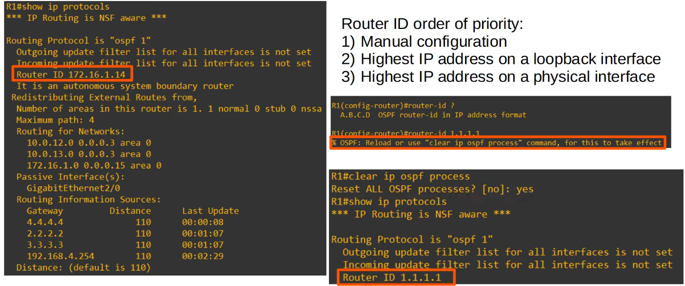

* Need additional command to change router id
  + Not recommended since will clear LSDB, but ok for CCNA
* Autonomous System Boundary Router (ASBR)
  + An OSPF router that connects the OSPF network to an external network
  + R1 is connected to the Internet
  + By using the "default-information originate" command, R1 becomes an ASBR
* R1(config-router)# **maximum-paths <no of paths>**
  + Number of paths allowed for ECMP
  + OSPF don't support unequal cost load balancing
* R1(config-router)# **distance <AD>**
  + Change the administrative distance for OSPF on the router

## OSPF (Part 2)

Things covered

* OSPF metric (cost)
* Becoming OSPF neighbours
* More OSPF config

**OSPF Cost**

* OSPF's metric is called cost
* Auto calculated based on bandwidth (speed) of the interface
* Calculated by dividing the a reference bandwidth value by the interface's bandwidth
* The default reference bandwidth is 100 mbps
  + Reference: 100 mbps / Interface: 10 mbps = cost of 10
  + Reference: 100 mbps / Interface: 100 mbps = cost of 1
  + Reference: 100 mbps / Interface: 1000 mbps = cost of 1
  + Reference: 100 mbps / Interface: 10000 mbps = cost of 1
* All values less than 1 will be converted to 1
* FastEthernet, Gigabit Ethernet, 10Gig Ethernet etc are equal and have a default cost of 1
* Can change the cost (and should do so)
  + R1(config-router)# **auto-cost reference-bandwidth <speed in megabits-per-second>**

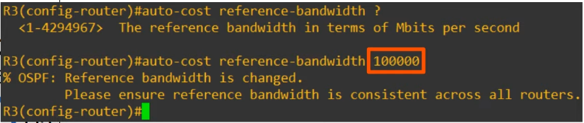

* 100000/100 = cost of 1000 for FastEthernet
* 100000/1000 = cost of 100 for Gig Ethernet
* Should configure a reference bandwidth that is greater than the fastest link in your networks (allow for future upgrades)
* Should configure the same reference bandwidth for all OSPF routers

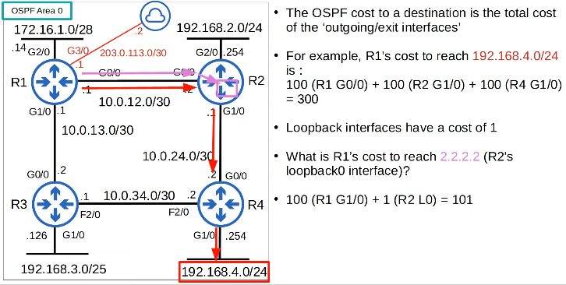

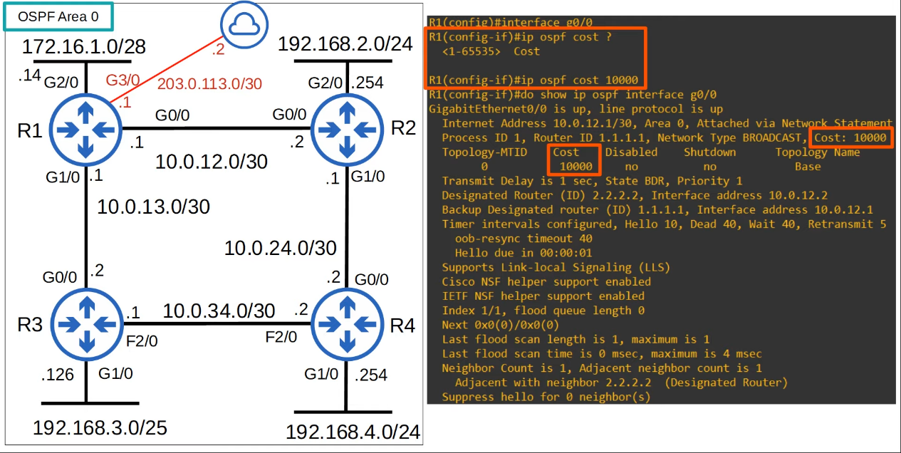

* One more option to change the OSPF cost of an interface is to change the bandwidth of the interface with "**bandwidth**" command
* The formula to calculate OSPF cost is **"reference bandwidth" / "interface bandwidth"**
* Although the bandwidth matches the interface speed by default, changing the interface bandwidth doesn't actually change the speed at which the interface operates
* Bandwidth is just used to calculate the OSPF cost, EIGRP metric etc
* To change actual speed, use **"speed"**
* Because bandwidth is used in other calculations, not recommended to change
* Recommended to change the reference bandwidth, and then use "**ip ospf cost"** command to change the cost of the individual interfaces you want

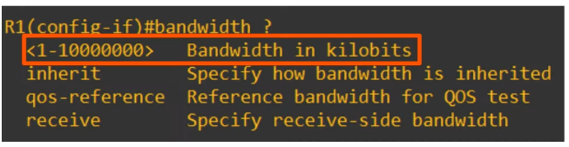

* The command above is to change the actual bandwidth
* In Kbps
* Not recommended

* 3 ways to modify OSPF cost
  1. Change reference bandwidth

R1(config-router)# **auto-cost reference-bandwidth <bandwidth Mbps>**

1. Manual config

R1(config-int)# **ip ospf cost <cost>**

1. Change the interface bandwidth

R1(config-int)# **bandwidth <bandwidth Kbps>**

* "show ip ospf int br"
  + Check the cost of the interface

**OSPF Neighbours**

* Making sure that routers successfully become OSPF neighbours is the main task in configuring

and troubleshooting OSPF.

* Once routers become neighbours, they automatically do the work of sharing network

information, calculating routes, etc.

* When OSPF is activated on an interface, the router starts sending OSPF hello messages out

of the interface at regular intervals (determined by the hello timer). These are used to

introduce the router to potential OSPF neighbours.

* The default hello timer is 10 seconds on an Ethernet connection.
* Hello messages are multicast to 224.0.0.5 (multicast address for all OSPF routers)
* OSPF messages are encapsulated in an IP header, with a value of 89 in the Protocol field.

**Down State**

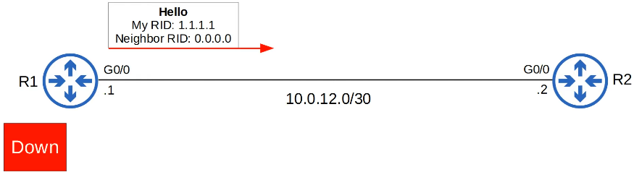

* OSPF is activated on RI's GO/O interface.
* It sends an OSPF hello message to 224.0.0.5.
* It doesn't know about any OSPF neighbours yet, so the current neighbour state is Down.

**Init State**

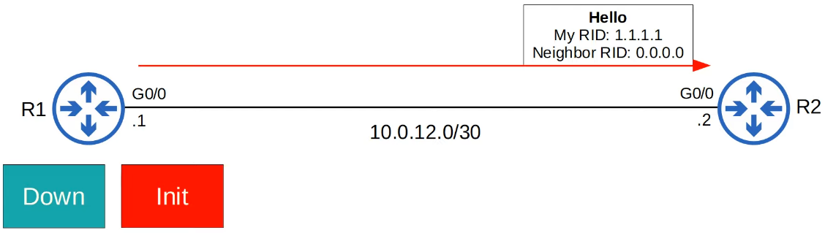

* When R2 receives the Hello packet, it will add an entry for RI to its OSPF neighbour table.
* In R2's neighbour table, the relationship with R1 is now in the Init state.
* Init state = Hello packet received, but own router ID is not in the Hello packet

**2-way State**

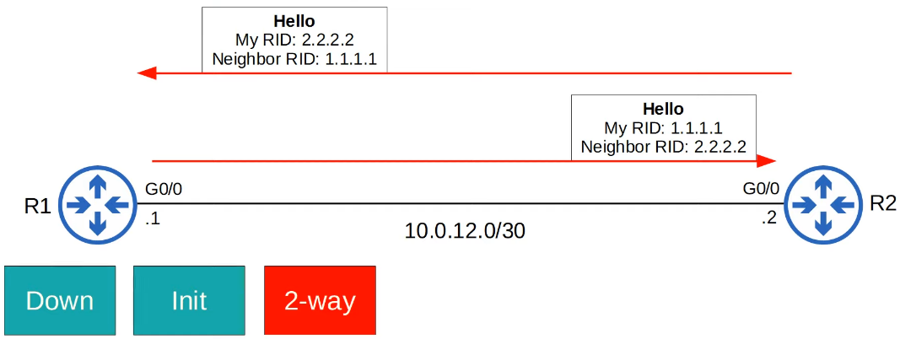

* R2 will send a Hello packet containing the RID of both routers.

R1 will insert R2 into its OSPF neighbour table in the 2-way state.

* R1 will send another Hello message, this time containing R2's RID.
* Now both routers are in the 2-way state.

* The 2-way state means the router has received a Hello packet with its own RID in it.
* If both routers reach the 2-way state, it means that all of the conditions have been met for them to become OSPF neighbours. They are now ready to share LSAs to build a common LSDB.
* In some network types, a DR (Designated Router) and BDR (Backup Designated Router) will be elected at this point.(Day 28)

**Exstart State**

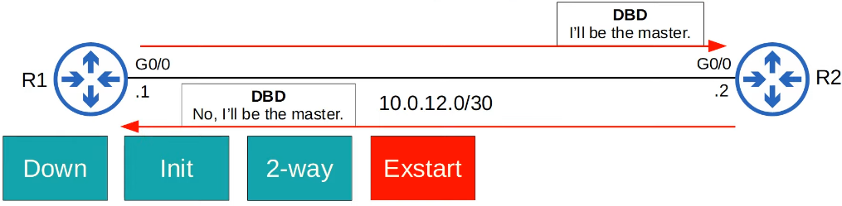

* The two routers will now prepare to exchange information about their LSDB.
* Before that, they have to choose which one will start the exchange.
* They do this in the Exstart state.
* The router with the higher RID will become the Master and initiate the exchange. The router

with the lower RID will become the Slave.

* To decide the Master and Slave, they exchange DBD (Database Description) packets.

**Exchange State**

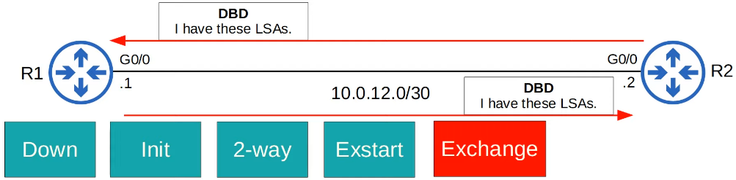

* In the Exchange state, the routers exchange DBDs which contain a list of the LSAs in their LSDB.
* These DBDs do not include detailed information about the LSAs, just basic information.
* The routers compare the information in the DBD they received to the information in their own LSDB to determine which LSAs they must receive from their neighbour.

**Loading State**

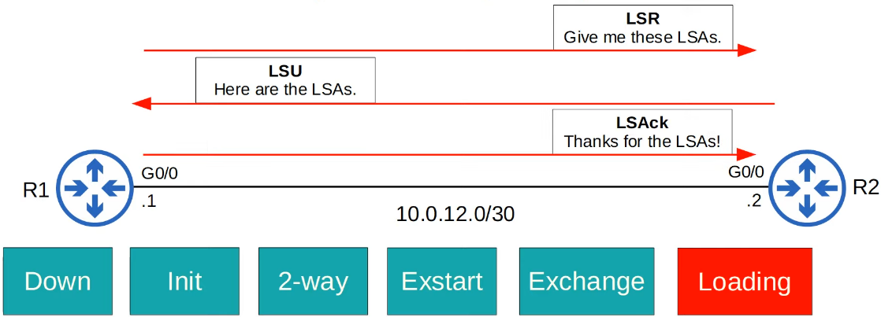

* In the Loading state, routers send Link State Request (LSR) messages to request that their neighbours send them any LSAs they don't have.
* LSAs are sent in Link State Update (LSU) messages.
* The routers send LSAck messages to acknowledge that they received the LSAs.

**Full State**

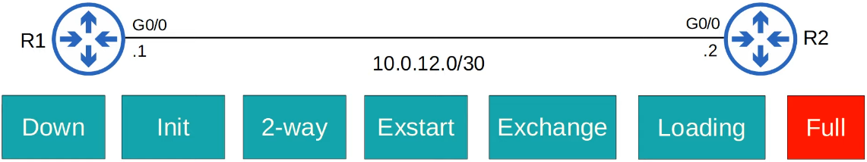

* In the Full state, the routers have a full OSPF adjacency and identical LSDBs.
* They continue to send and listen for Hello packets (every 10 seconds by default) to maintain the neighbour adjacency.
* Every time a Hello packet is received, the 'Dead' timer (40 seconds by default) is reset.
* If the Dead timer counts down to 0 and no Hello message is received, the neighbour is removed.
* The routers will continue to share LSAs as the network changes to make sure each router has complete and accurate map of the network (LSDB).

**Summary**

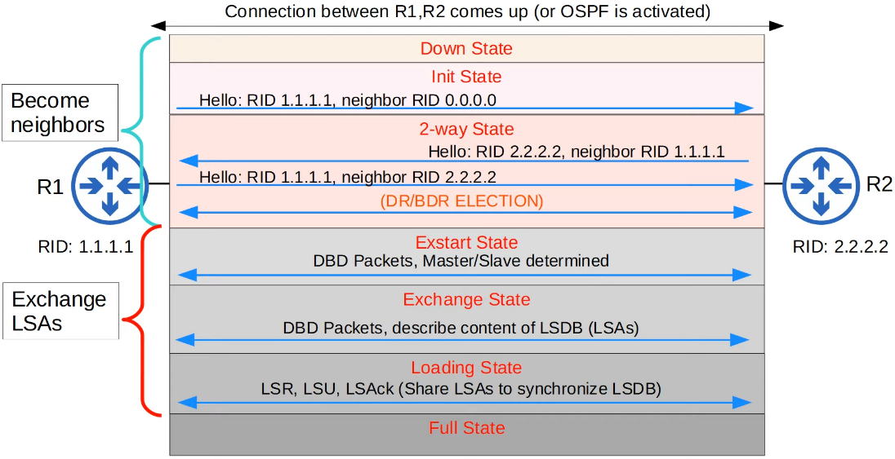

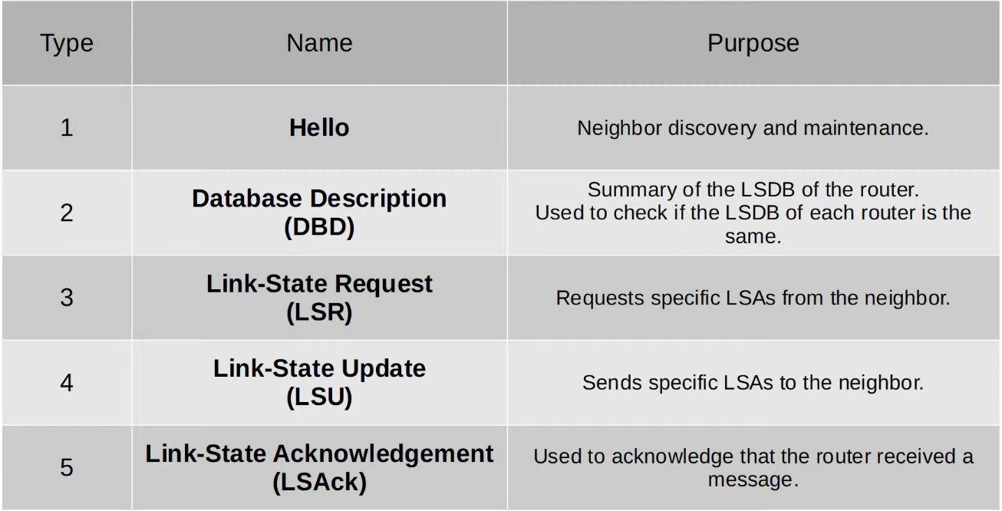

OSPF Neighbours

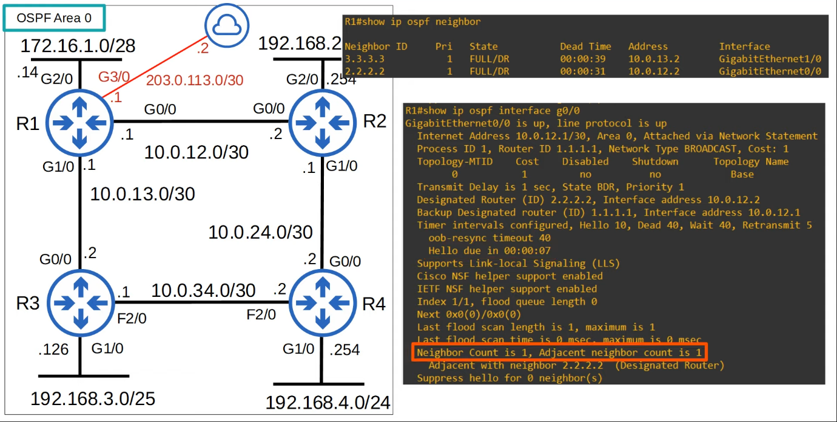

**Configurations**

* Configure OSPF directly on interface

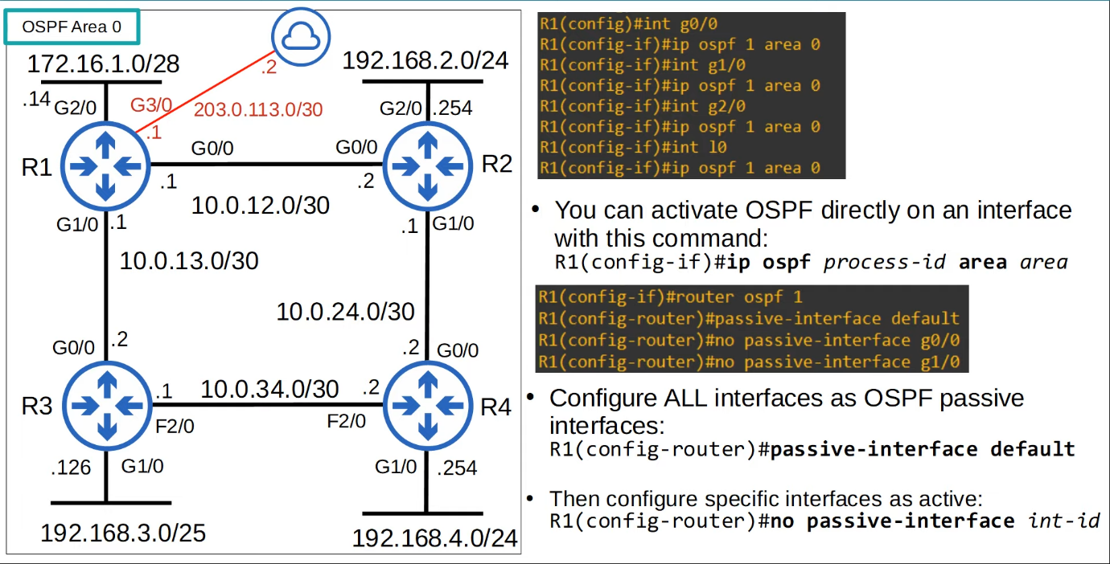

* If configure directly on interface, there will be some differences
  + "Routing for networks" will be empty
  + "Routing on Interfaces Configured Explicitly" will contain the interfaces
  + The rest will be the same

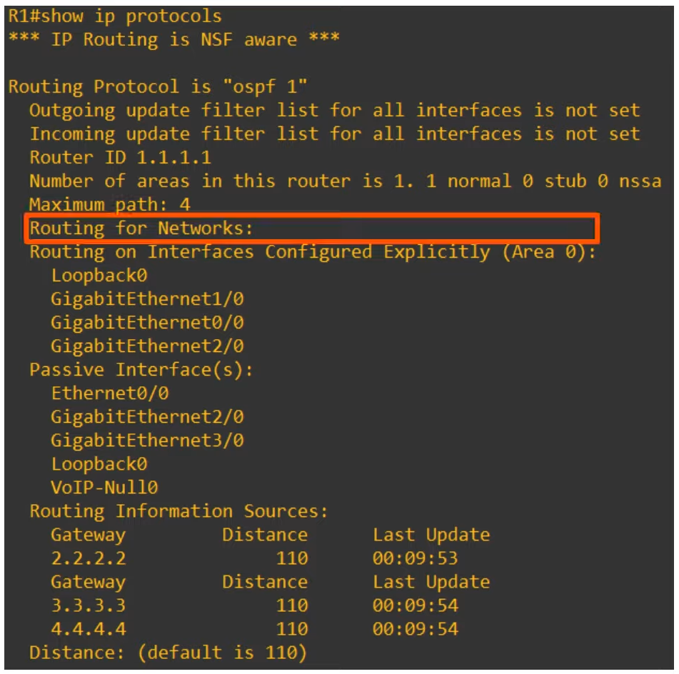

**Overall Summary**

**OSPF metric (cost)**

* Reference bandwidth / interface bandwidth = cost (values less than 1 are converted to 1)
* Default reference bandwidth = 100 mbps
* Modify the reference bandwidth:

R1 (config-router)# **auto- cost reference-bandwidth <megabits-per-second>**

* Manually configure the cost of an interface:

R1 (config-if)# **ip ospf cost <cost>**

* Modify the interface bandwidth:

R1 (config-if)# **bandwidth <kilobits-per-second>**

* Total cost of outgoing interfaces = metric of the route

**OSPF Neighbours**

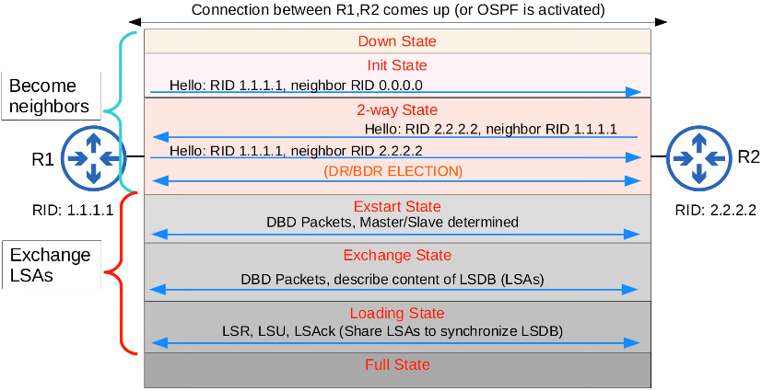

**More OSPF Configuration**

* Activate OSPF directly on an interface:

R1 (config-if)# **ip ospf <process-id> area <area-id>**

* Configure all interfaces as passive interfaces by default:

R1 (config-router)# **passive-interface default**

**Message Type**

* Hello: 1
* DBD: 2
* LSU: 3

OSPF (Part 3) (Day 28)

Topics covered

* OSPF network types
* OSPF neighbour/adjacencies requirements
* OSPF LSA types

**Loopback Interfaces**

* A virtual interface in the router
* Always up/up (unless manually shutdown)
* Not dependent on a physical interface
  + Won't fail unless router fail
* So, it provides a consistent IP address that can be used to reach/identify the router

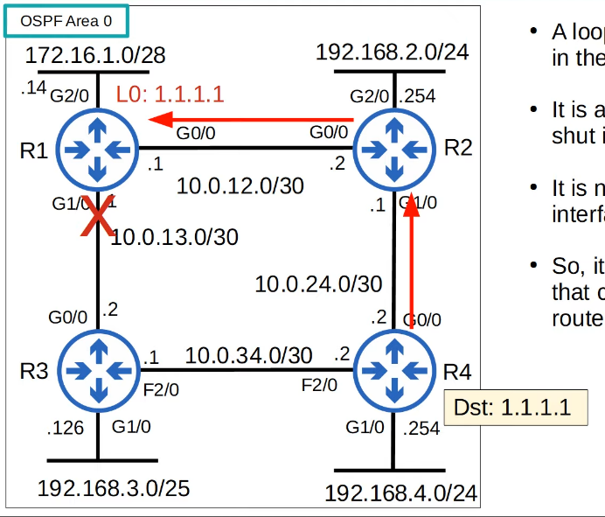

**OSPF Network Types**

* Refers to the type of connection btw OSPF neighbours (Ethernet etc)
* There are 3 main OSPF network types
  + Broadcast
    - Enabled by default on
      * **Ethernet** interfaces
      * **FDDI (Fiber Distributed Data Interfaces)** interfaces
  + Point-to-Point
    - Enabled by default on
      * **PPP(Point-to-point)** interfaces
      * **HDLC (High-Level Data Link Control)** interfaces
  + Non-broadcast
    - Enabled by default on
      * **Frame Relay** interfaces
      * **X.25** interfaces

**Broadcast Network Type**

* Enabled on Ethernet and FDDI interfaces by default
* Routers dynamically discover neighbours by sending/listening for OSPF hello messages using multicast address 224.0.0.5
  + Non-broadcast need to manually configure neighbours (not in CCNA)
* A DR(designated router) and BDR (backup designated router) must be elected on each subnet
  + Only DR elected if there are no OSPF neighbours (e.g. R1 G1/0 interface)
* Routers that are not DR or BDR are DROther

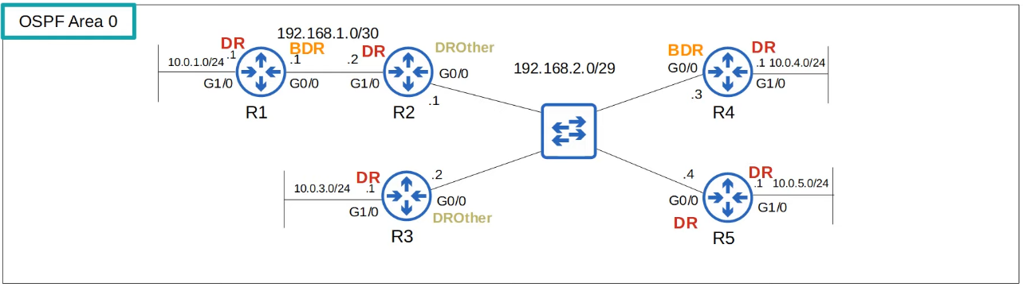

* DR/DBR election
  1. Highest OSPF interface priority
  2. Highest OSPF router ID
* 1st place become DR, 2nd place become BDR
* By default, OSPF interface priority is 1 on all interfaces

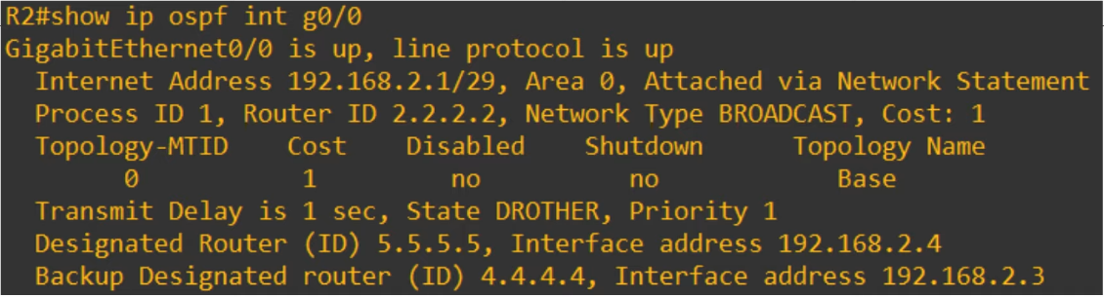

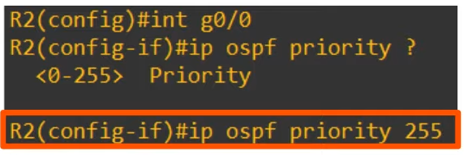

* If set to 0, router cannot become DR/BDR for the subnet
* However, R2 will still remain DROther
  + DR/DBR selection is non-pre-emptive
  + Once they are selected, will not change until OSPF is reset (interface fail/ shutdown)

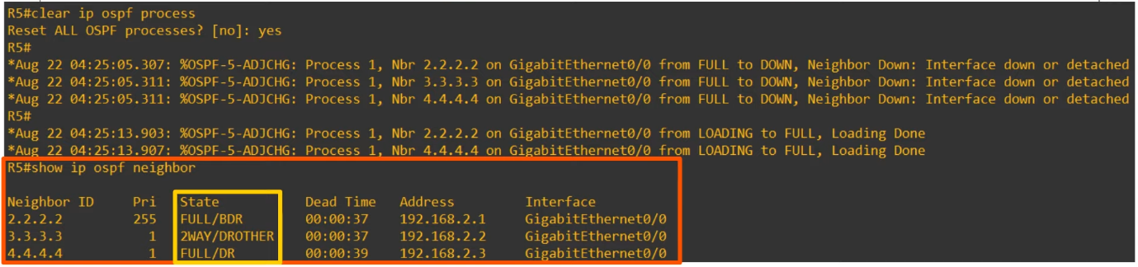

* R4 became the DR, not R2
  + R2 became the new BDR
  + When the DR goes down, the BDR becomes the new DR
  + Then, an election is held for the new BDR
* R3 is a DROther, and is stable in the 2-way state
  + Only neighbour state btw DROther and DR/BDR will be Full
  + If btw DROther and DROther, it will be 2-way

* In the broadcast network type, routers will only form a full OSPF adjacency with the DR/BDR of the segment
* Therefore, routers will only exchange LSAs with DR/BDR
  + DROthers will not exchange LSAs with each other
* All routers will still have the same LSDB, but this reduces the amount of LSAs flooding in the network
* Messages to the DR/BDR are multicast using address 224.0.0.6

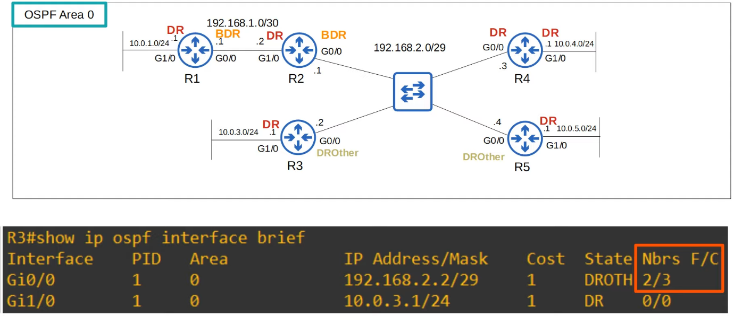

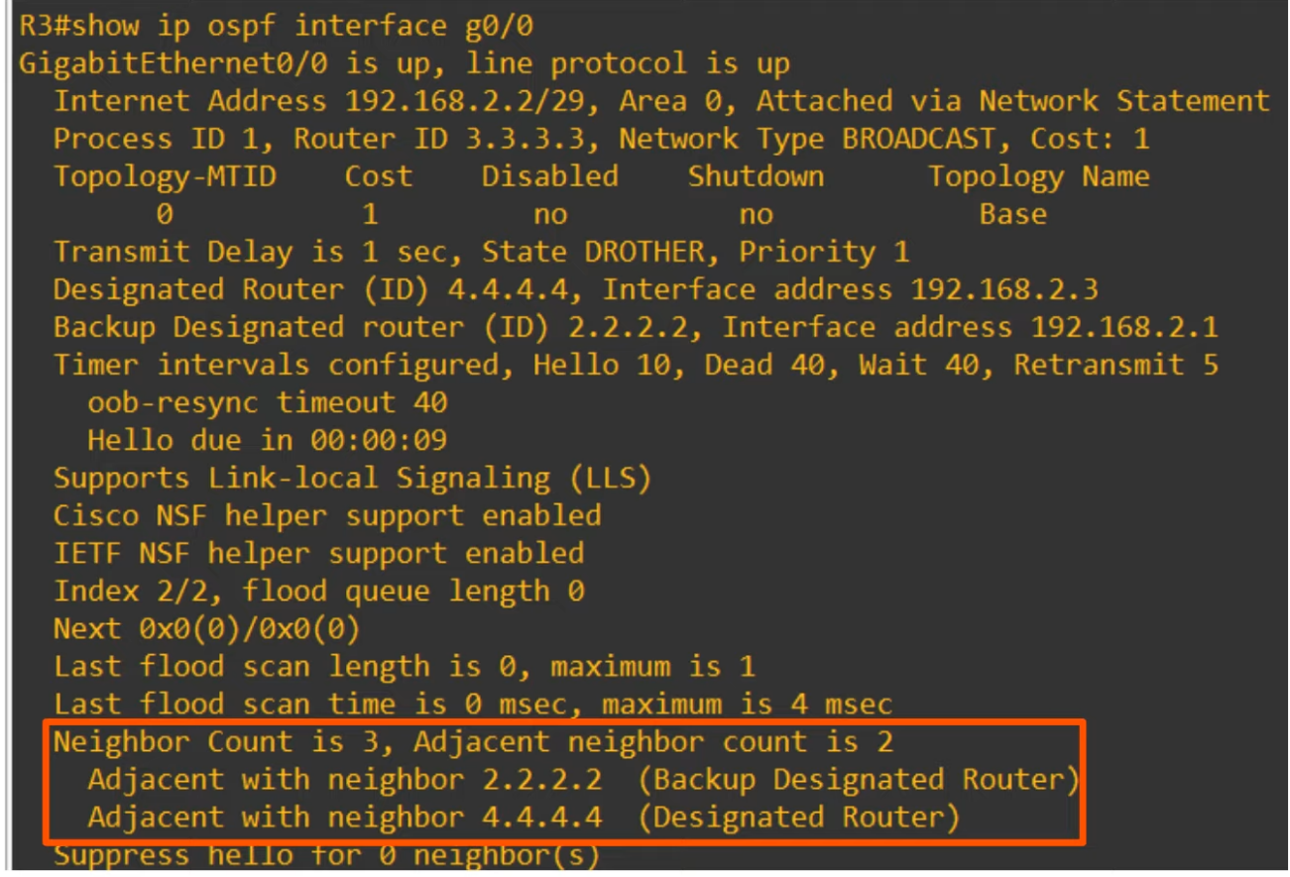

* R3 has 2 neighbours in 'Full' adjacency
* R3 has a neighbour count of 3

**Point-to-point Network Type**

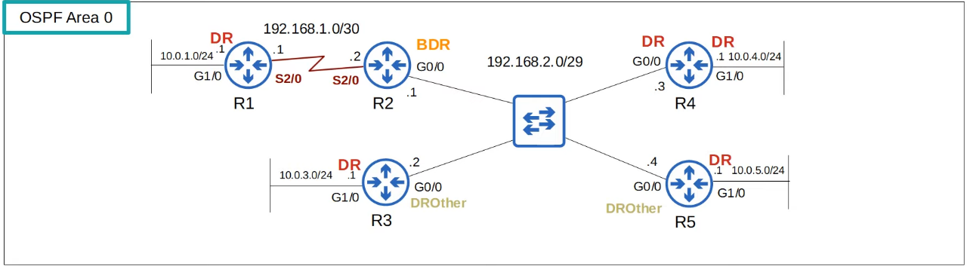

* Enabled on serial interfaces using PPP or HDLC encapsulation by default
* Routers dynamically discover neighbours by sending/listening for OSPF Hello messages using multicast address 224.0.0.5
* A DR and DBR is NOT elected
* These encapsulations are used for 'point-to-point' connections
* Therefore, there is no point in electing DR and BDR
* The 2 routers will form a Full adjacency with each other

**Serial Interfaces**

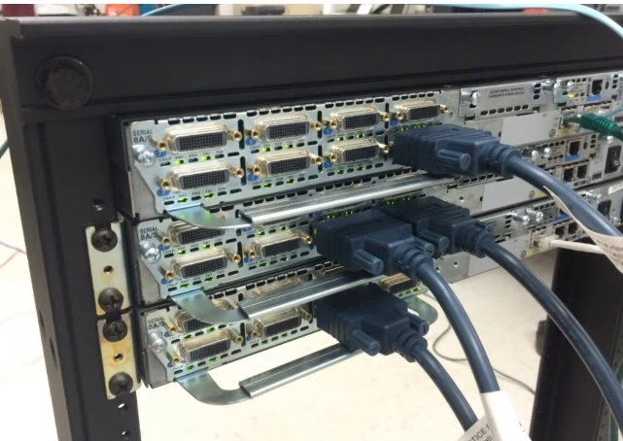

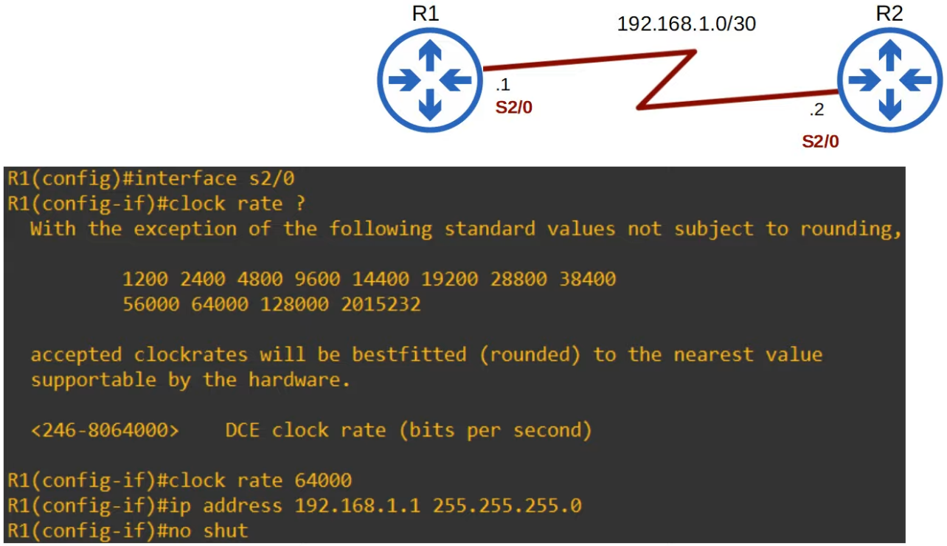

* One side of a serial connection functions as DCE (Data Communications Equipment)
* The other side functions as DTE (Data Terminal Equipment)
* The DCE side needs to configure the clock rate (speed) of the connection
* Note
  + Ethernet: "speed"
  + Serial: "clock rate"

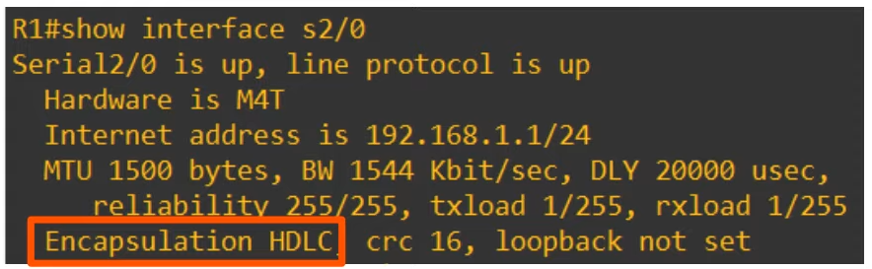

* The default encapsulation on a serial interface is HDLC
  + Actually cHDLC (Cisco HDLC)

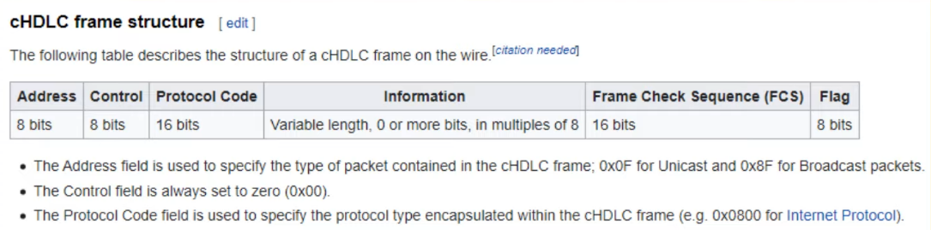

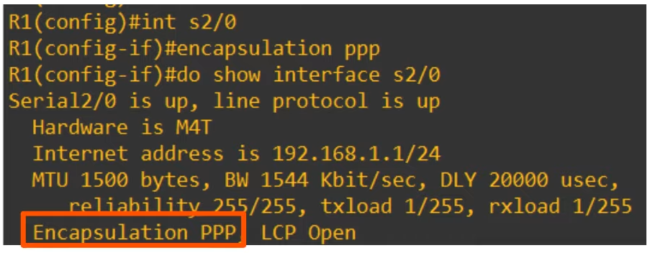

* If you change the encapsulation, it must match on both ends or the interface will go down

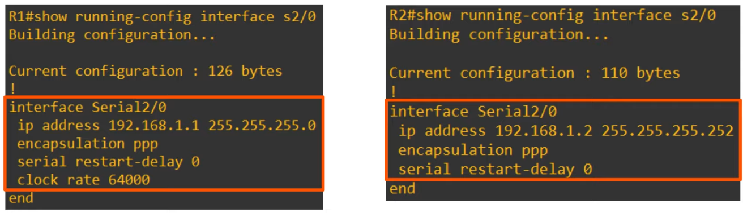

**Summary (Serial Interfaces)**

* Default encapsulation is HDLC
* Can configure encapsulation as PPP
  + R1(config)# **encapsulation ppp**
* One side is DCE and other side is DTE
* Identify which side is DCE/DTE
  + R1# **show controllers <interface_id>**
* You must config the clk rate on the DCE side
  + R1(config-if)# **clock rate** <rate in bps>

**Point-to-point**

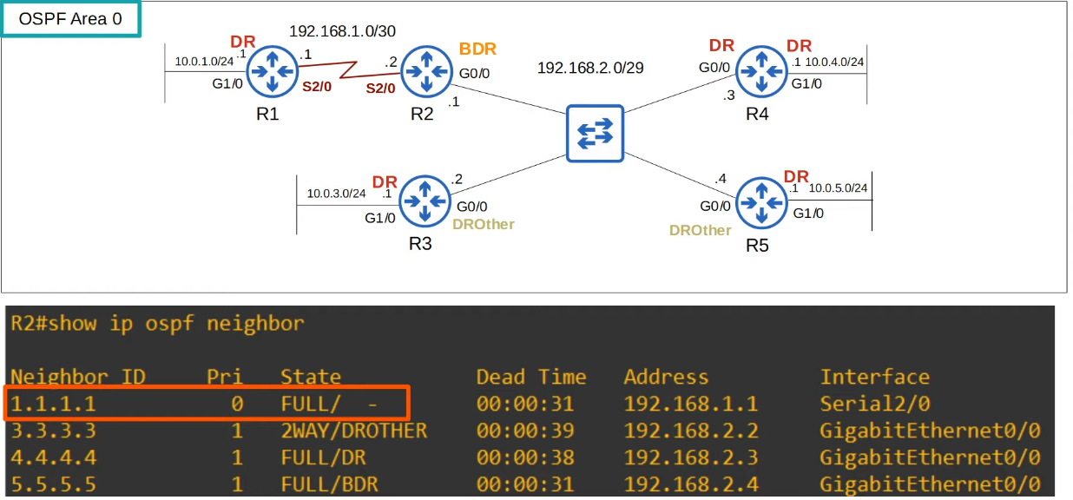

* Not considered any router type since it is a point-to-point connection

**Config Network Type**

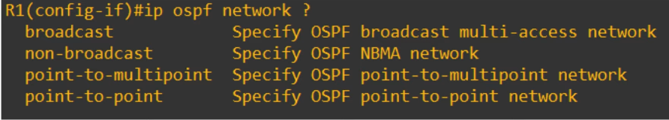

* Can configure network type on an interface
  + R1(config-if)# **ip ospf network <network-type>**
* For example, if 2 routers directly connected with an Ethernet link, no need DR/BDR. Can config a point-to-point network type instead
* Note: Not all network types work on all link types
  + E.g. Serial link cannot use the broadcast network type

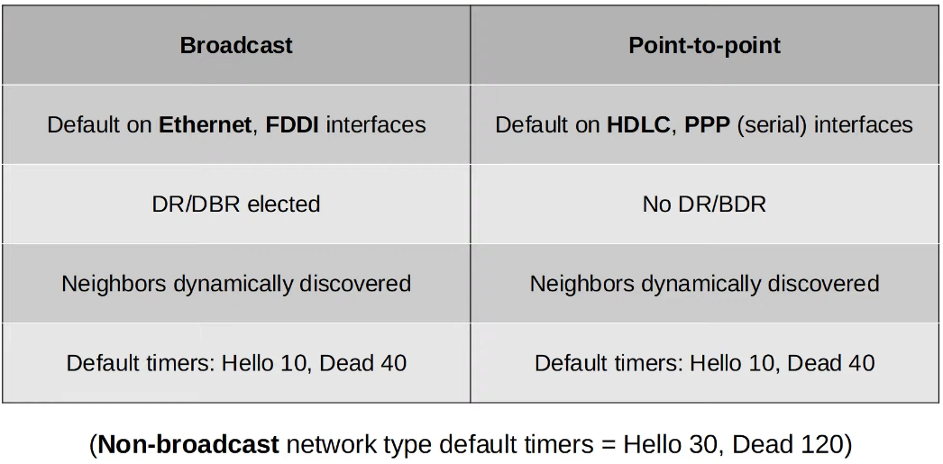

**OSPF Neighbour Requirements**

1. Area number must match
2. Interfaces must be in the same subnet
3. OSPF process must not be shutdown
4. OSPF router IDs must be unique
5. Hello and Dead timers must match
6. Authentication settings must match

The following rules still can become OSPF neighbours, but OSPF doesn’t operate properly

1. IP MTU must match
2. OSPF network type must match

Point 3 - OSPF process must not be shut down

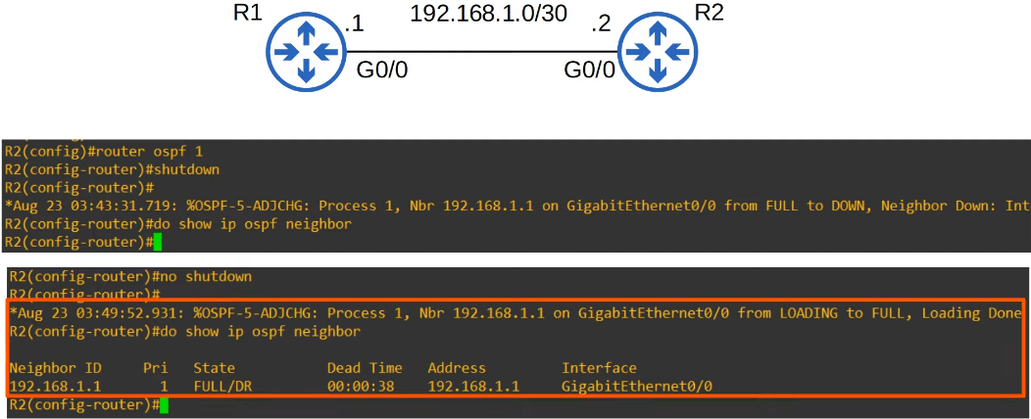

* Can shutdown OSPF without deleting the configurations

Point 4 - Router IDs must be unique

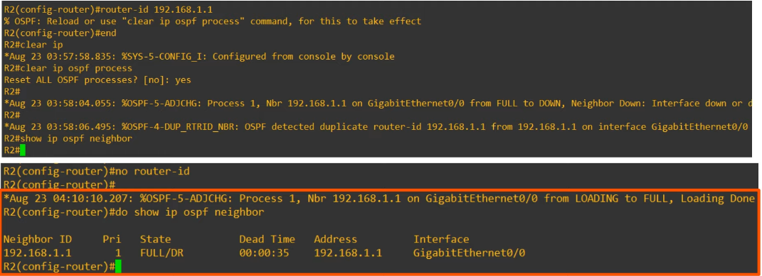

* Why don't need to reset?
  + R2 does not have any other neighbours, so don't need to worry about affecting other routers

Point 5 - Hello and Dead timers must match

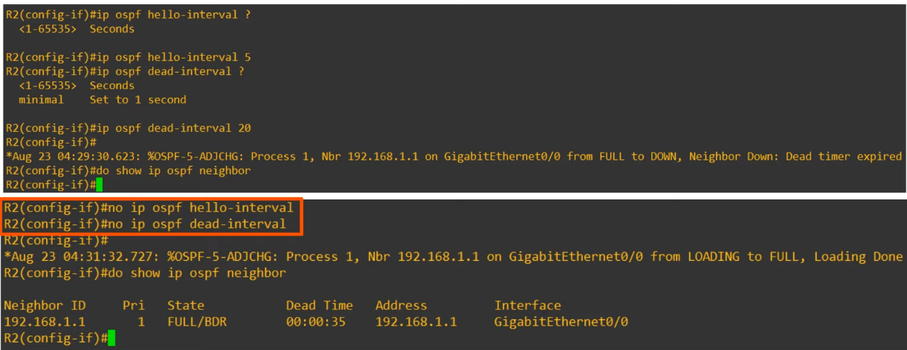

* Can manually config the Hello and Dead timers
* Can reset them to default values by using "no"

Point 6 - Authentication settings must match

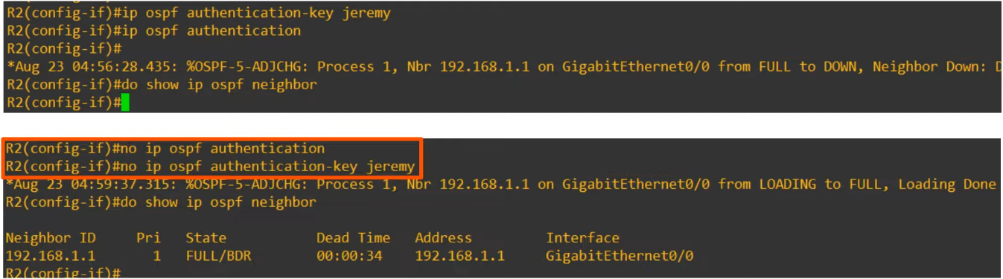

* Passwords on both routers must match

Point 7 - IP MTU must match

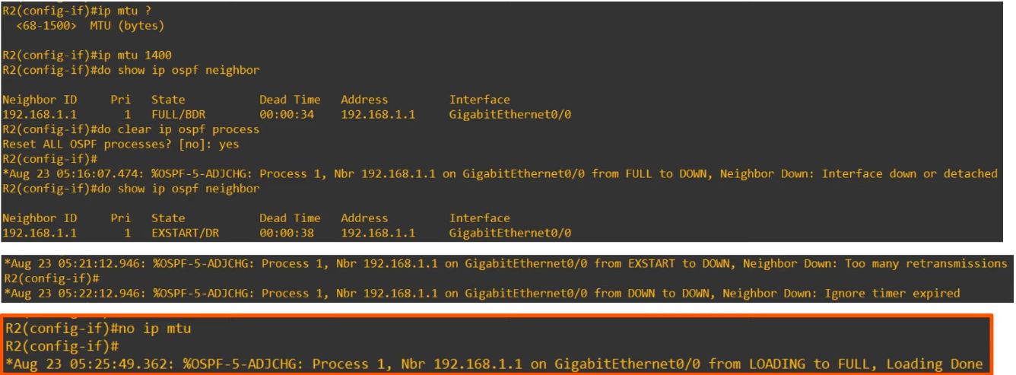

* Default MTU value = 1500

Point 8 - OSPF network type must match

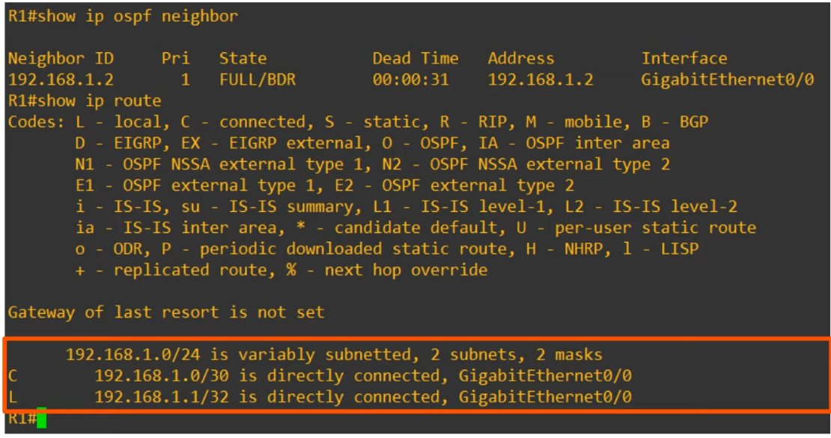

* R2 loopback address is missing from the routing table
* A bit difficult to spot

**OSPF LSA Types**

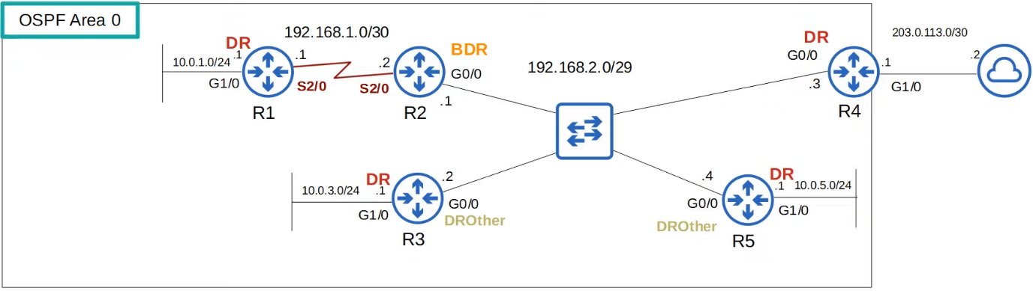

* The OSPF LSDB is made up of LSAs
* There are 11 types of LSA, but only 3 needed for CCNA
  + Type 1 (Router LSA)
  + Type 2 (Network LSA)
  + Type 5 (AS External LSA)

* Type 1 (Router LSA)
  + Every OSPF router generates this type of LSA
  + It identifies the router using its router ID
  + It also lists networks attached to the router's OSPF-activated interfaces

* Type 2 (Network LSA)
  + Generated by the DR of each 'multi-access' network (e.g the broadcast network type)
  + List the routers which are attached to the multi-access network

* Type 5 (AS-External LSA)
  + Generated by ASBRs to describe routes to destinations outside of the AS (OSPF domain)

